Stock Market Simulation

Computer Science. Akeley Wood School 52125.
James Williams 2203

Table of Contents
Analysis:
Initial Ideas and Problem Identification 4
Existing Solutions - Stockscan 5
Existing Solutions – Simul8or 6
Existing Solutions – Fakeonomy 8
Stakeholders 10
Questionnaires and Initial Feedback 11
Computational Methods 15
Requirements 17
Success Criteria 18
Limitations 25

Design, Testing and Implementation:
Decomposition 27
Visual Design 33
Implementation approach 38
Initialising a Window 38
Design 38
Implementation 41
testing 42
Creating Text Boxes 45
Design 45
Implementation 47
Testing 48
Creating Buttons 51
Design 51
Implementation 53
Testing 53
Text Input Boxes 56
Design 56
Implementation 59
Testing 61
Data Collection 64
Design 64
Implementation 67
Testing 69
Graph 72
Design 72
Implementation 75
Testing 77
Graph – Second Iteration 82
Design 82
Implementation 83
Testing 85
File Organisation 90
Loading Multiple Stocks 91
Design 91
Implementation 93
Testing 93
Buying and Selling Stocks 96
Design 96
Implementation 98
Testing 100

Evaluation:
Final Testing 102
Initialisation 102
Text Boxes 109
Buttons 114
Text Input Boxes 117
Data Retrieval 119
Graph 121
Unmet Success Criteria 137
Price Predictor 138
Menus 138
Accounts 139
Game Modes 140
Actions 141
Initialisation 141
Data Retrieval 142
Accounts and Saving/Loading Data 143
Music 151
Usability Features 152
Longevity 154
Limitations 154

Additional Sources:
Final Project Code 155
Bibliography 168

Analysis

Initial Ideas and Problem Identification
Some initial ideas I have for my project include:
- A stock market simulator with a price predictor
- A 3D graphical engine
- A 2D game with AI opponents
Teachers and students at my school have expressed an interest in stock market simulation and trading. Since the students are interested in competing against each other and the teachers wish to educate the students about the stock market, they have formed clubs where teams will trade virtual stock over a term and will compare the money they make. However, many online stock market simulators are blocked on school devices, meaning that those who want to learn about it are limited to unblocked websites. Many of these simulators lack features, such as not having live data, or are too complicated for new investors to understand. My aim is to deliver a program that is easily comprehensible and educational, but not lacking in expert features.
This project won’t only be useful for the stakeholders, as I can stretch my programming and mathematical skills. I can easily expand the project to further its complexity and the amount of new content I learn. For example, I will need a way to display the data that I collect and the resultant predictions – Therefore, I may need to create a graphical user interface that draws graphs. Furthermore, I could diversify my product to appeal better to students who can use it for educational purposes. Therefore, I will aim to create game modes that challenge the user, such as timed game modes.
Additionally, the field of machine learning and data science greatly interests me, so implementing a price predictor in this project will allow me to research deeper into the subject and learn more about new computational and math related concepts.
In summary, my intended product for this project is a stock market simulator that includes a graphical display of prices, a stock value predictor and an additional game mode feature:
- Graphical User Interface
  - There should be a graphical representation of the data so that users can easily understand what the program is presenting to them. Therefore, for my project to be successful, I will need to make a GUI capable of drawing accurate graphs.
  - In addition, I can expand on the features of my GUI by adding different displays of company stocks, variable time frames for the graph to span and further displayed analytics like change in price over time, average, max and min price.
  - Potentially, I could also allow for different themes such as a light and dark mode, and custom colours, with the ability for users to draw on the graph.
- Long Short-Term Memory Recurrent Neural Network
  - Ideally this will have reasonable accuracy and will be able to predict relatively far into the future. However, since stock market prices cannot be accurately predicted through data analysis alone, having the model working correctly will be my focus.
- Additional Game Modes
  - With the RNN and GUI fully completed, I can add extra features to my program that will extend its functionality. For example, I can create a timed game mode, where a player will be given a starting amount of virtual money that they will use to invest in the selection of stocks. Once the allocated time has elapsed, their final cash balance will be displayed on a high score table. This could be implemented with a text file, so the scoreboard data isn’t lost when the program is shut down.
  - Conversely to the previous game mode, there could be another where the aim is to lose as much money as possible.
  - I could also create unique scenarios that the player must interact with. For example, I could use stock market data from a time of market collapse, so the player must make wiser choices with their capital.

Existing Solutions - Stockscan

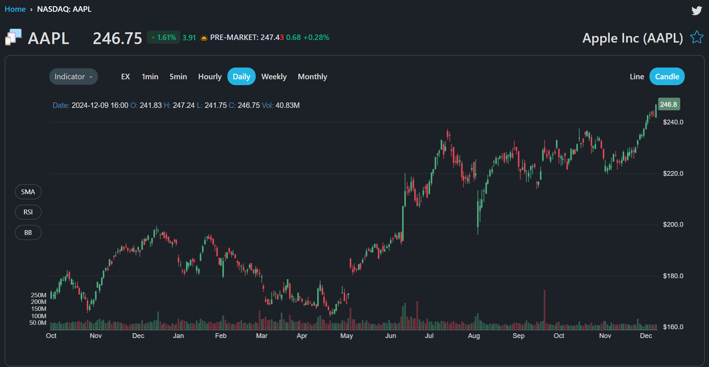
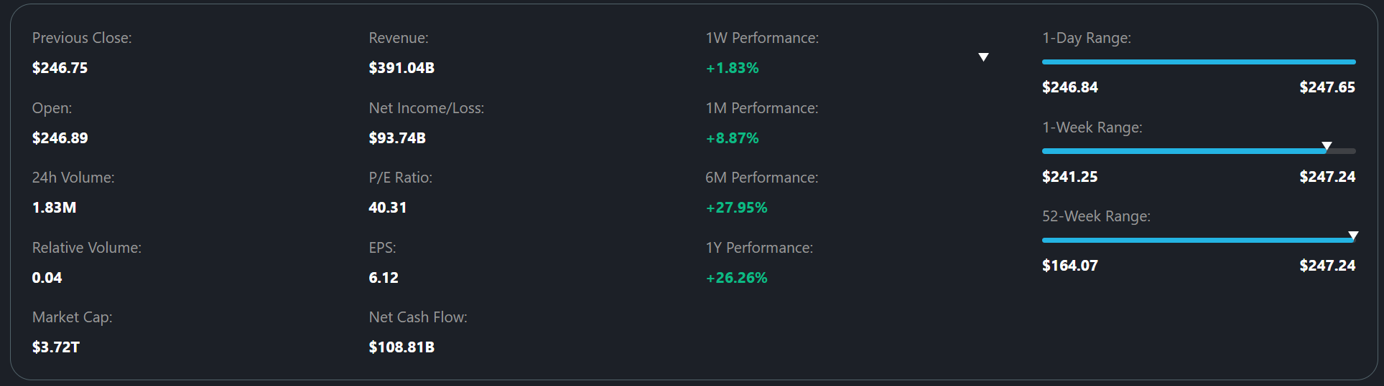
Screenshots taken from Stockscan https://stockscan.io/stock-market-simulator
Positive elements of similar solutions that I can use in my project:
- Graphical representation – Stocks are displayed in an easily understandable manner through the use of an updating graph. A colour-coordinated candlestick graph provides a lot of useful information at a glance, with colour showing if the stock is increasing or decreasing in price and the candlestick form displaying its current price, open, close, low and high. Together, this presents data in an understandable, but professional manner and enables users to access the most recent prices.
- Time frame indication – The range of data that the graph displays varies depending on what setting a user has selected. Being able to see larger, or smaller sets of data could be beneficial to users who want to study the stock to understand how it may fluctuate in price. For example, a seasonal business like an ice cream company may have a large increase in spring and summer months, but low prices in colder months, therefore, being able to see years of data will allow users to spot patterns and make better decisions with how they invest.
- Additional in depth data – Underneath the graph, there is a large set of additional data, such as volumes, market caps, cash flows and more. This data may be of use to users, who may not gain as much information as they require through the graph alone.
- Choosing different stocks – Since Stockscan and similar simulators usually use real world stock market data, they have access to all of the real world stocks. This means that users of the programs can invest in multiple different stocks, contained in different economic sectors, all at once. This may teach users about diversifying their portfolio and focusing more on general markets rather than spending a large amount of time making small amounts of money on one stock.
- Account creation – To store a user’s data, such as the stocks they have bought and the money they have accumulated, accounts are created. Emails/usernames are checked to be unique, and passwords must be at least 6 letters to set and correct to sign in. I could implement a similar system that would allow those that use my program to keep progress with their trading portfolios or games. Furthermore, an account page in the menu would be beneficial since I would be able to have a dedicated area to implement account creation and also have a section to display all of the user’s information.
- Hosted on a website – This makes the program more accessible since it doesn’t need to be downloaded and can be accessed by anyone. This feature would be incredibly beneficial to anyone wishing to use my program, at the very least reducing setup time and making it easier to access. However, hosting my program on a website would be a difficult and time consuming task, so initially, I won’t consider implementing my simulator in this way. Once I have a complete product, If time permits, I can think about hosting the program online.

Existing Solutions – Simul8or
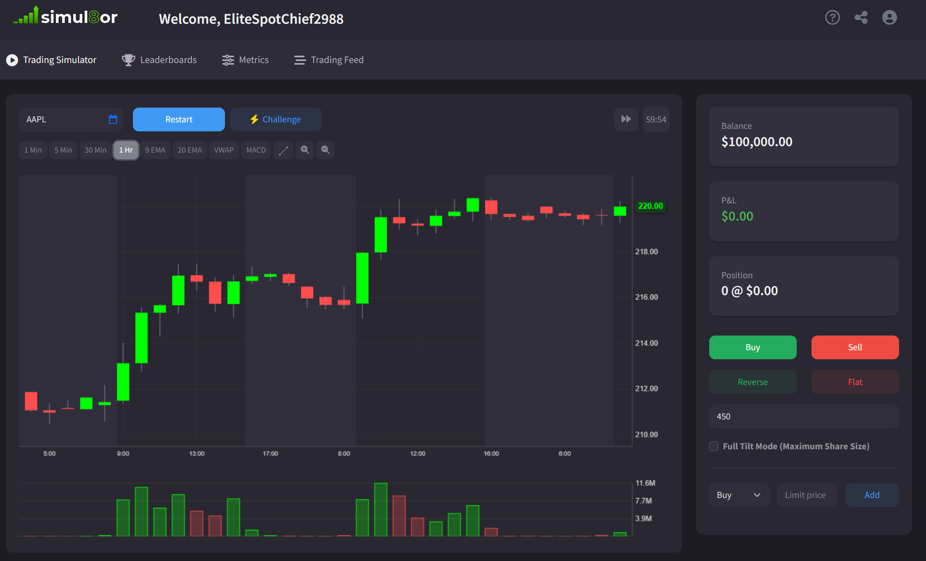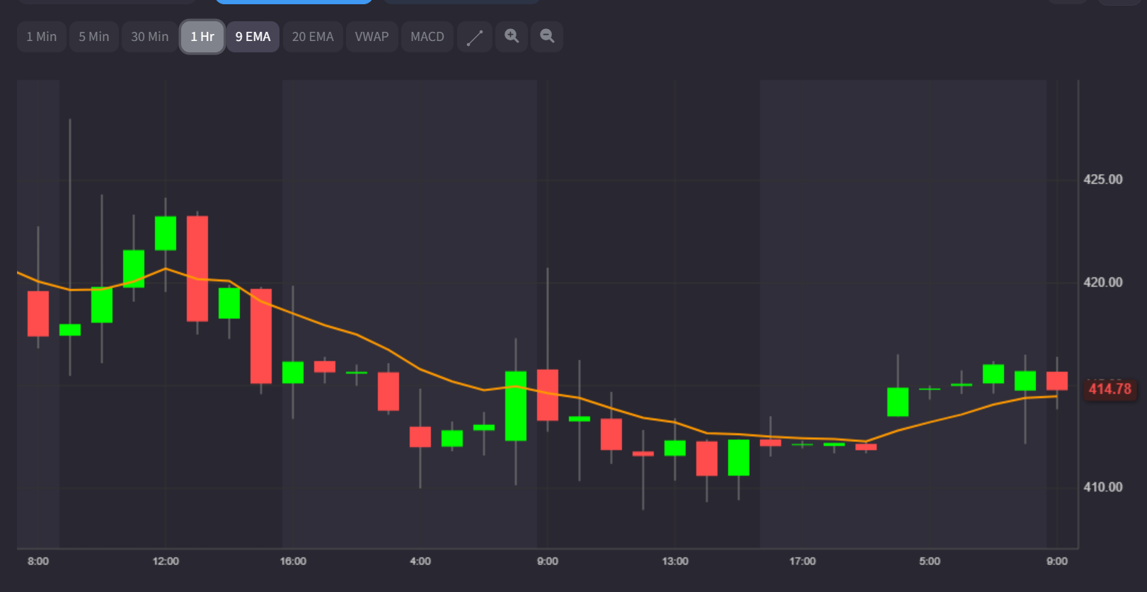
Screenshots taken from simul8or https://simul8or.com/
Similar positive features I could implement:
- Graphical representation – Simul8or also uses an updating candlestick graph, but has a simpler design and a less cluttered GUI, making the interface easier to use, especially for inexperienced users. However, despite the easy design, this solution does not sacrifice any detail, still including all price figures through the candlestick style, also containing extra predictive information such as exponential moving averages over different time frames. Values like your current balance and number of stocks you’ve bought are also clearly displayed. Most of these features are useful, however, since I am already planning on implementing a price predictor, I won’t also include exponential moving average lines, especially since it will clutter the screen and potentially make the GUI more confusing for beginner users.
- Input features – This website easily allows you to switch stocks, just by typing the name of the ticker you want to use. You can simply buy or sell the amount of stock you want by typing the value and clicking a button. It also includes hotkeys like f1 and f2 for buying and selling.
- Challenge mode – By choosing the challenge mode, a random ticker is selected, meaning the user has to generate the most profit from an unseen stock, making the task much more difficult and engaging.
With inspiration from this solution, I would like to use a similar design scheme since my stakeholders are either young or intending to use my product to educate students in secondary school or below. This simplistic approach will make my product easy to understand and use, whilst still providing important information for those who want to further their abilities. Specifically, I plan to make use of the coloured candlestick charts and a non-cluttered GUI with a few simple controls, for example, only inputs for buying, selling, amount of volume, time frame and ticker. Including additional overlays like the moving averages may be a positive addition for my stakeholders, however, due to time constraints, I may not be able to add similar features.

Existing Solutions – Fakeonomy

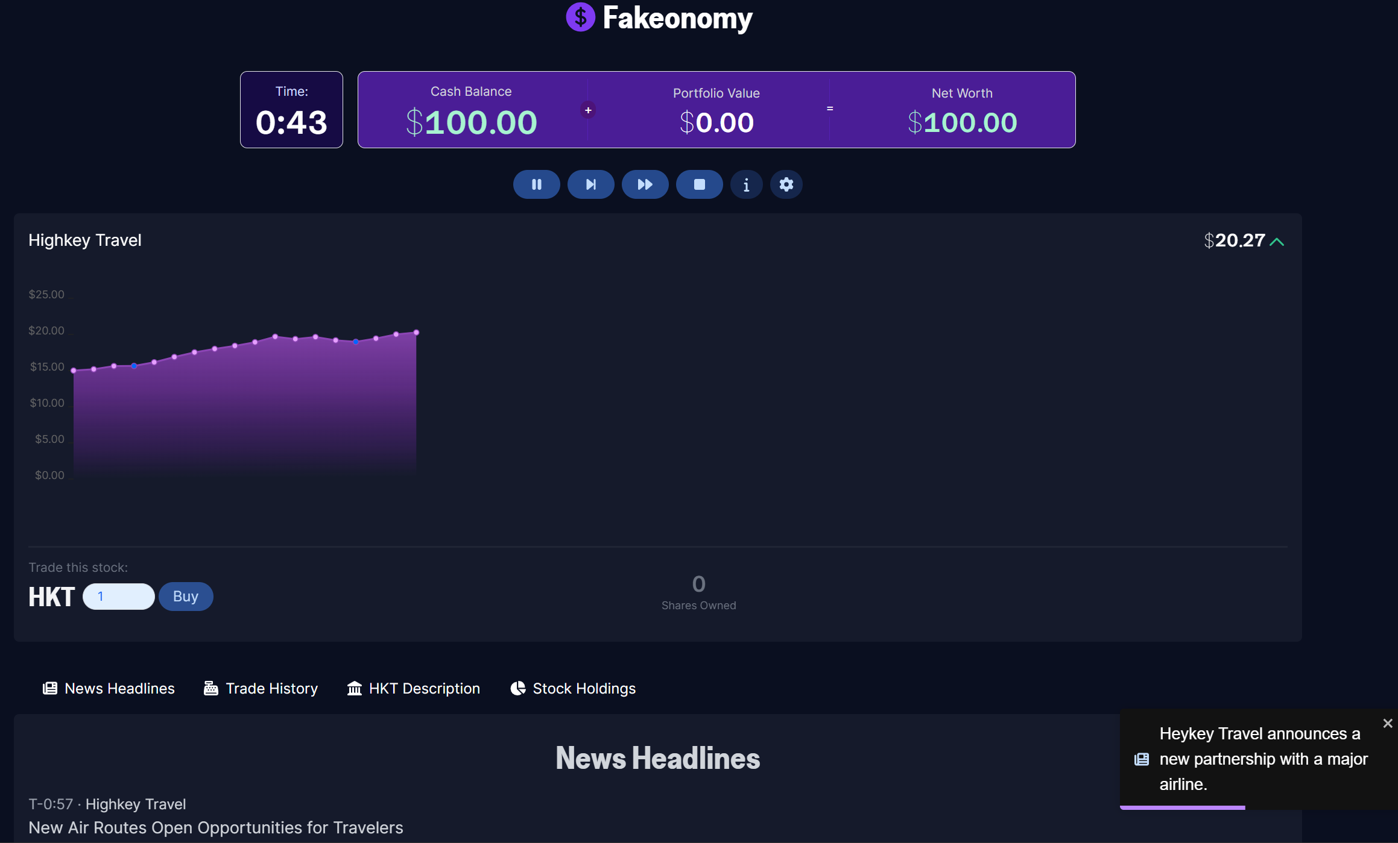
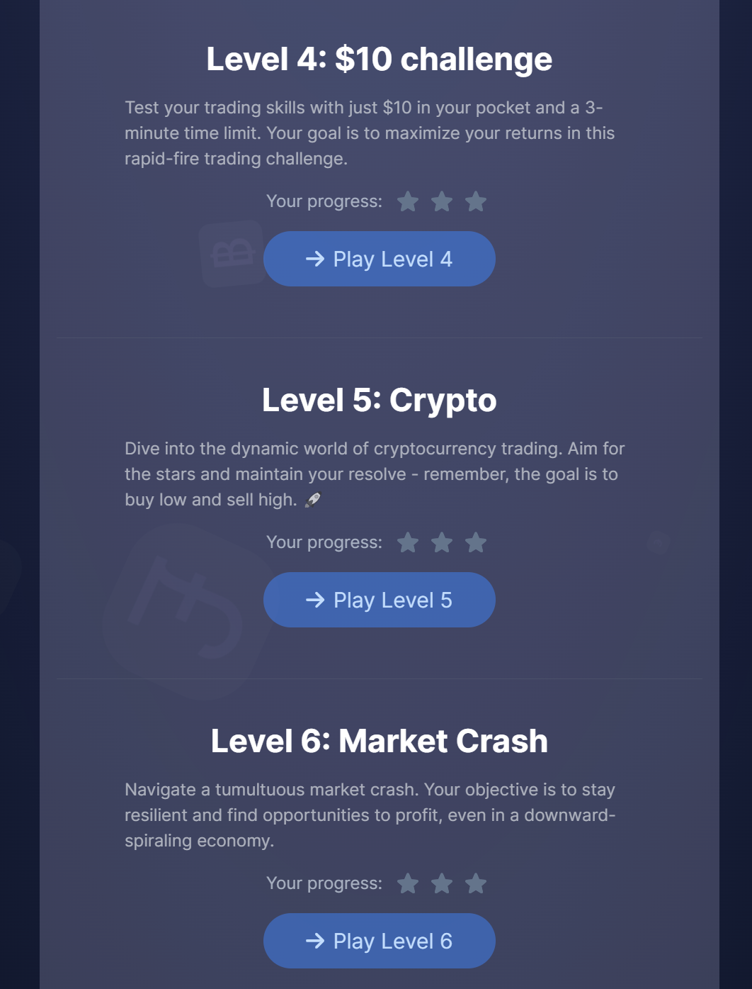
Screenshots taken from Fakeonomy https://fakeonomy.com/
Similar positive features I could implement:
- Game modes – Fakeonomy is an online stock market simulator that focuses on different game modes. To begin with, it has the player learn the tutorial to understand how to buy and sell stocks, later leading to levels with interesting scenarios including low amounts of initial capital and investing in times of stock market crash. Allowing the player to learn with different situations can make the experience more enjoyable and engaging since they have to pay more attention to the environment they are working in. A levels and stars system also gives the player something to work towards and gives them a sense of achievement in completing a certain challenge. There is also a help feature that, when clicked, shows a more in depth description for the objective of that level.
- Simplistic design – Again, this simulator takes advantage of a simplistic design to stay accessible and understandable to all demographics. This approach only displays the most important information, as to not confuse users or take up screen space with unnecessary detail for a short game.
- Additional game features – Since this website is primarily for stock market games, it includes a timer to ensure games aren’t too long, and to add pressure to the trading environment. Furthermore, there is a scoreboard after completing a level where you can compare your profit to others, creating competition between users that entices them to return to the game and beat the previous high score. This example also has a news system which periodically notifies the player of something that is happening in the virtual trading world, allowing them to make more informed decisions. For example, in the image above, the news displays that Heykey Travel is forming a partnership, something that may increase stock prices. This leads to a situation where the user may be able to generate more profit if they change their playstyle or are more vigilant and observant of the data they are presented, creating an additional layer of depth, complexity and mastery to the simulation. Whilst this system would be a positive addition to my program, I won’t attempt to add this, at least not until I can implement it into an already working prototype.
From this solution, I could implement features such as the timer and random ticker system. Again, simplifying the GUI for competitive game modes can reduce confusion and make the games more accessible to less confident traders. Furthermore, a tutorial for each different mode will make the user feel comfortable before heading into a full length game.
Despite being inspired by this solution, having better knowledge of the game modes and systems I could implement, I won’t be including any game mode based features until later stages in development. This is because I think it would be more efficient to create a completed stock market simulator that I can build on, adding games after, rather than developing both major sections at once.
Overall, I would like to have a complex simulator with in depth information and customisability, like Stockscan with candlestick graphs, ability to change stocks, time frames, settings and account creation. However, to appeal to my stakeholders, I will need to make the simulator easy to understand for all ages, meaning I should design the program to be visually simplistic and with basic interactions, with large colour-coded buttons for buying, selling and time frames, with large windows displaying the most important information like current stock price, current capital and profit. To increase engagements, I can add a game mode section that includes features such as timed modes, random stocks, quickly changing prices and also competitive aspects like scoreboards that will encourage students to get better at investing.

Stakeholders
- Business and economics teachers and leaders of investment clubs:
  - The business and economics teacher at my school, Mr. James Etherton, has an interest in my project because he can use this program to teach students how the stock market operates in a practical manner, rather than having them just learn theory.
My simulation will remove all financial risk, whilst keeping realistic data that accurately reflects that of the real world. As a result of this, students under the age of 18 will be able to gain hands-on experience with the stock market, despite being too young to trade with real currency.
My teacher will keep an active role in the development of my program, regularly testing and providing feedback on elements such as the reliability of the graphs and predictions, to the design of the GUI and the available game modes. To meet my teacher’s needs, I will take his feedback into account and will improve my project accordingly.
  - During a preliminary meeting (3/12/24), Mr. Etherton suggested that I should add a timed game mode. This would allow the students to have a competitive environment that they could use to play against each other whilst learning about the stock market. Since his students would either play for a short time frame – roughly 5 to 10 minutes – or long -over a term - the ability to change the speed at which the stock’s price changes is vital. For example, over 5 minutes a stock’s price will only slightly vary, rendering the program almost useless for a competition. Therefore, the ability to project 6 months of data in 5 real world minutes will be necessary. In addition, Mr. Etherton suggested a high score table could be used to create a competitive environment between his students, leading to more involvement in the field of economics. Based on this feedback and future interviews, I can improve my program for my main stakeholder.

- Business and economics students:
  - Similarly to the involvement of teachers, students can aid in the development of my program. My program can act as a form of education for those with a passion for business and finance.
They can use my simulation to further their knowledge of the stock market and can provide useful feedback about features they believe need to be improved or implemented. As students studying finance, they will be able to use my product effectively, and not just for recreational use, therefore, their feedback will allow me to adjust the program to cater to stakeholders that want to use it for productive reasons
  - From individual meetings with my stakeholders, they have advised that I should add a multitude of displays for figures such as change in stock price, minimum, maximum and average that may aid users in their tasks.

- Those interested in a stock market simulation game
  - Other people are also interested in my simulation, for use in competitions, where they will compete against each other under timed conditions to determine who can generate the most profit by buying and selling stocks. To provide an experience that meets my stakeholders’ needs, I will need gameplay feedback to add features they require.
  - Some essential features have been pointed out by those who are interested in my simulation. Many have displayed the need for a timer system and a scoreboard to display the results of a competition and to create time trial game modes. Some have expressed an interest in potentially adding multiplayer team functionality as well.
Through my stakeholders’ feedback, I will be able to develop my game to meet all of the requirements set both by myself and those who would use my program in real applications. To gain this data, I will conduct a series of one-on-one interviews, including questionnaires that will target feedback to any areas of my program that I wish to improve and will allow my stakeholders to reflect any flaws in my program, or anything I can implement to expand the functionality of my program.

Questionnaires and Initial Feedback
Over the course of my project, I will conduct a few questionnaires to better understand what I should aim to implement. Initially, I will create a survey consisting of both open and closed questions, to gather general data and more specific, long-form text answers. I will repeat this for each category of stakeholder and from this feedback I will create a plan for what features I need in my program, and from there I will be able to design the code. It is essential that I ask the correct questions to receive as much useful data as possible about each section of my work, since understanding the needs of those who would use my program will allow me to create a satisfying product that appeals to a wide audience. For example, my questionnaire may reveal that my stakeholders aren’t interested in a game but are instead interested in my program being displayed on a website.
Closed questions asking about a range of interest and usefulness will follow this structure:
- Extremely interesting
- Somewhat interesting
- Neutral
- Somewhat not interesting
- Extremely not interesting
Open questions will be in the form of a text box that the stakeholder can fill out with their own opinions and ideas.
- Student Survey
This survey will plan to gain feedback from my target market - a class of business students who may potentially use software such as mine to aid in their education and career development. Importantly, the sample size of this class will be significant, providing me with a wide range of information to model my program around. The questions I have chosen to ask consist of:

  - How interested are you in the stock market?
  - Have you ever used or been interested in a stock market simulator?
  - What basic features would you expect from a stock market simulator?
  - Are there any additional features you would want to be available?
  - If the simulation was made into a game, what game modes should be included?
  - How useful would an AI price predictor be to you?
  - How do you think you would use a stock market predictor?
  - Do you have anything else you wish to add?

- Teacher Survey
Whilst this survey will only have one set of results, the information I gain will be far more valuable, since it will be from a teacher with years of experience. Therefore, Mr. Etherton’s opinions on features to make the program better for education will be invaluable. From this survey, I can shape my project to meet his needs as someone who may use my program to practically inform students about important aspects of real-world economics. The questions I will ask him are:

- How useful do you think a stock market simulator is in educating students?
- How might you use a stock market simulator in lessons?
- What basic features would you expect from a stock market simulator?
- Are there any additional features you would want to be available?
- How useful do you think adding game modes (such as timed competitions where students compete to make the most money) to the program will be to increase interest in business?
- Is there anything else you would like to add?

- Entertainment Survey
The results of this survey will be significant because it will show me how to expand my project beyond being made for purely educational purposes. Furthermore, adding gaming aspects to my program may inspire players to learn more about business, or they will use it as an entertaining alternative to reading textbooks. To produce a simulation that is both a functional representation of the world’s stock market and an exciting competitive game, I will need input from those who would spend their time playing my game. Therefore, I have decided to ask these stakeholders the following questions:

- What game modes would you want included in the program and what features would these consist of?
- Are there any additional features that you think will improve your experience?
- Is there anything else you would like to add?

Student Survey Feedback:
Overall, four people have completed my survey, three of which are in year 10, and the fourth in year 12, each studying business and economics. Each student was presented with the questions listed above; however, some questions were left unanswered, and therefore won’t be included here.
- Luca – Year 12
  - How interested are you in the stock market? – Extremely interested
  - Have you ever used or been interested in a stock market simulator? – Used before
  - What basic features would you expect from a stock market simulator? – “Realistic and accurate data”
  - Are there any additional features you would like to see? – “That you can trade different types of stock”
  - What game modes should be included? – “A timed game mode where you can only trade from a selection of random stocks”
  - How useful do you think a price predictor would be? – Somewhat useful
  - How do you think you would use a stock market simulator? – “Using it would allow me to gain insight into how a stock market really works”

- Lydia – Year 10
  - How interested are you in the stock market? – Extremely interested
  - Have you ever used or been interested in a stock market simulator? – Used before
  - What basic features would you expect from a stock market simulator? – “To buy stock and have it represent a value”
  - Are there any additional features you would like to see? – “Graphs and tables that show extra information”
  - What game modes should be included? – “A mode where we can compete against each other to make the most money with a scoreboard that shows how well we all did”
  - How useful do you think a price predictor would be? – Somewhat useful
  - How do you think you would use a stock market simulator? – “For my study since it would teach me how the stock market works”

- Ben – Year 10
  - How interested are you in the stock market? – Somewhat interested
  - Have you ever used or been interested in a stock market simulator? – Used before
  - What basic features would you expect from a stock market simulator? – “Accurate and realistic buying and selling of stocks”
  - Are there any additional features you would like to see? – “Graphs that show how the stock is doing and menus that let you access them”
  - What game modes should be included? – “A timed mode where you make as much money as possible”
  - How useful do you think a price predictor would be? – Somewhat useful
  - How do you think you would use a stock market simulator? – “Very since it would help with understanding of the stock market”

- Ashley – Year 10
  - How interested are you in the stock market? – Somewhat interested
  - Have you ever used or been interested in a stock market simulator? – Interested but not used
  - What basic features would you expect from a stock market simulator? – “Being able to see graphs of the prices”
  - Are there any additional features you would like to see? – “Menus that allow me to easily navigate the program”
  - What game modes should be included? – “A competition over a school term”
  - How useful do you think a price predictor would be? – Extremely useful
  - How do you think you would use a stock market simulator? – “Would be beneficial in economics as stocks are a crucial point in the course”
Using this data, I can build a plan for what features I need to include and which I may aim to add in later sections of my program. Understanding how interested my stakeholders are in my program and how they wish to use it will allow me to adjust elements and features to satisfy those who are most enthusiastic about it and are most likely to use my program. Overall, these stakeholders are invested in the educational aspect of my project and aim to gain knowledge of the stock market. From this and their recommendations, I will need to simulate accurate and realistic stock buying and selling. Similarly, to widen the applications of my program, I will need multiple different stocks to represent – ideally in different economic sectors. In addition, I can apply their feedback to the entertainment section of my program, including a competitive timed mode that will create a competitive environment in their class. Finally, I will have to present all the stock data and game mode information in an organized manner. Therefore, I will include a GUI with menus and accurate graphs of the prices.

Teacher Survey Feedback
- Mr. Etherton – Business and Economics teacher
  - How useful do you think a stock market simulator is for teaching students? – Somewhat useful
  - How might you use a stock market simulator in lessons? – “To teach risk/reward and the principles of investing”
  - What basic features would you expect? – “To be able to simulate future share prices over different lengths of time e.g. 1day/1week/1month/1year”
  - Are there any additional features you would want to be available? – “If it could work out student’s overall profits/losses for them”
  - How useful do you think inclusion of game modes would be to increase interest in business? – Extremely useful
  - Is there anything else you would like to add? – “I look forward to trying the simulator in class!”
Mr. Etherton has displayed an interest in using my program in class. He aims to take advantage of the game modes and accurate simulation to teach his students about the stock market in a fun and realistic way. To provide a satisfactory product I will need to implement his desired features, creating an accurate and precise simulation that can be displayed over different time frames, and a variety of games to engage his students.
Entertainment Survey Feedback
- Xi– Year 12
  - What game modes or entertainment features would you like a stock market game to consist of? – “An idle game where you can make money when not running the program”
  - Are there any additional features that you think will improve your experience? – “Add abilities and upgrades that you can unlock from playing the game more or spending more money”

- Alex– Year 12
  - What game modes or entertainment features would you like a stock market game to consist of? – ”Quick random changes in prices. A game mode where stocks liquidate randomly. Another where stocks are heavily diluted or concentrated randomly”
  - Are there any additional features that you think will improve your experience? – “A nice UI and menu would be good”
This feedback has provided me with a wide range of potential game modes I can include in my project. To allow some of these game modes to work, I will need features such as a menu to navigate games, a scoreboard to record high scores, a way to save progress in games and potentially a way to allow for multiplayer competitions. A way to implement random data or modify existing data to create pseudo-random events such as a market crash in a simulated stock would be interesting and would allow me to make the game modes that Alex described.

Since my stakeholders are focused on the academic benefits of my program, I should make an effort to ensure my program is easy to understand and use. Therefore I should focus on the visual design and usability features of my program. As such, there are features present in other simulators that I will not include. For example, excessive amounts of additional information like in stockscan, current news displays like in fakeonomy, fast forward or rewind buttons, any additional non-main graphs, like simul8or’s volume graph and more. If I added these features, they would only clutter the screen, making the program more confusing and bloating it with features my stakeholders do not want or need. Overall, omitting these features will make my program more user friendly and informative, allowing them to focus on the most important aspects of trading.

Computational Methods
My project is highly compatible with many computational methods due to the three sections of my program and how they can each be made. The following methods will be of great use:
- Decomposition and modularity
The whole project has been split into three separate sections that can each be broken down into simpler subsets. Decomposition will allow me to gauge the scope of my project and understand how to implement each individual portion of each section efficiently. Furthermore, I can implement each decomposed section by using OOP methods, functions and procedures. I will most likely use functions since they return a value.

  - General Data Handling
Before prices can be used in RNN calculations and displayed graphically, I need to collect and clean data, preparing it for use.
  - GUI
I can break down the GUI into multiple parts that will be combined to create the full interface. The main part will be the graph that represents the stock price over time. In addition to this, I can add windows that display extra information such as price highs, lows, opens, closes and averages. I will need to make a menu to navigate through my program, between stock graphs, to the game modes section and to leaderboards.
  - RNN
My price predictor will be incredibly complex as a whole, so breaking down what needs to be implemented into smaller manageable segments is invaluable.
  - Game Modes
Depending on what games I implement I will need different features. I will at least need to create a scoreboard and a timer system.

In the design section, I can begin to decompose the program into smaller individual parts to make implementation more manageable. I can even write parts in pseudocode to ensure my method of solving each problem is correct, efficient and that it won’t cause errors in the future.

- Abstraction
I can also remove unnecessary details from my decomposed problems to simplify them, making them easier to understand and implement. For example, I can use abstraction to ignore extra data I can present, such as price open and highs until I am ready to implement them.

- Visualization
This will be necessary for displaying the prices in a graphical form – otherwise, all of the prices and predictions would be inaccessible, or in a format that makes it difficult to read and understand. I can display data in graphs, line or candlestick like existing solutions. I could also display raw data but make it easier to understand by providing labels to describe what the numbers mean – for example, I could have a number displaying the current price of the stock, but instead of just a standalone number in a command line interface, it could be in a GUI accompanied by a header defining it as the current stock price.
I also require a way to allow the user to interact with the program, which could be done with a command line interface, but a GUI of some kind will make the program much easier to understand and quicker to navigate. I can ensure that the layout of the program is simple and not cluttered to make using my program much more intuitive. By using whitespace and planning sizes of features, I can lay my program out in an easy to understand manner.

- Integrated Development Environment
For the duration of my project, I will be using PyCharm. This will aid in my programming since it contains common helpful features such as syntax highlighting and smart indentation, but it also has a handful of advanced features such as debugging, testing, function lists and autocompletion of things like brackets and quotation marks. Using this IDE will increase my efficiency and productivity.

- Problem Recognition
Being able to identify where errors may occur within my program will aid in my identification of inputs and outputs. From knowing how my program needs to operate, I will be able to design and code it better.

- Thinking procedurally
Using designs I have made with decomposition, modularity and abstraction, I can implement sections of my code one at a time with functions, procedures and classes. Coding in a modular way will allow me to reuse code often, saving time on implementation. Encapsulating functions and data in classes will isolate bugs and will make testing much easier as a result. It will make my code much easier to read and maintain, being split into small sections, which are all clearly defined by the class or method name. I can also create prototypes with each new function or class added.
- Thinking ahead
By thinking ahead I can design my program to be more efficient and maintainable in the future. I can make use of all of the above computational methods to plan future iterations of my program – how I can implement it and lay it out to meet my stakeholders’ requirements. I can do things such as use functions, methods and classes to reuse code. I can also carefully design my code in pseudocode before implementing it to reduce risk of logic errors.
In addition to all of these specific computational methods, I will be constantly using common methods such as sequence, selection and iteration throughout my program.

Requirements
- Hardware
  - Before my stakeholders can begin to take advantage of my program, they will need access to a computer that is able to run, interact with and display outputs from it. The laptops used at my school have the following specifications:

    - CPU – AMD Ryzen 5 5600U
    - GPU – Integrated Graphics
    - RAM – 8GB 3200MHz
    - Storage – 237GB SSD

The minimum / recommended specifications for python are:

    - CPU – Any / multi-core 2.5GHz+
    - GPU – None
    - RAM – 2GB / 8GB
    - Storage – 10GB / 100GB

The minimum / recommended specifications for IDEs such as PyCharm and Visual Studio Code are very similar to that of python, with exact requirements being found here:
    - PyCharm - https://www.jetbrains.com/help/pycharm/installation-guide.html#toolbox
    - Visual Studio Code - https://code.visualstudio.com/Docs/supporting/requirements
Comparing the required hardware for python and the machines used, it is clear that the devices my stakeholders own have met or exceed even the recommended level of hardware, and as such, should be able to run my program.
Since the devices are laptops, input and output peripherals are already included in the form of a trackpad and screen. If someone wanted to use my program on a different machine, they would need to ensure that their computer has the capability to run it, in addition to making sure they have a mouse to navigate the GUI, a keyboard to input the amount of stocks to buy, and a monitor to display the program.

- Software
  - An operating system that supports python – such as Windows 11.
  - An IDE that can interpret python code – most likely IDLE, PyCharm or Visual Studio Code.
  - Python libraries that my program will depend on:
    - yfinance – For gaining market data. Has notable dependencies that include:
      - Pandas – for data analysis and manipulation. This is what organizes the data that yfinance reads from yahoo finance.
      - NumPy – for mathematical operations. Other libraries depend on this, and I may need to use it on its own, too.
      - Requests – Allows you to send HTTP requests. This is how yfinance takes data from yahoo finance.
      - Multitasking – library that allows for multitasking, increasing the performance of a program.
    - Pygame – I will use pygame to create the GUI.
    - Tensorflow – Using tensorflow’s keras API, I can create a recurrent neural network that can predict the price of stocks.

These are all required to allow my program to run. Some have already been downloaded by my stakeholders, such as a correct operating system, however, the rest of the software must be downloaded before the program can be used.

Success Criteria
Stock Market Simulator
Feature Number | Feature | Explanation | ☑ | Reference
1 | Initialisation | Main simulator class:  - Create a window using pygame – allow for different resolutions  - Set the framerate  - Give the window a title  - Change the icon of the window  - Create the main loop  - Loop through pygame events  - Listen for keyboard and mouse input  - Handle exiting the program – clicking window’s X and esc hotkey | ☐ | Initial ideas
2 | Text boxes | Text box superclass must have functionality for:  - Drawing a box of different size, position and colour  - Adding text of different fonts, sizes and colours | ☐ | Initial ideas, existing solutions, stakeholders
3 | Buttons | Buttons can inherit from the text box class, meaning they must have the same base functionality. On top of the text box functions, buttons must have:  - Collision detection with the mouse, creating a hover over effect  - Click detection, creating a click effect and performing a function  I should be able to change:  - Box hover over colour  - Box click colour  - Box click function | ☐ | Initial ideas, existing solutions, stakeholders
4 | Text input | Similarly to buttons, text input can inherit from the text box class, building on its functionality. Text input boxes must have:  - Click detection, changing the colour of the box and allowing the user to type, updating the box with their text.  - Functionality for entering text. When a hotkey (enter) is pressed, the text typed should be taken as an input  I should be able to change:  - Text input box click colour  - Text input function  - Size, colour and font of text input | ☐ | Initial ideas, existing solutions, stakeholders
5 | Loading ticker data | Class for data retrieval should allow for:  - Different tickers  - Different time frames  - Different intervals  It should return the data in an array. | ☐ | Existing solutions, stakeholders
6 | Drawing axes | A method in the graph drawing class that draws an x and y axis of specified:  - Positions  - Lengths  - Widths  - Colours | ☐ | Initial ideas, existing solutions
7 | Labelling axes | Another part of the graph class.  Should be able to:  - Add titles to the axes (potentially using text boxes)  - Add labelling to the axes, determining correct spacing and values to display (for example, if the y axis goes up in 100 or 10,000, and if each label is 10 pixels apart or 50) | ☐ | Initial ideas, existing solutions
8 | Candlestick plots | Separate class that the graph class calls. It needs to use data gathered to:  - Display open, close, low and high data for the specific time it is placed at.  It should be able to:  - Change position  - Change size  - Change colour (to display if the price is increasing or decreasing) | ☐ | Existing solutions
9 | Drawing plots | Part of the graph class. Needs to ensure:  - Plots are placed in the correct time relative to the x axis and are spaced correctly, filling the whole space of the graph, but not exceeding it.  - The height of the candlestick plots is correct, matching the y axis labels.  - The width of the candlestick plots are correct, making sure they don’t overlap. | ☐ | Initial ideas, existing solutions
10 | Additional display of information | Using text boxes, more data fetched using the data loader class can be displayed. For example, this could include volume, range, market cap and more. | ☐ | Existing solutions
11 | Side menu for navigating stocks | Buttons can be added to the side of the screen to switch between any loaded stocks. A button should be created when a new stock is loaded. Aspects of the button that should change are:  - The position (lower as more stocks are loaded)  - The text inside the box displaying the stock that is loaded | ☐ | Existing solutions, stakeholders
12 | Ability to buy/sell, with different volumes | The user should be able to change the amount of stocks they buy at once. This should be implemented as:  - A number of buttons that change a variable in the buy/sell function (for example, from 1 to 10, meaning the amount of stocks bought will be 1 * 10 = 10)  - Specifically, there should be a 1x, 10x, 100x, max and text input button. 1-100x buys/sells that many stocks, with the max one trading the highest amount possible with current cash/stocks owned. Text input will allow users to trade exactly how much they would like at once.  For buying and selling there must be functions that:  - Take the value of the volume variable and multiply the price of one stock by that number to calculate total buy/sell price  - If buying, there should be checks to ensure the user has enough money to buy the number of stocks they want. If not, it should return an error message, However, if they have the funds, they should gain stocks and lose the correct amount of money.  - If selling, there should be a check to ensure the user has enough stocks to sell. If they don’t, return an error, otherwise, give them the correct amount of money in return for the correct number of stocks | ☐ | Initial ideas, existing solutions, stakeholders
13 | Current portfolio price tracker | A specific text box display that shows the user their total current balance, total number of stocks, and the total price of their stocks if they were to sell at that point in time. The text in the box should be able to change colour, indicating overall profit/loss. | ☐ | Initial ideas, existing solutions, stakeholders
14 | Price predictor model creation and training | I can create and train a model using libraries and data fetched using my data loader, or from a large dataset I can download online. For the price predictor to be successful, It must have a high enough accuracy to be useful to users. | ☐ | Initial ideas, stakeholders
15 | Graphical display of price predictor | This will be similar to the drawing plots function, but with a line graph rather than candlestick plots. It should include:  - Position normalisation  - Functionality for changing colour | ☐ | Initial ideas, stakeholders

Menus
Feature Number | Feature | Explanation | ☑ | Reference
1 | Buttons that link to another menu | Using buttons, ensure:  - When clicked, they start a function that opens the corresponding menu by drawing over what’s already on screen. | ☐ | Initial ideas, existing solutions, stakeholders
2 | Main menu | Should include:  - A title text box  - A button for navigating to the main stock market simulator  - A button for navigating to the game modes menu  - A button for navigating to the account and settings menu | ☐ | Initial ideas, existing solutions, stakeholders
3 | Game modes menu | Should include:  - A title text box  - A button for navigating to each game  - A button for navigating to each game’s scoreboard  - A button for navigating back to the main menu | ☐ | Initial ideas, existing solutions, stakeholders
4 | Account and settings menu | Should include:  - A title text box  - A button to navigate to account sign up/ sign in  - A button to navigate to the settings page  - A button to navigate back to the main screen | ☐ | Initial ideas, existing solutions, stakeholders

Account features
Feature Number | Feature | Explanation | ☑ | Reference
1 | Creating an account | In the account sign up/ sign in page there should be:  - A title text box  - Text input boxes for creating a new account name and password  - Text input boxes for signing into an account  - A button to input typed data / enter hotkey | ☐ | Initial ideas, existing solutions, stakeholders
2 | Permanently saving account data | Data will need to be permanently saved. To do this, account data can be saved to a file, with an individual one (or section in one) for each new account created. For security reasons, the password should be passed through a hash function before being saved. | ☐ | Initial ideas, existing solutions, stakeholders
3 | Displaying data in account menu | Account data can be fetched from where it was saved and displayed using text boxes. | ☐ | Initial ideas, existing solutions, stakeholders
4 | Settings | The settings page should include:  - A title text box  - Buttons and text input that allow the user to set settings to True/False, or a specific value.  - Settings must be permanently saved with other account details | ☐ | Initial ideas, existing solutions, stakeholders

Game modes
Feature Number | Feature | Explanation | ☑ | Reference
1 | Timer system | Should feature:  - A function that allows the user to change the amount of time they have to trade  - Functionality for drawing a text box that has the current time remaining displayed | ☐ | Initial ideas, existing solutions, stakeholders
2 | Pausing | Players may not always be able to finish a full game mode in one sitting. To improve the usability of my program, I will implement a pause button/hotkey that temporarily stops the game from continuing. | ☐ | Existing solutions
3 | Saving games | Using the account save data, game data can be loaded to retrieve the progress players had previously made. | ☐ | Initial ideas, existing solutions, stakeholders
4 | Upgrades/abilities game | Using buttons and permanently saving data, I can allow players to buy upgrades that make the game more interesting. There will need to be checks to ensure the player has enough money to buy an upgrade. | ☐ | Stakeholders
5 | Game over screen | Once the user has completed the game’s objectives, the timer has run out, or they have failed objectives, a screen should appear displaying the user’s stats for that run. It should also have buttons that link back to the main menu and to the scoreboards. | ☐ | Initial ideas, existing solutions
6 | Sound effects/music | When buttons are pressed:  - A specific sound can play to emphasise clicks  - A specific sound can play when a successful transaction is made  - A specific sound can play when a transaction isn’t successful  When new menus / games are opened:  - The general music can play | ☐ | Existing solutions
7 | Scoreboards | To make the scoreboard:  - Account names with their high scores can be permanently saved  - The values can be sorted  - The top values and the players who achieved those scores can be fetched and displayed in the scoreboards menu | ☐ | Initial ideas, existing solutions, stakeholders

Limitations
Whilst my program has many aspects that are feasible, there are some features that I cannot initially implement, and some that I may not be able to include at all. This is due to many factors such as time constraints, with deadlines for sections of my project and needing to spend time on other a-level courses.
Some features that I may not include:
- Hosting the program on a website – In the first iteration of my program, I intend to create a full standalone product. Hosting the simulator online would be time consuming. Since I already have many features that need to be designed, implemented and tested, also intending to include this would be unrealistic. However, the positives of having the program accessible via a website are clear, being able to log into accounts on different devices, potential for multiplayer and more. All of the existing solutions are run in this fashion, too. If I have an excess of time once I have completed all other aspects of my project, I may work on hosting a website for my program.
- Online functionality – similar to the benefits of hosting on a website, allowing for online capabilities would increase the breadth of the interactions players can have with others. Alongside being able to log into your account through any device and having multiplayer, leaderboard data would include all games from all players. This would make the leaderboards global displays of the highest scores rather than just the best scores achieved locally on one device. Additionally, school laptops and networks may not allow for online capabilities since there are a lot of blockers in place to protect students.
- Multithreading – multithreading could significantly increase the performance of my program, allowing for individual threads to handle aspects of the code, for example, allowing multiple stocks to be loaded in parallel. However, this may not be possible for a few reasons. For example, my program may not be computationally complicated enough to need multithreading, and the laptops my stakeholders own may not benefit from it enough to justify implementation.
- Features I won’t initially include – I will first implement features that can be used throughout my program, like features of the main stock market simulator. Aspects of my program that aren’t integral to the functionality of my program will be left until later, such as window name and icon, music and sounds, the price predictor and more. While I do plan on implementing these, I am aware that I could run out of time, therefore, I will focus on more pivotal features to allow the program to run.

DesIGN, Implementation and Testing

Decomposition
Here, I have decomposed the program into each individual section, including a short description of what I need to include to complete each section. From this, I can identify how to simplify my implementation using concepts like classes and methods to reuse code. Later, I can also create diagrams that outline what each aspect of my project will look like, visually. When I begin to implement each section, I can decompose it further into even more specific parts, too.
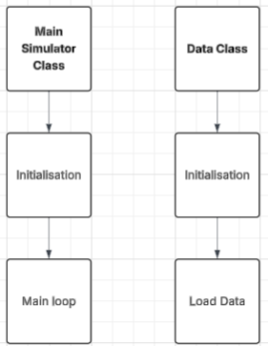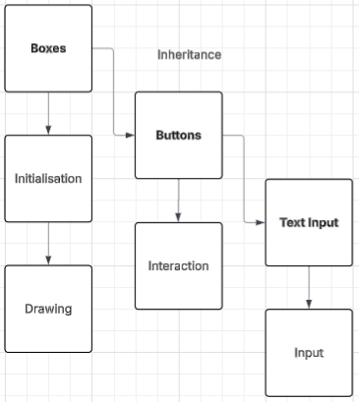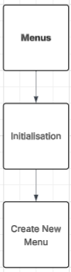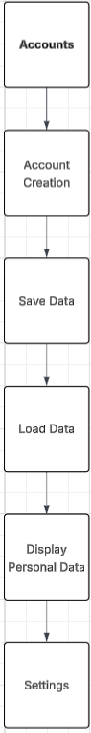

Stock Market Simulator:
- Loading data
  - Yfinance – using the yfinance python library, I can easily download financial data that can be used in my program. By setting up a data loading class, I can create unique objects that holds the individual data for each stock. This will allow my program to scale to allowing usage of a large number of stocks since I can reuse the code for data collection, and it will let users choose which stocks they would like to trade with by inputting the ticker.
- Visual display of data
  - Graph:
    - Drawing axes:
      - Axes – can be added by drawing a straight line horizontally and vertically.
      - Labelling – both for the names of the x and y axis (e.g. time and price), but also the scale of each axis.
    - Drawing plots
      - Plot location and normalisation – using the price of a stock at a specific time, I can find the location that the plot needs to be and draw it. Also, the plots spacing will need to be normalised since if the spacing is constant, the plots will eventually be drawn off screen.
      - Candlestick plots – I will create a class for candlestick plots that allows me to instantiate as many different plots as needed.
    - Price predictor:
      - Creating and training the model – the model can be created easily using machine learning libraries. I can train the model on a few different tickers, then save its hyperparameters to use in the simulator.
      - Showing predictions – using the predictions and the code for connecting two plots on the graph, I can offset the drawing of the predictions to make it display what it believes to be future prices.

  - Boxes – I can create a class that allows me to make boxes that contain a title and a main display of data. Using this class, I can instantiate as many displays of data as I need in each section.
- Menus
  - Main menu design – since my program requires multiple menus, I will implement a menus superclass that other menus can inherit from to make coding easier and to reduce the amount of boilerplate code. This general class will have functionality for creating a menu overlay and allowing for additional objects to be drawn on top of it.
  - Game modes menu – this menu will consist of multiple large interactable boxes containing information about the game mode. Clicking on the mode will start the game. This can be implemented using the superclass and the reusable box interactable class.
  - Game over and scoreboard – I can use the general menu superclass to create a popup when the game the user is playing has ended. This will contain a scoreboard that holds all of the data of the best previous games from any player who played before, specifically having the username and total score of the player. If the player isn’t signed in, then their name will be saved as “anonymous”. There will also be a button that redirects the player back to the main menu.
  - Settings and account menu – this menu will contain three sections:
    - Account creation / sign in - This will consist of text input boxes for an account name or password, with an additional interactable button to switch between creation and login.
    - Account stats – This will be shown when signed in. It will contain multiple pieces of text displaying account stats such as total profit earned, number of stocks traded, etc.
    - Settings – This will be a collection of buttons and text input that can be interacted with to change settings. For example, there will be a button to activate / deactivate the price predictor. Text input could be used to change the colour of aspects in the display, such as graph colours since 3 numbers can be input, representing RGB values.
  - Potentially additional popup menus – this would be to implement tutorials, or to have menus that give the user additional information like the definitions of terminology they may not understand.
- Permanently saving data
  - Creating accounts – through the settings menu, I can take a text input for an account name and password. I can then permanently save user’s account details by writing to a file.
  - Saving account data – whenever the user would like to save data, I can take information from variables that hold their current session data and update their own account file with that data by writing to it. To ensure that users can save their progress, I can implement a button that saves data when pressed and even create a timer system that automatically saves at regular intervals.
  - Saving scoreboard data – once the player reaches the “end of game screen”, their data can be written to a separate scoreboard file that can permanently store data. The scoreboard will take the username (unless the user isn’t signed in, in which case it will take “anonymous” as the username) and total score of the player, then write to the file and sort it, to ensure that the scoreboard is arranged by highest score.
- Interactable objects
Since my program frequently needs to make use of interactive objects, I can create classes for the following:
  - Buttons – interactable by clicking. Dimensions, location, colour and more can be set through creating it. The button will be a box that can also contain text displaying the function of the button – for example, a large green button with “BUY” text, or another smaller blue one with “BUY 10”.
  - Text input boxes – focuses on the box when clicked, then allows for keyboard input that relates to the box’s function. For example, a text box that allows the user to type what ticker they would like to trade with.
I will try to separate some of these features into individual python files to allow for easier maintenance. I can group specific classes together in files, then import them into a main file that runs the simulator.

Visual Design
To aid in understanding what features my finished product needs to include and how it should be laid out, I will create general designs for each aspect of my project.

Firstly, the main part of the simulator, the stock trading screen:
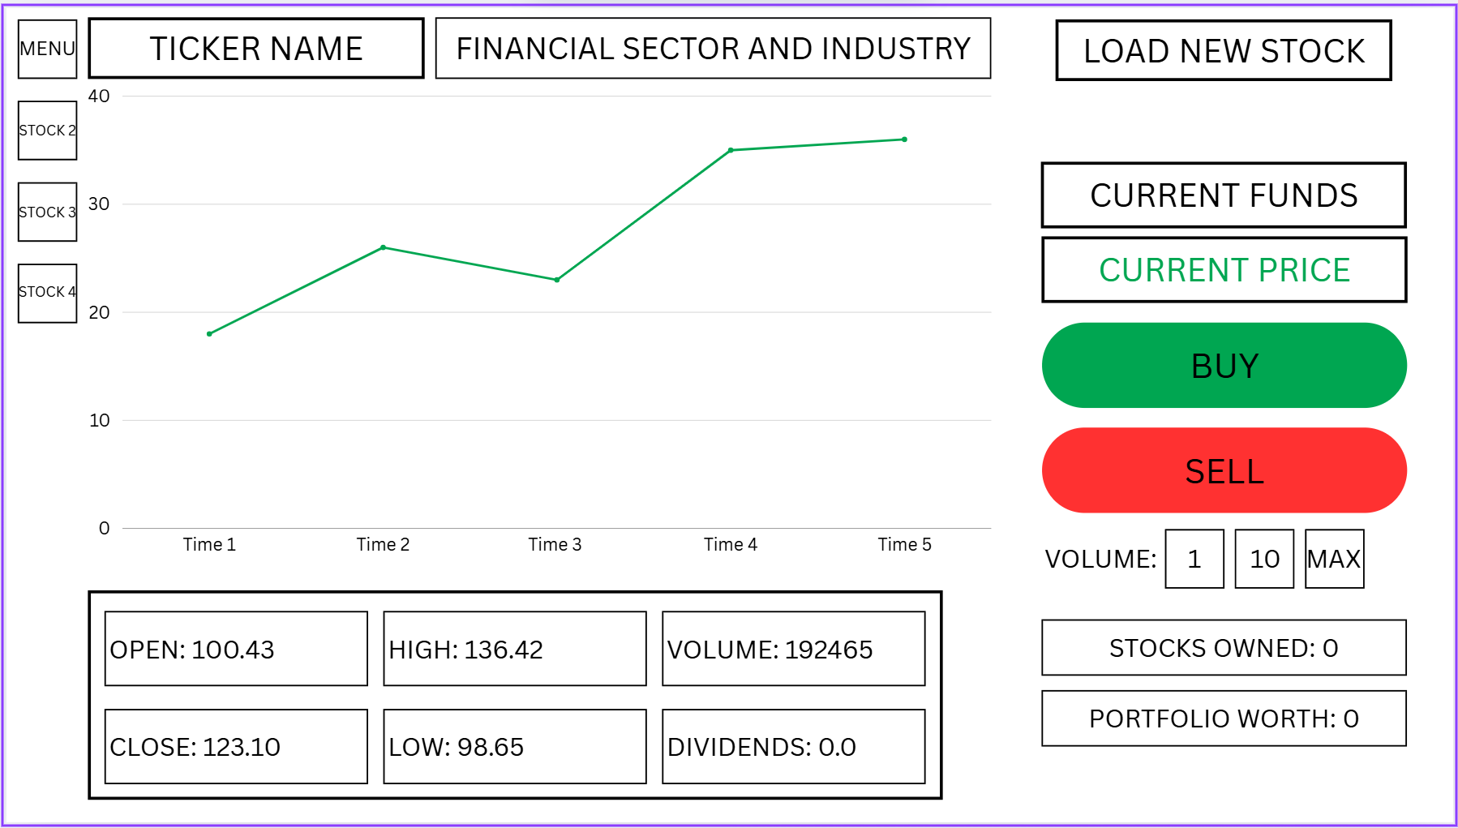
This display shows how I can include many of the features that my simulator requires. It also conveys how the implementation can be simplified using object-oriented programming techniques. For example, I can create a class that draws a box with some text inside it at a specified location. Then, I can create another class that inherits from the previous class and add a function that allows for mouse or keyboard input.

I will use this design as a rough template for the actual layout of the stock trading screen. However, this may not be the same as the final design, since, with stakeholder feedback after each prototype I make, I may decide to change the overall layout to make the program more intuitive and easier to navigate.
However, the same rough principles will apply. I can group similar aspects of the program together, such as the buy and sell buttons, additional display information, etc. I can space these similar parts with whitespace to visually separate them, making each part more recognizable and easier to understand. I can also consider things like font, text size and colour to make things easier to understand at a glance. For example, the buy and sell boxes can be green and red with large bold text to make them stand out, whereas the volume buttons are less important, so could use a smaller text size and a less bold font. Additionally, I could also prioritize the location of more important features. Since my stakeholders all read left to right, I can move the most important features closer to the left, such as the graph. Inside the additional display of information I can have the most important displays like open and close towards the left, with the less important volume and dividends to the right.
(I plan on making candlestick plots and changing the colour of certain parts, such as current price display, depending on if the stock is going up or down in price. I couldn’t include these features using the program I used to create the visual display.)

The importance of code reuse is highlighted in the design of the menus, where the majority of the features are text boxes or buttons that I would’ve already created for the stock trading screen. For example, the main menu is comprised of only buttons.
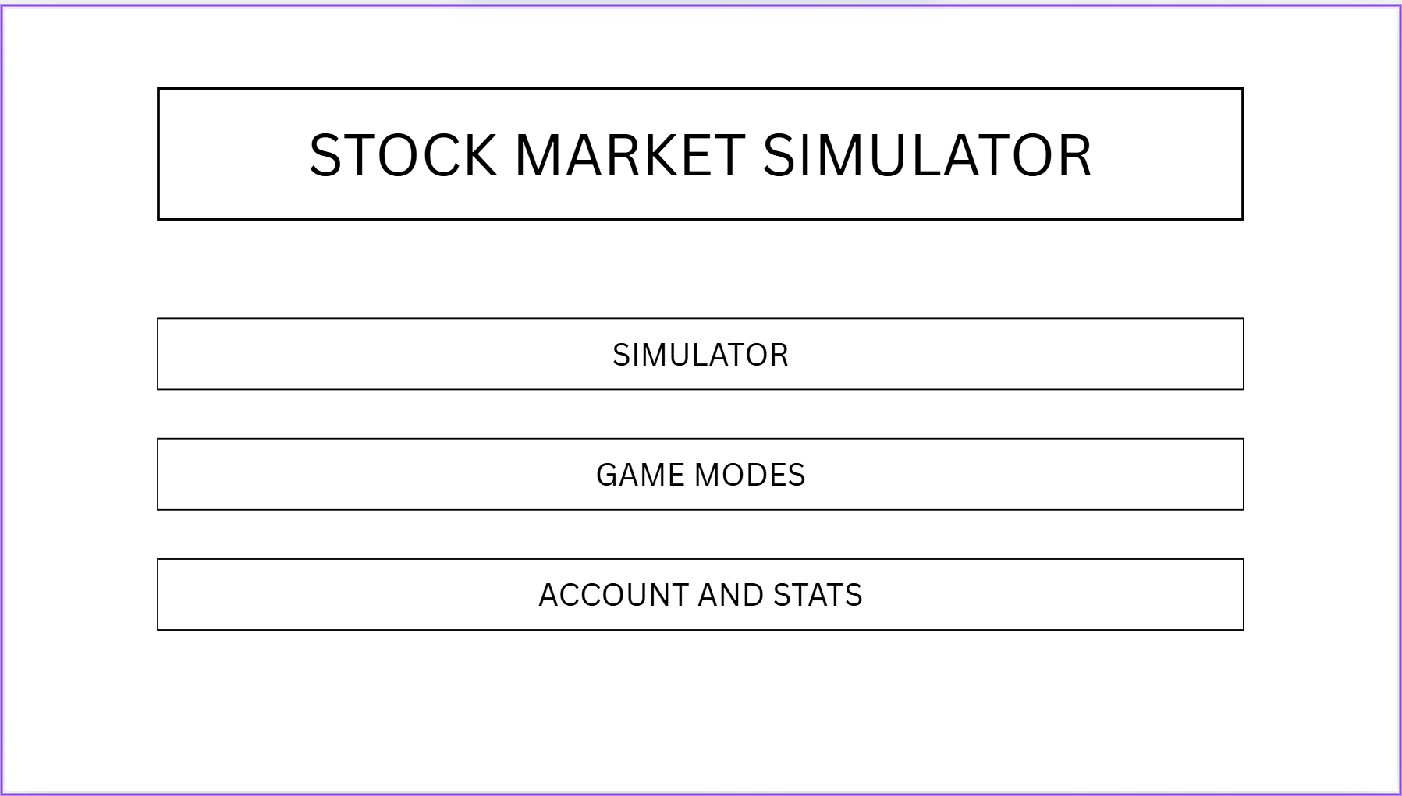
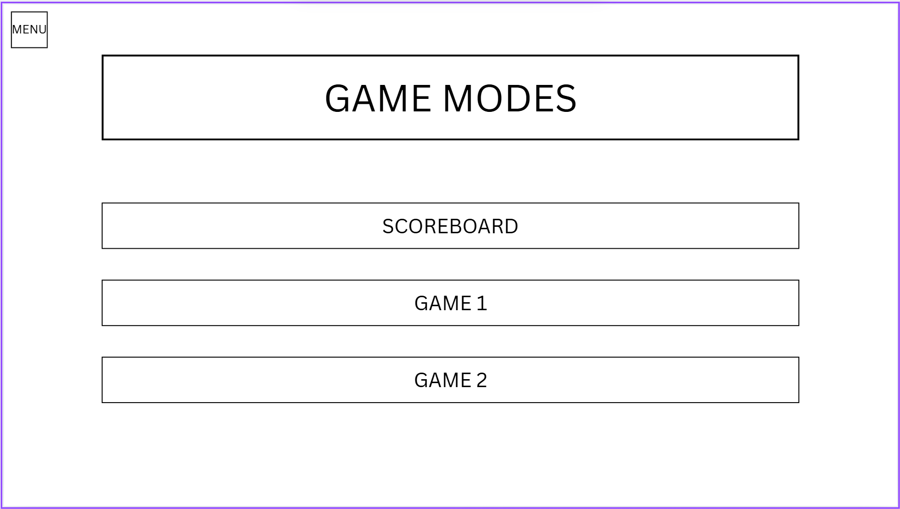
The game modes menu works the same way, only using buttons. When a game mode is clicked, it will bring the user to a screen exactly like the main stock market simulator, with any adjustments being made. For example, this may mean that the “FINANCIAL SECTOR AND INDUSTRY” section is replaced by a timer. There is also a button that opens the scoreboard, which will display a table of top scores for each of the games.
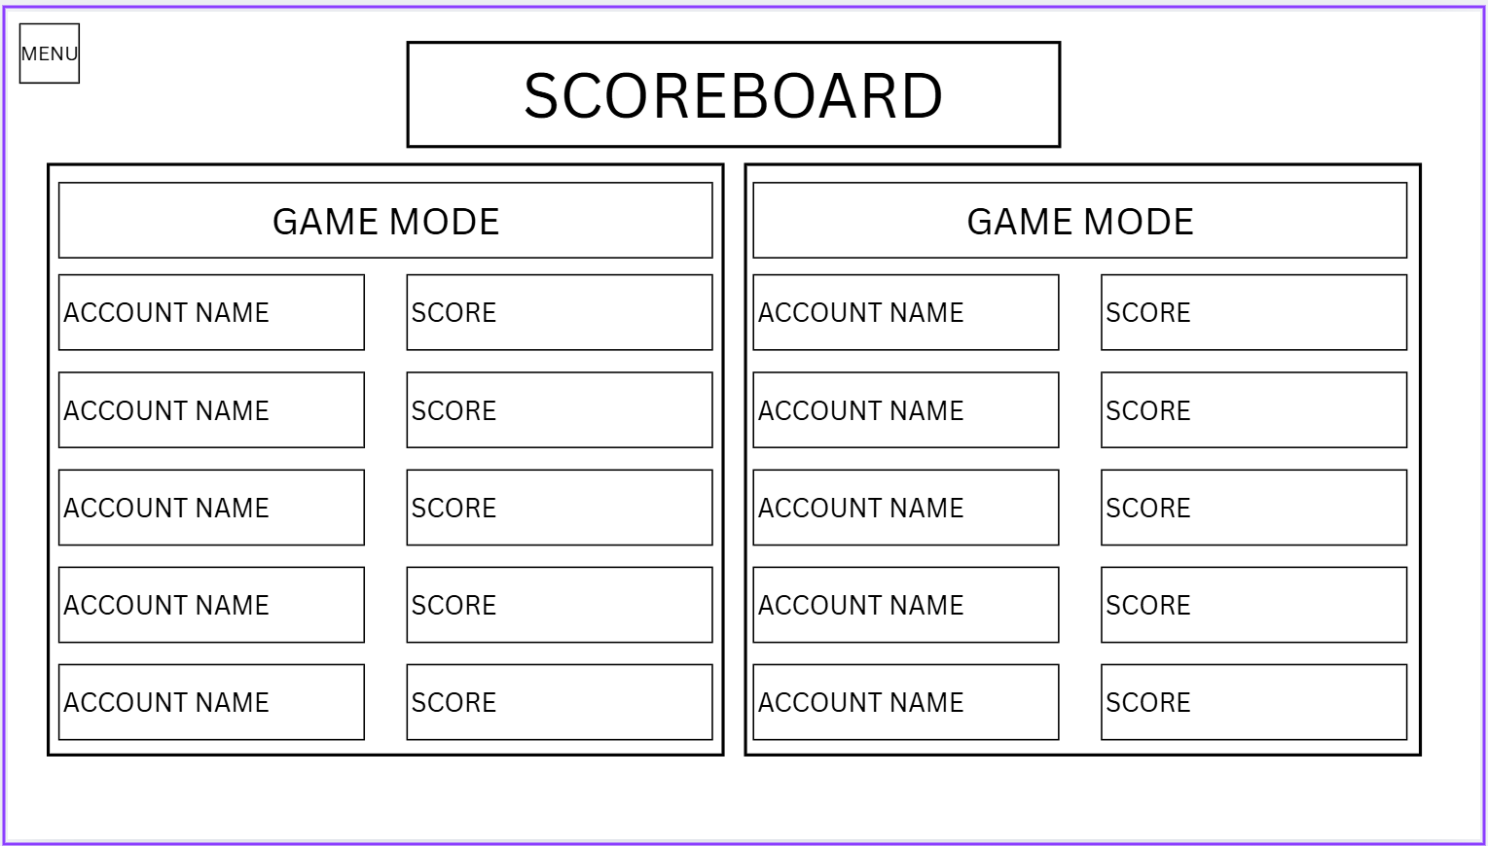

Similarly, the account menu is identical to other selection menus, only a title display and buttons to navigate to other sections.
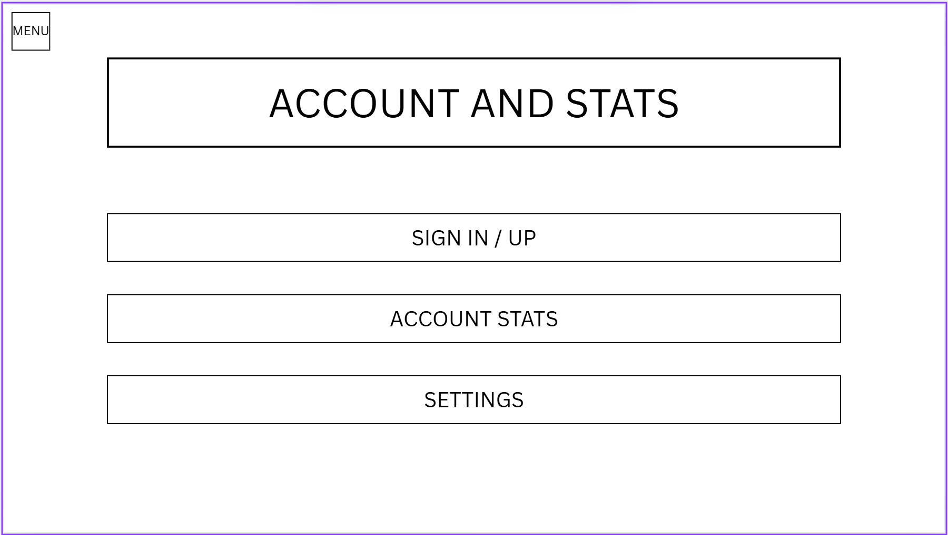

The account sign in / up section will make use of text input boxes to allow the user to create their own accounts and secure passwords.
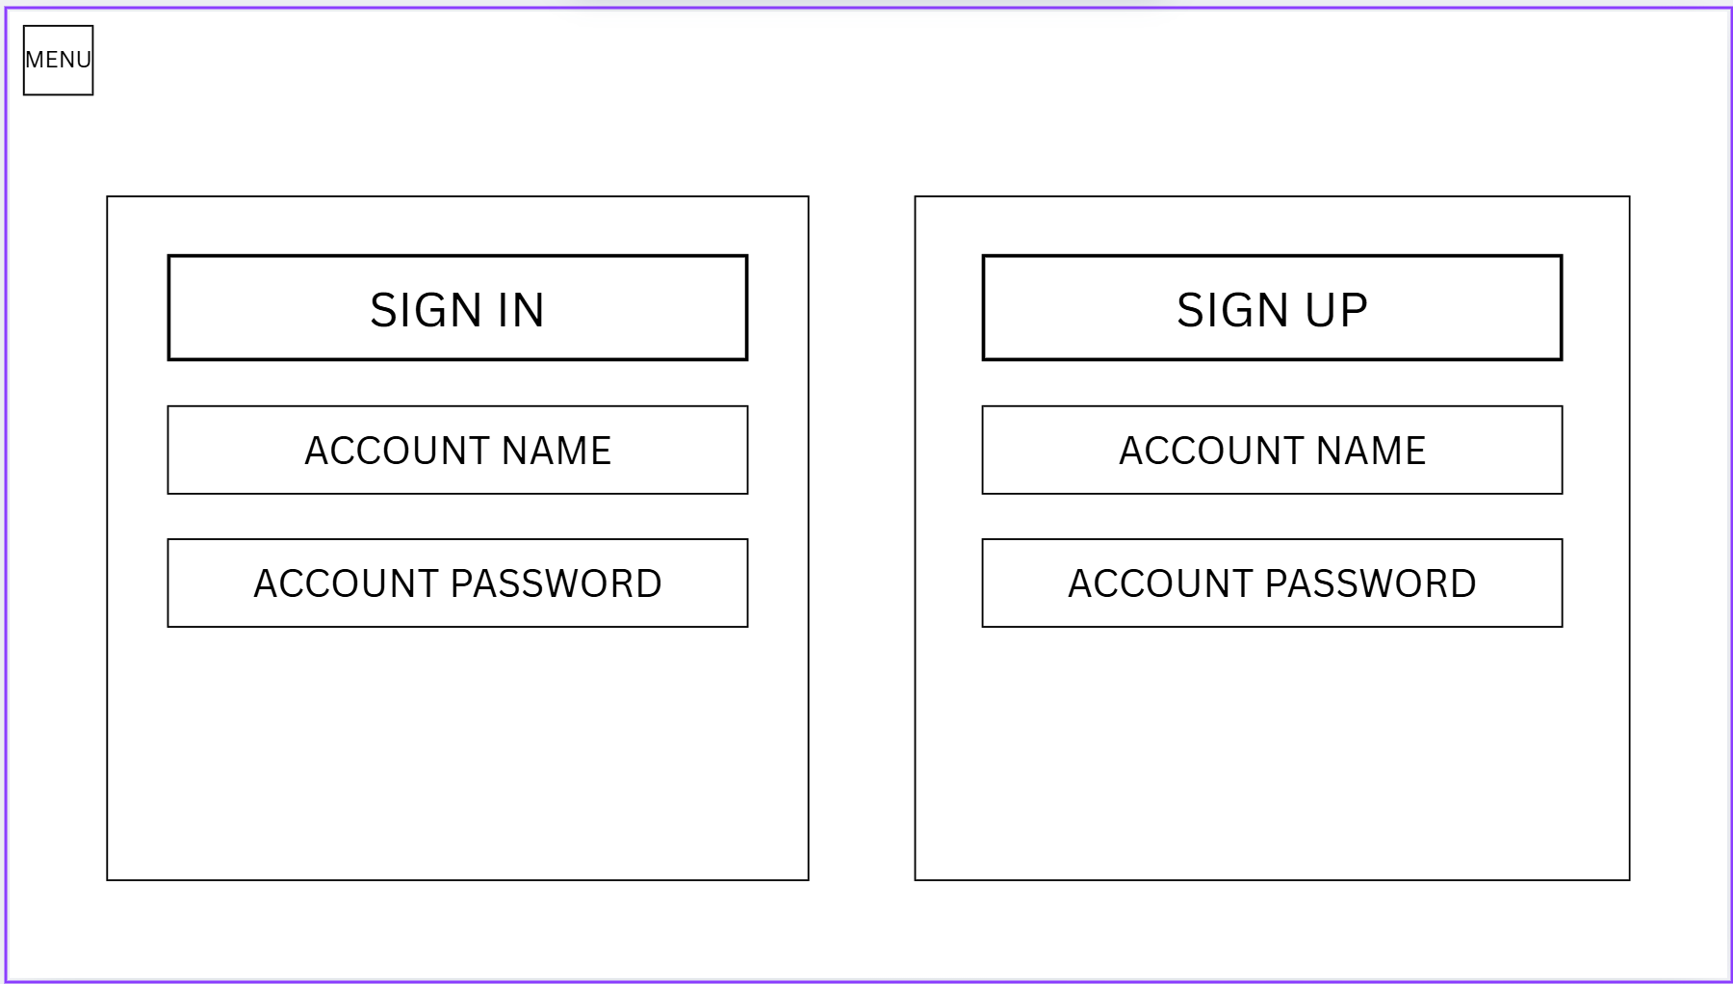

Finally, there’s the account stats and settings pages:
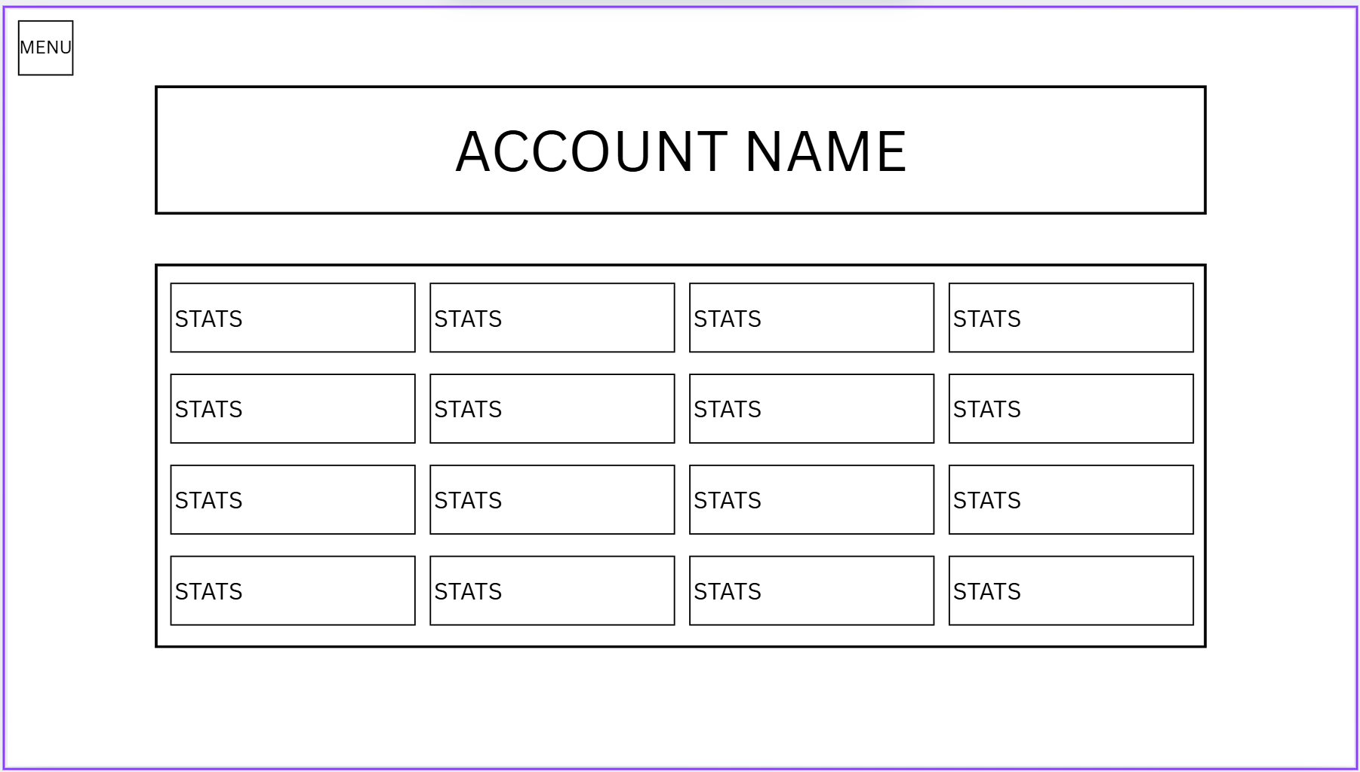
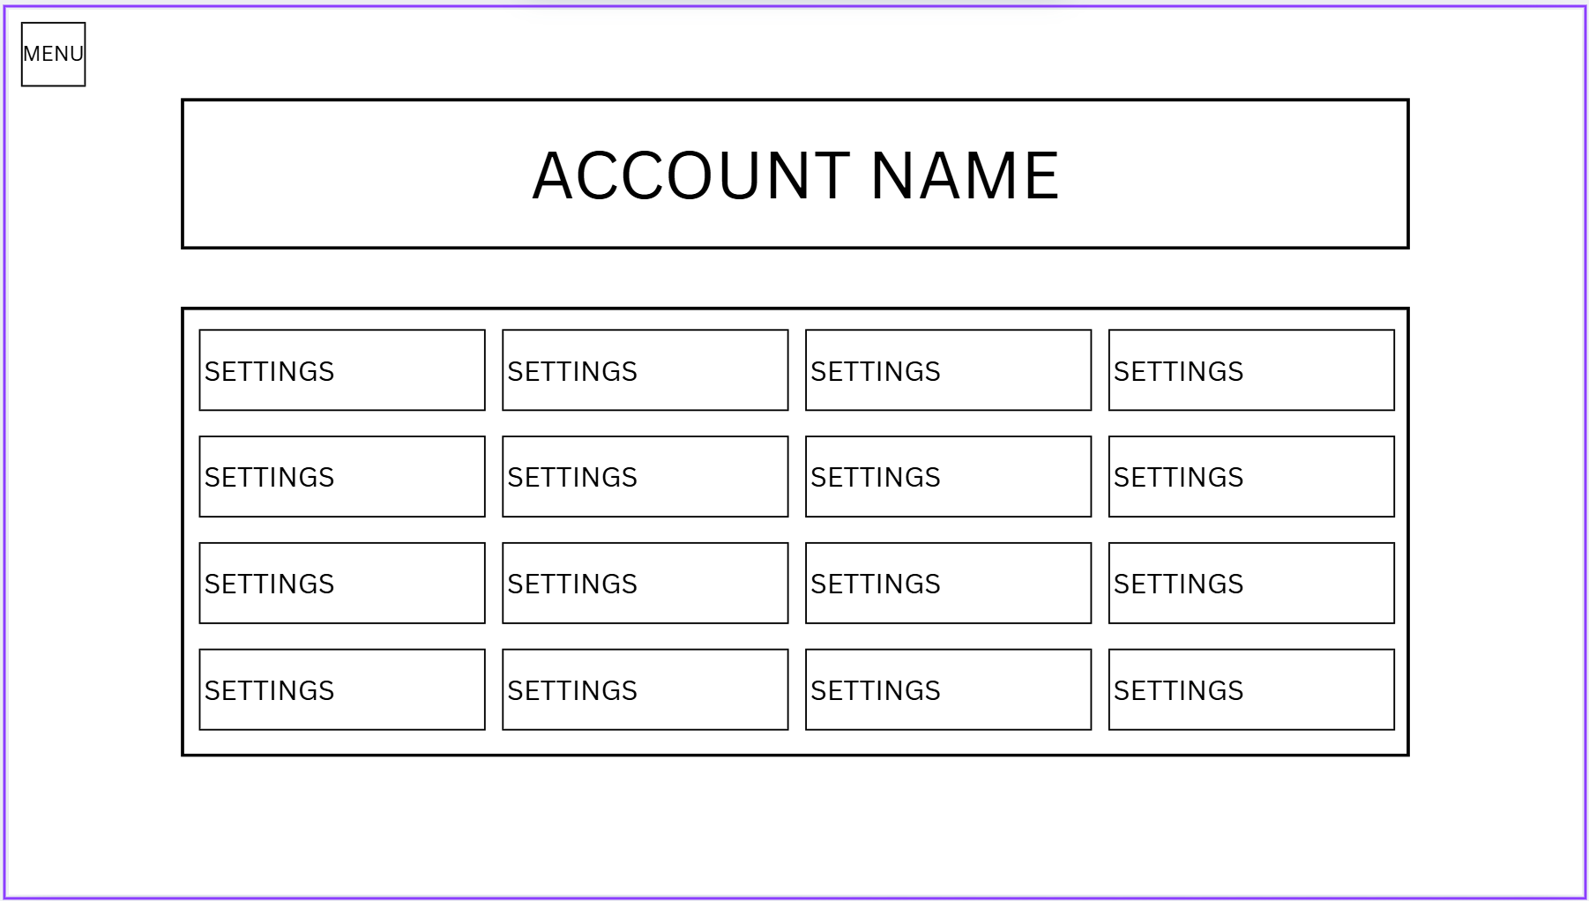
I doubt there will be this many stats and settings to display, however, this design shows the general idea of what these pages are, how they work and what features they require.

In conclusion, these visual designs have shown how I can decompose my program and simplify the implementation into a few parts.

Implementation approach
I will integrate implementation in with design to maintain an agile development methodology. I will attempt to develop a section of the total program in one sprint, sticking closely to the requirements. However, I may decide to develop the fundamental features of the program before other less integral parts, for example, for the main window, naming and changing the icon can come much later in the development process.
Design – algorithm, variables, class structure, data structures, test data,
Implementation – display of code and explanations of how it works
Test – proof that each section works. If it doesn’t, then there will be an additional design, implementation and test section. I will confirm any future test data to be used in the final testing section of the evaluation.
I will allocate an individual python file to each class, to make maintenance of each class simpler. It will aid in isolating errors to only one class and can reduce risk of editing code that is complete.

Initialising a Window

Design

Initialising a window is the main foundational part of the program, since the rest of the graphics will be drawn onto this screen. To initialise a window, I will first need to implement the baseline boilerplate code that pygame needs to initialise. By making this into a class, I can group functions and procedures together – for example, when I need to add boxes, I can create a procedure that instantiates the boxes and put it inside of the class. Inside the class, the procedure and its variables are encapsulated, so are kept safe from accidental modification from outside the class.

Algorithm
Import pygame
Pygame.init()
class StockMarketSimulator
procedure initialisation(resolution, framerate)
self.width, self.height = resolution
self.screen = ** set pygame screen **
self.clock = ** set pygame clock **
self.framerate = self.framerate
endprocedure

procedure run()
while loop
** event handler - exiting, keypresses and mouse functionality **
pygame clear screen

endclass

Together, this will initialise all of the code needed for pygame to display a screen, in addition to setting up some of the functions needed for later in the program, such as the event loop and input checking. I will implement each feature in the order it was written.

Variables
Initialisation method
Variable name | Description | Data type
self.width | By unpacking the resolution tuple passed into the class, the height of the window can be set to this variable. | Integer
self.height | The second variable used to unpack the resolution tuple. | Integer
self.screen | Variable assigned to the screen | Window (not a data type but I feel like I should include it)
self.clock | Sets a class that has functionality for keeping track of time. Used with the integer framerate that is passed into the function to set the maximum framerate | Class

Run method
Variable name | Description | Data type
run | A bool that sets the While True loop, also allowing it to stop when set to false | Bool
event | The first element in the queue of pygame events is assigned to this variable. Can be used for checking things like pygame.QUIT, when the X of the program’s window is clicked. | Multiple (uses queues)
keys | A list of Boolean values are assigned to this variable, with the index and value relating to which key is/isn’t pressed. | List of bool

Outside the class
Variable name | Description | Data type
simulator | An instance of the class, initially passing resolution as (1280, 720) and framerate as 30. Simulator can call the class’ functions, for example, using simulator.run() | Class

Data structures
Data structure | Where in code | Use
Tuple | passing resolution into the class | Tuples are static and immutable, meaning the size and contents cannot be changed. This is useful, since resolution needs to always have only a height and width value that should stay constant while the program runs.

Class diagram
StockMarketSimulator
width
height
screen
clock
run
event
keys
Initialisation()
Run()

Test data
Variable/function | Explanation of how it will be tested | Test data
Height, width, initialising a window | These variables all take the data from the resolution parameter. To check these variables take the correct data, I will change the resolution passed into the class. Then, I will print the values of the height and width variables, and observe the size of the window. | Resolutions:  - (1280,720)  - (1920, 1080)  - (800, 800)
framerate | Clock.tick() sets the max framerate of the game. To check that the correct framerate is set, I will lower the framerate to an easily measurable amount, then I will update the screen every frame, counting how often it updates. | Framerate = 1  Draw a line to the screen each frame. A new line will be drawn every second if the framerate is properly capped.
Updating the screen | Each frame, the screen should fill with a solid colour to clear, then draw, then update. | Set the clear colour to black, (0,0,0)  Ensure it is updating properly (same check as framerate)
Exiting the program (clicking X) | Windows created by pygame all have an X in the corner that, when clicked, pass an event to the events queue. Using this, I can stop the program. If the program shuts down, it is successful. | Click on the window’s X
Exiting the program (esc hotkey) | Additionally, I can check for keyboard input, then set run to false if a specific button is pressed. Specifically, I will check for if esc is pressed. | Press esc when the program is running

Implementation

import pygame
pygame.init()
class StockMarketSimulator:
def __init__(self, resolution, framerate):
# initialise screen, resolution and framerate
self.WIDTH, self.HEIGHT = resolution
self.screen = pygame.display.set_mode(resolution)
self.clock = pygame.time.Clock()
self.framerate = framerate
def run(self):
run = True
while run: # main loop
for event in pygame.event.get(): # get events
if event.type == pygame.QUIT: # if the X is pressed on the window, close program
run = False
keys = pygame.key.get_pressed() # liten to keystrokes
if keys[pygame.K_ESCAPE]: # if esc pressed, close program
run = False
self.screen.fill((0,0,0)) # start of every frame - clear screen
pygame.display.flip() # end of every frame - update screen
self.clock.tick(self.framerate)
# initialise simulator object and run
simulator = StockMarketSimulator((1280,720), 30)
simulator.run()

testing

Height, width, initialising a window:
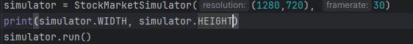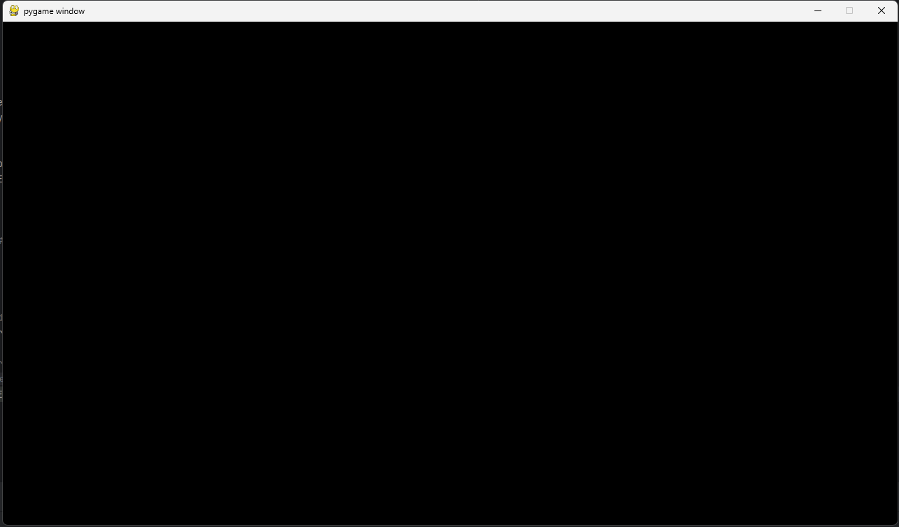
When the height is set to 1280 x 720, the height and width variables print the correct values. A window of the correct resolution is also created. The results are the same for different resolutions, including 1920 x 1080 and 800 x 800.

Framerate and updating the screen:
Firstly, I will set the framerate to 1, to easily see how many updates per second the screen displays. To actually see the screen updating, I will draw a line to the screen, then the screen will clear and the position of the line will change, to be drawn the next frame.
Inside the run function’s While True loop:
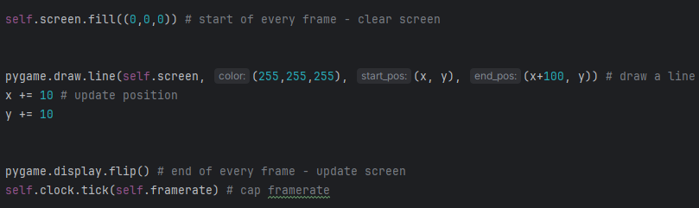
The framerate has been set to 1
The output of this code is a window that, every frame, clears the screen, draws a line, then updates the screen to show the line. As the program runs, the line appears to move diagonally down, once per second, without leaving behind another drawn line. This shows that the framerate and screen update are working properly.
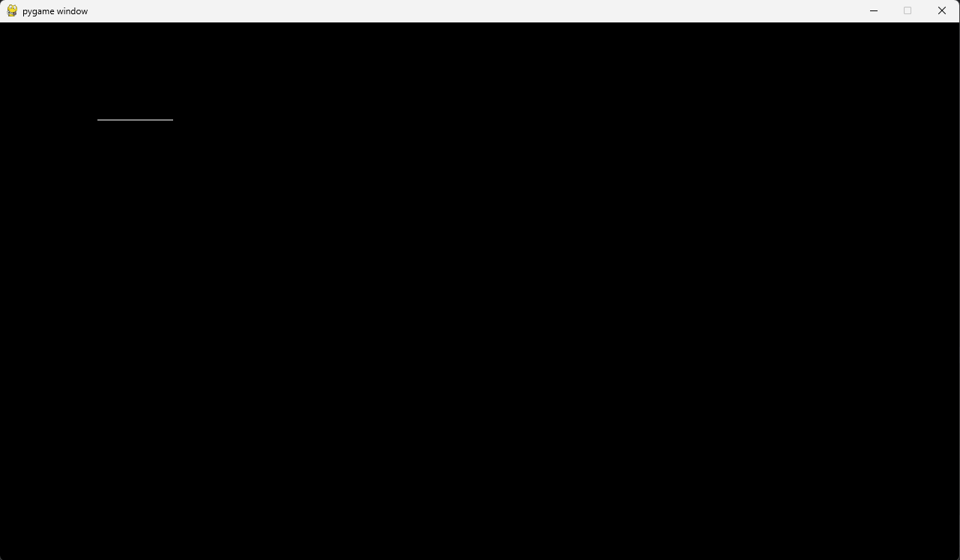

Exiting the program (X and esc):
In the run function’s While True loop, this section loops through events to detect if the X is pressed, then setting the True to False, stopping the program. Then, it listens to key inputs, terminating the program if esc is pressed.
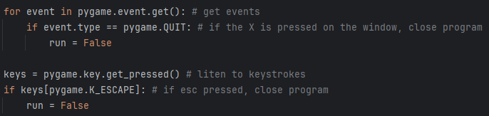
These sections of code both work as designed.

Creating Text Boxes

Design

Firstly, I will create a class that has functionality for drawing a box with text. By utilising classes, I can make subclasses that inherit from the text box parent class, allowing them to use its functions, avoiding the need to rewrite the code for the functions. Additionally, by using classes as a blueprint for instances of text boxes, I can instantiate each box with different parameters, allowing me to change their position, size, colour, text and more. Each text box object will encapsulate its own data as well, so I can individually modify the variables for each of the boxes even after they have been created. This will be helpful later in my project as I will be able to update things like an individual box’s colour when the mouse hovers over it or clicks.

Algorithm
class TextBox
procedure initialisation(screen, rect, boxcolour, fontsize, font, text, textcolour)
self.screen = screen
self.rect = ** set pygame rect **
self.boxcolour = boxcolour
self.fontsize = fontsize
self.font = ** set font **
self.text = text
self.textcolour = textcolour
endprocedure

procedure drawbox()
** pygame draw rect **
endprocedure

procedure drawtext()
** render text **
** centre text in box **
** draw text onto the box **
endprocedure

endclass

I can also ensure that the way I code my classes aids in the readability of my code and makes maintaining it easier. One way I can do this is by ordering a class's functions and procedures in a hierarchy. Here, in the text box class, the initialisation function will be called first, and as such is the first procedure. When the box needs to be drawn, It will first draw the box, then it will draw the text on top of the box, therefore I can write the code for the drawbox procedure first with the drawtext procedure after to show this.

Variables
Initialisation
Variable name | Description | Data type
self.screen | A representation of the screen in the box class
self.rect | A tuple of integers representing (left, top, width, height) | Tuple of int
self.boxcolour | A tuple of integers representing RGB values for the box | Tuple of int
self.font | A font made with a string for the font and an integer for the text size. | Uses string and int
self.textcolour | A tuple of integers representing RGB values for the text | Tuple of int

Draw box – will have no original variables, just using the screen, rect and boxcolour to draw a (rounded) rectangle to the screen.

Draw text
Variable name | Description | Data type
text_render | Uses pygame to render the text using the font made, adding the font, textsize and textcolour to the text. | Uses string and int
centre | A rect that is set to the centre of the box (centers text) | Tuple of int

Data structures
Data structure | Where in code | Use
Tuple | Positions (rects) and colours | Has a set number of set values, meaning the positions and colours will be kept constant. I wont want to change the positions of the boxes, and if I want to change the colour, I will set the boxcolour to a different tuple.

Class diagram
Box
screen
rect
boxcolour
font
text
textsize
textcolour
Initialisation()
drawBox()
drawText()

Test data
Variable/function | Explanation of how it will be tested | Test data
rect | To ensure that the positions and size of the boxes can be changed, I will use a few different examples of shapes and sizes. | Rects:  - (100, 50, 500, 50)  - (1000, 200, 200, 50)  - (1000, 260, 200, 50)
boxcolour | I can change the box colours by using different tuples of RGB values | RGB values:  - (255, 255, 255)  - (0, 0, 255)  - (100, 100, 100)
font | I can change the font by passing a string containing a different font name | fonts:  - David  - Aptos  - Comic sans
text | I can change the text by inputting a different string of text. | Text:  - “Stock Market Simulator”  - “BUY STOCKS”  - “SELL STOCKS”
textsize | I can change the text size by changing the integer input for the textsize variable | Text sizes:  - 50  - 40  - 30
textcolour | I can change the RGB values | RGB values:  - (0,0,0)  - (0,255,0)  - (255,0,0)

Implementation

class Box:
def __init__(self, screen, rect, boxcolour, font, textsize, text, textcolour, border_radius=20):
# set the variables
self.screen = screen
self.rect = pygame.Rect(rect) # make into a Rect object to make drawing and getting centre easier
self.boxcolour = boxcolour
self.font = pygame.font.SysFont(font, textsize) # pygame font initialisation
self.text = text
self.textcolour = textcolour
self.border_radius = border_radius
def drawBox(self):
# draws a rectangle on the screen, with the correct colour, at the rect position with the correct border radius
pygame.draw.rect(self.screen, self.boxcolour, self.rect, border_radius=self.border_radius)
def drawText(self):
text_render = self.font.render(self.text, True, self.textcolour) # render text
centre = text_render.get_rect(center=self.rect.center) # get the centre of the box to get a position for the text to sit centred in the box
self.screen.blit(text_render, centre) # draw the text on top of the box
I found that the border radius value can round out the corners of the rectangle, making it more aesthetically pleasing. Since I am now adding a new variable, I can test it with the following test data:
border_radius | I can change the border_radius value in the instantiation of the object | Border radius values:  - 20 (normal value)  - 0  - 10

Testing
With a new simulator initialisation function, I can hard-code box objects for testing. It can be called before the simulator’s run function is called.
Each box has a different rect, boxcolour, font, text size, text, text colour and border radius
def init_simulator(self):
self.box_title = Box(self.screen, (100, 50, 500, 50), (255, 255, 255), "david", 50, "STOCK MARKET SIMULATOR", (0, 0, 0))
self.box_buy = Box(self.screen, (1000, 200, 200, 50), (0, 0, 255), "aptos", 40, "BUY STOCKS", (0, 255, 0), border_radius=0)
self.box_sell = Box(self.screen, (1000, 260, 200, 50), (100, 100, 100), "comic sans", 30, "SELL STOCKS", (255, 0, 0), border_radius=10)

# initialise simulator object and run
simulator = StockMarketSimulator((1280, 720), 30)
simulator.init_simulator()
simulator.run()

I can run the functions for drawing the boxes and text in the run function between clearing the screen and updating it.
self.box_title.drawBox()
self.box_title.drawText()
self.box_buy.drawBox()
self.box_buy.drawText()
self.box_sell.drawBox()
self.box_sell.drawText()

The result of this is
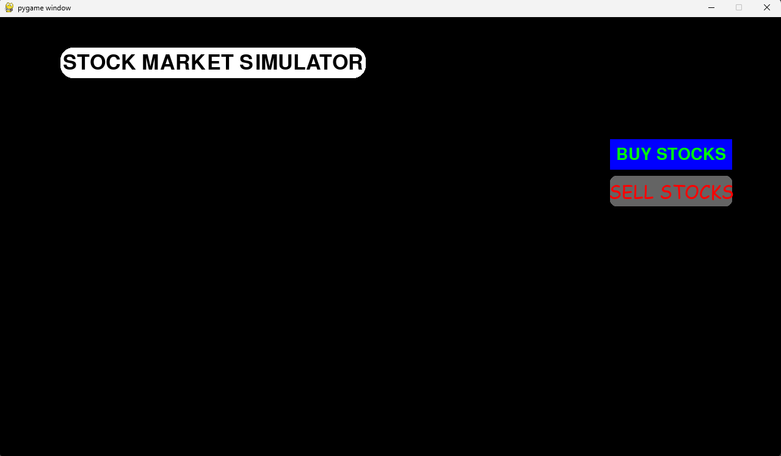
Clearly, every aspect of the box class is working correctly:
- Every box has a different position, with x and y values differing. The sizes of the boxes are different, too with the title box being longer than the others
- The colours of the boxes are different, from white to blue to grey. Alongside box colour, the text colour changes, too.
- While subtle, the font and text size of each box is unique, with a more explicit change in text content.
- The border radius changes, with the title box having fully rounded sides, whereas the sell stocks box has rounded corners, and the buy stocks box is a rectangle.

Creating Buttons

Design

The button class can inherit from the box class, making use of the draw box and text functions. As well as having functions for being drawn, the buttons class will need an interaction method to function properly.

Algorithm
class Button inherits Box
procedure initialisation(box parameters, hovercolour, clickcolour)
** use super() to inherit box class parameters **
self.hovercolour = hovercolour
self.clickcolour = clickcolour
self.originalboxcolour
endprocedure

procedure interaction(mouse position, event, function)
** check if the mouse collides with the box area **
self.boxcolour = self.hovercolour
** check if there is a click**
self.boxcolour = self.clickcolour
** call the function passed into the procedure **
else
self.boxcolour = self.originalboxcolour
endprocedure

endclass

Variables
Initialisation method
Variable name | Description | Data type
Super().__init__() | Acts like the init function for the box class and sets variables for the same things.
self.hovercolour | An RGB value for the box to change to when the mouse hovers over it | Tuple of int
Self.clickcolour | An RGB value for the box to change to when the mouse clicks it | Tuple of int
Self.originalboxcolour | An RGB value containing the box’s original colour (boxcolour). self.boxcolour is used to set the box’s colour, so can’t be used to save the box’s original colour. | Tuple of int

Interaction method
Variable name | Description | Data type
mousepos | Takes the x and y coordinates of the mouse – can be used to check for collisions with the button | Tuple of int
event | The current event in the queue of events in the main run function. Used to check if the mouse has been clicked that frame. | Multiple (Bool in the context of clicking)
function | The function the button will perform once clicked

Data structures
Data structure | Where in code | Use
Tuples | Values for colours, mouse positions. | Colours must be three fixed integers representing red, green and blue. The mouse’s position must be two set integers representing x and y coordinates.

Class diagram
Button(Box)
screen
rect
boxcolour
font
text
textsize
textcolour
border_radius
hovercolour
clickcolour
originalboxcolour
Initialisation()
Interaction()
drawBox() - inherited
drawText() - inherited

Test data
Variable/function | Explanation of how it will be tested | Test data
Inherited variables and functions | They have already been tested through the box class, but I can observe if the functions are still working for the buttons class.
hovercolour | I need to set the boxcolour to hovercolour when the mouse collides with the box. I only need to check if the colour changes. | Set hovercolour to a different colour to box colour and observe the button’s colour when hovered over.
clickcolour | The same as hovercolour but on click rather than hover | Set clickcolour to a different colour to boxcolour and hovercolour, then observe the box colour when clicked
originalboxcolour | Set originalboxcolour to boxcolour to save the box’s original colour | After the box has been hovered over or clicked, observe if it returns to its original colour

Implementation

class Button(Box):
def __init__(self, screen, rect, boxcolour, font, textsize, text, textcolour, hovercolour, clickcolour, border_radius=20):
super().__init__(screen, rect, boxcolour, font, textsize, text, textcolour, border_radius)
self.hovercolour = hovercolour
self.clickcolour = clickcolour
self.originalboxcolour = boxcolour
def interaction(self, mousepos, event, function):
if self.rect.collidepoint(mousepos):
self.boxcolour = self.hovercolour
if event.type == MOUSEBUTTONDOWN:
self.boxcolour = self.clickcolour
function()
else:
self.boxcolour = self.originalboxcolour

Testing
Firstly, I can ensure that the inherited features of the button class are working properly, meaning that the box is being drawn to the screen, with correct features for both the box and text inside it.
Instantiating the button objects:
self.button_buy = Button(self.screen, (1000, 200, 200, 50), (255, 255, 255), "david", 40, "BUY STOCKS", (0, 255, 0), (180, 180, 180), (0, 255, 0))
self.button_sell = Button(self.screen, (1000, 260, 200, 50), (255, 255, 255), "david", 40, "SELL STOCKS", (255, 0, 0), (180, 180, 180), (255, 0, 0))

Using the inherited functions:
self.box_title.drawBox()
self.box_title.drawText()
self.button_buy.drawBox()
self.button_buy.drawText()

Whilst I am testing this, I can also hover over another button to prove that the box changes colour when the mouse collides with it.
self.button_buy.interaction(mousepos, event, self.testthing) # interactions have to go in event space
self.button_sell.interaction(mousepos, event, self.testthing)

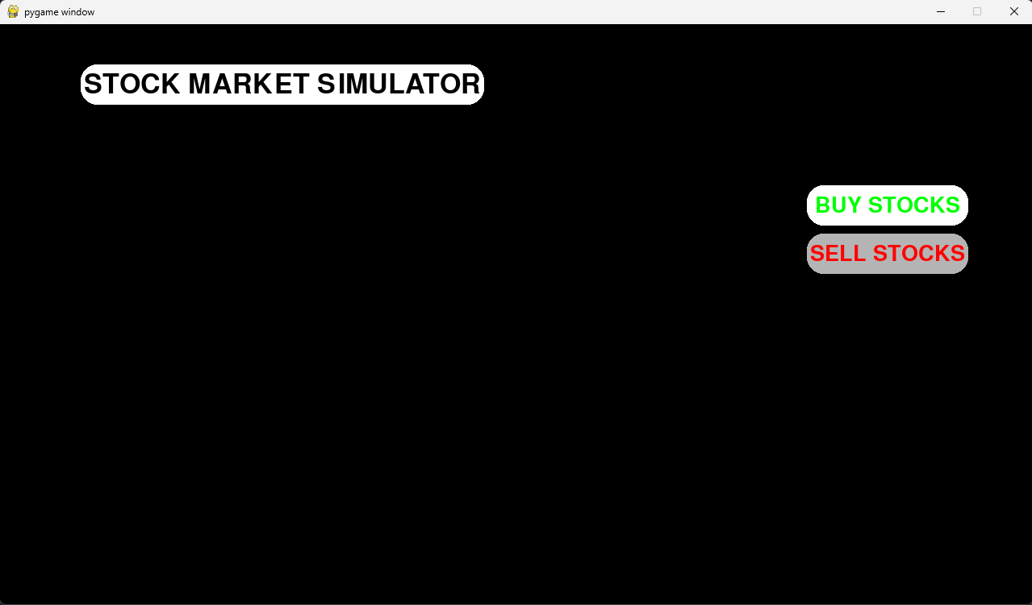
Now, I can compare the hovercolour to the clickcolour. When the button is clicked and held, the box changes colour. For example, the SELL STOCKS button boxcolour changes to red. (Unfortunately, I will not be able to screenshot the result since I cannot screenshot and hold the button simultaneously).
Alongside the boxcolour changing when the button is clicked, a function is also executed. I have made a temporary test function (self.testthing in the code above) that will give a visual confirmation of when the button is clicked.
def testthing(self):
for i in range(20):
self.screen.fill((255,0,0))
pygame.display.flip()
self.screen.fill((0,255,0))
pygame.display.flip()
self.screen.fill((0,0,255))
pygame.display.flip()
This function quickly changes the colour of the screen, creating a flashing effect when the buttons are clicked. This function is successfully run when the buttons are clicked. This method should be able to work with any function, meaning I can customise the function of buttons in the future.
Finally, I have observed that the boxcolour returns to its original when the mouse is no longer clicking or hovering over the button.

Text Input Boxes

Design

The text box class can inherit from the buttons class, making use of the drawbox and drawtext functions in the box class, whilst also inheriting the interactions function from the button class. The text input box class will also need have a function that listens for text input when the box is clicked.
Now that I have begun designing the class, I have realised that since the user is able to input text, there will need to be some form of validation in place to stop the user from creating errors with their inputs. As such, I will include a validation function that can validate things like length of input, datatype of input, if there is any input at all, etc. For more specific inputs, after testing, I can go back to a different class that the text box is interacting with and potentially add more detailed validation for its specific input. For example, for inputting a username for accounts, I may want the input to be all capital letters. However, I may not want other inputs in other places to be this way, so I can create a specific validation in the account making class, leaving all of the general validations to the text input class.
Algorithm
class TextInput inherits Button
procedure initialisation(box parameters, usertext="")
** use super() to inherit box class parameters **
self.usertext = usertext
endprocedure
procedure input(event, function, maxlength, datatype
** check if the button has been clicked **
** checks for if a specific key has been pressed **
** if key = backspace **
** delete a character from self.usertext using string manipulation **
** if key = enter **
** run validation function **
self.text = self.usertext
** checks for if any key has been pressed **
self.usertext += input key
self.text = self.usertext
self.drawText()
endprocedure
function validate(userinput, maxlength, datatype)
self.usertext = ""
// if any of the following tests fail, print an error message and return None
** check that userinput is not whitespace **
** check that the length of userinput isnt longer than maxlength **
** check that the datatype of userinput matches that of datatype **
return userinput
endfunction
endclass

Here I will be using nested ifs to check if a key has been pressed, then if a specific key has been pressed. This is widely known to be a solution that can cause logic errors or inefficient code, however it is a solution I am familiar with and can implement within the time I have. It can make the code harder to read and understand, resulting in mistakes. I will take extra care to ensure this function works as desired. If I had more time, I would research a more reliable and efficient solution, spending longer, implementing it carefully.

Variables
Initialisation method
Variable name | Description | Data type
Super().__init__() | Acts like the init function for the box class and sets variables for the same things.
self.usertext | A string containing the current text that has been inputted by the user | String
Input method
Variable name | Description | Data type
function | A variable that represents the function that will be used
Length | An integer representing the maximum length of the text input | Int
datatype | A string representing which data type the input should be | String
event | The current event in the queue of events in the main run function. Used to check if the mouse has been clicked that frame. | Multiple (Bool in the context of keyboard input)
validateduserinput | A string containing the returned value from the input validation method | String (or None if the validation fails)
usertext | A string of the text the user has input | String
Input validation method
Variable name | Description | Data type
userinput | A string also representing the user’s input | String
Datatype | Same as datatype above | String
Length | Same as length above | Int
inputlen | Length of the user’s input | Int

Data structures
I have not created any data structures for this class (aside from those used in inherited parts), since it does not require any.

Class diagram
TextInput(Box)
Self.usertext
Function
Length
Datatype
Event
Validateduserinput
Usertext
Userinput
Inputlen
Initialisation()
Input()
InputValidation()
Inherited functions

Test data
Variable/function | Explanation of how it will be tested | Test data
Test that hovering and clicking functionality is present | Observe if the box colour changes when hovering over / clicking | Observe if the box colours change
Test that usertext is updated properly – typing, deleting, entering and not updating when not clicked | Get the program to print the usertext variable when it is changed. When entered, the entered value will be printed. Observe if usertext is updated when the box isn’t being hovered over | Type “Hello” then backspace 5 times, then type “100” and enter
Test that the current usertext is being displayed | Observe if the text in the textbox is changing to the same as the printed usertext value | “Hello”
Test that the original text reappears | Record the original text, then observe if the text returns to that after typing in the box
Check the end function works | If the input is valid (an integer in this case, where the string input is cast to an integer), it should be used as an input to a function. I can make a temporary function to test if the value is passed properly, by printing the passed value. | “100”
Check validation works – length, datatype | Input multiple different datatypes and lengths. The validation function will be set to allow only integers of length less than 5 and more than 0 to pass | “Hello”  “Hello!”  “100”  “1.2”  “”

Implementation

class TextInput(Button):
'''
uses box.drawBox and box.drawText to display
uses button.interaction to check for mouse hover/click detection
then if the button is clicked and continuously hovered over, textinput.input is run, reading input from the user
when the user presses enter, the text is then validated. If it is correct then it passes as a parameter into the function you want to run.
'''
def __init__(self, screen, rect, boxcolour, font, textsize, text, textcolour, hovercolour, clickcolour, usertext="", border_radius=20):
super().__init__(screen, rect, boxcolour, font, textsize, text, textcolour, hovercolour, clickcolour, border_radius)
self.usertext = usertext
def input(self, event, function, length=100, datatype=None):
if self.active: # if the box is clicked
if event.type == pygame.KEYDOWN: # if a (specific) key is pressed
if event.key == pygame.K_BACKSPACE:
# when backspace is pressed, usertext is set to usertext, but minus the last character
self.usertext = self.usertext[:-1]
if event.key == pygame.K_RETURN:
# enter pressed, validate input then (if correct) pass to the function you want
validateduserinput = self.inputValidation(self.usertext, length, datatype)
if validateduserinput != None:
function(validateduserinput)
if event.type == pygame.TEXTINPUT:
# adds user text input to the userinput string
self.usertext += event.text
# self.text is what is used in box.drawText to actually display the text, so its easier to just set this to usertext, then reset later
self.text = self.usertext # updates text in box to show what the user has typed
self.drawText() # updates text in text box
def inputValidation(self, userinput, length=100, datatype=None):
self.usertext = "" # resets the usertext when enter is pressed, resetting the text box
inputlen = len(userinput)
if inputlen == 0 or inputlen > length: # input is longer than the specified length value
print("invalid input - invalid length")
return None
if datatype == "int": # for specific data types --- maybe add more validation for different data types if needed.
try:
return int(userinput)
except ValueError:
print("invalid input - wrong type")
return None
return userinput

Since I need detection for when the mouse is hovering over the text box, I have changed the code for the buttons class to record this
class Button(Box):
def __init__(self, screen, rect, boxcolour, font, textsize, text, textcolour, hovercolour, clickcolour, border_radius=20):
super().__init__(screen, rect, boxcolour, font, textsize, text, textcolour, border_radius)
self.hovercolour = hovercolour
self.clickcolour = clickcolour
self.originalboxcolour = boxcolour
self.originaltext = text
self.active = False # added to check if the box is currently being hovered over/ clicked (for text input later)
def interaction(self, mousepos, event, function):
if self.rect.collidepoint(mousepos):
self.boxcolour = self.hovercolour
if event.type == pygame.MOUSEBUTTONDOWN:
self.boxcolour = self.clickcolour
try:
self.active = True
function()
except TypeError: # stops from trying to call NoneType
pass
else:
self.boxcolour = self.originalboxcolour
# for text input later, to display the original "click here to input text type text on a text box, and stopping typing into the box when not clicked.
self.text = self.originaltext
self.active = False

For testing purposes, I have made this
# temporary function to ensure text box functions are working
def testnum(self, number):
print("final textbox input is:", number)

And I have instantiated the test text box with the following
self.text_box = TextInput(self.screen, (1000, 320, 200, 50), (255, 255, 255), "david", 40, "INPUT TEXT", (0, 0, 0), (180, 180, 180), (255, 0, 0))

self.text_box.interaction(mousepos, event, self.text_box.input(event, self.testnum,5, "int"))

self.text_box.drawBox()
self.text_box.drawText()

Testing
Hovering and clicking functionality:
This is working for text boxes and still works for the other classes

Usertext variable updates:
I can simply add
print(self.usertext)
then type the testdata:
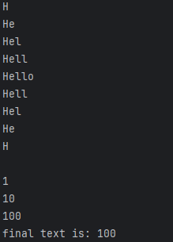

Current textbox text updates :
Firstly, I will check that the text in the box changes to reflect what the user is currently typing
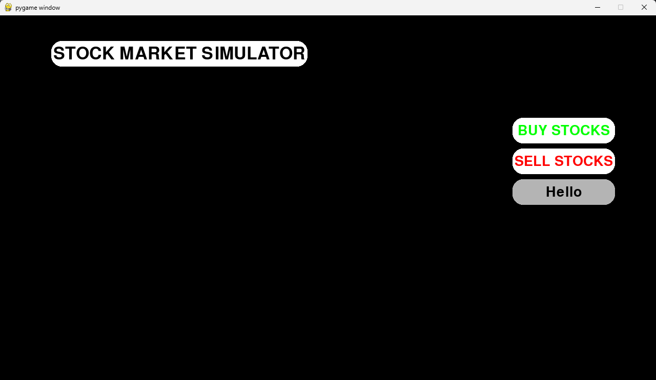
Then I will move my mouse off of the box to see if the original text reappears
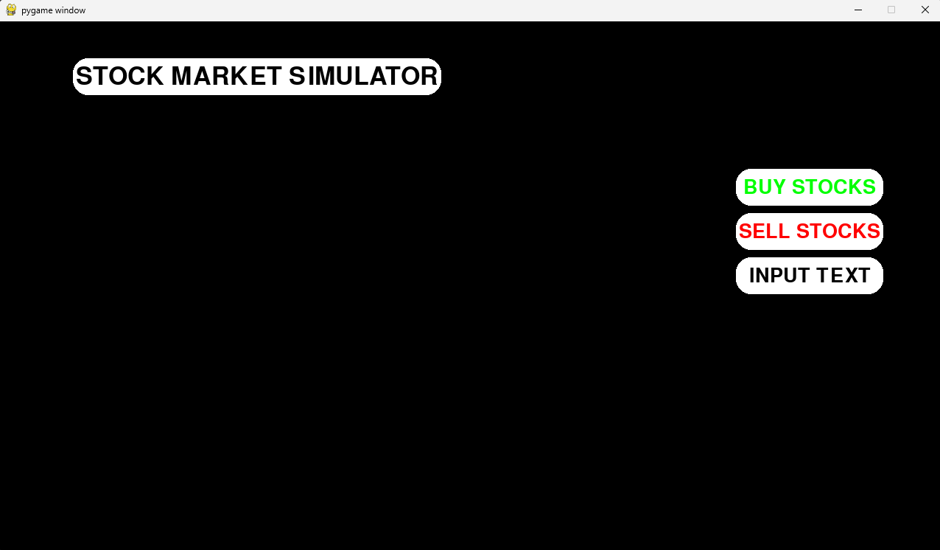

Check validation and final function works
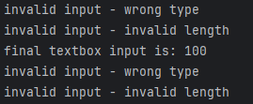
Typing and inputting the test data as written in the check validation works part results in the above. Inputting the wrong datatype or length results in an “error”, but inputting something valid results in the text box’s function taking the input as a parameter.

Data Collection

Design

The data collection class will make use of the yfinance library to retrieve data from the yahoo finance website. It will need functionality for passing stock names, the total trading period and the interval between each reading. I can use text input boxes for allowing the user to input a stock of their choosing, then I can validate it. I can also use buttons to allow for different periods and intervals.
By making this into a class, I can create different data objects that hold their own stock values. This will allow the user to load data for multiple different stocks at the same time. Additionally, the data will be encapsulated within the object, stopping outside functions from accidentally modifying the data.

Algorithm
class Data
procedure initialisation(period, interval)
self.period = period
self.interval = interval
self.period_index = global_periods(period)
self.interval_index = global_intervals(interval)
endprocedure
procedure setperiod()
self.period_index += 1
** add a check for if period index is out of the array **
self.period = global_periods[self.period_index]
endprocedure
procedure setinterval()
self.interval_index += 1
** add a check for if inteval index is out of the array **
self.interval = global_intervals[self.period_index]
endprocedure
procedure initialisestock(stock)
self.stock = stock
self.getdata()
endprocedure
procedure getdata()
** use yfinance library to get financial data for a specific stock **
procedure
procedure printdata()
** print data for debugging purposes **
endprocedure
endclass

Variables
Initialisation method
Variable name | Description | Data type
Self.period | a string containing a pneumonic representing a time frame, e.g. “1wk”, “1mo” for a week and month. | String
Self.interval | Functionally the same as self.period, but represents the interval between when data is gathered. | String
Self.period _pointer | An integer that is used as an index in a tuple of valid period values | Int
Self.interval_pointer | Same as period_pointer, but for a tuple of interval values | Int

Function for setting stock period – only uses self.period_pointer and global_periods
Function for setting stock interval – only uses self.interval_pointer and global_intervals
Stock initialisation
Variable name | Description | Data type
Self.stock | Variable that stores the stock ticker name that the user has input | String

Data gathering function
Variable name | Description | Data type
ticker | A yfinance Ticker object that gathers data
data | Stores the ticker.history values – historical data of the stock

Data printing function – only uses data gathered in the data gathering function

Global variables
Variable name | Description | Data type
Global_periods | a tuple containing strings that can be used to set the period of a stock | String
Global_intervals | A tuple containing strings that can be used to set the interval of a stock | String

Data structures
Data structure | Where in code | Use
tuple | Global period and interval | Allows for a pointer to set the stock interval and period using indexing. Making it a tuple means that it is immutable, so the data in each tuple cannot be changed at runtime, potentially mitigating risk of modifying the data and causing errors
array | How the gathered data is formatted | The gathered data is returned as an array. This can then be used later for the graph, as indexing can be used. Each index in each array correlates to the same time, making it easier to manage and use.

Class diagram
Data
Self.period
Self.interval
Self.period_pointer
Self.interval_pointer
Self.stock
Ticker
Data
Global_periods
Global_intervals
Initialisation()
Set_period()
Set_interval()
Initialise_stock()
Get_data()
Print_data()

Test data
Variable/function | Explanation of how it will be tested | Test data
Initialisation and stock initialisation | The initialisation function should update the variables in the function. The stock initialisation function should also update the stock variable, whilst also calling the data collection function. I can print all of these variables and print a message to show that the data collection function has been called. | Period=”1y”  Interval=”1wk”  Stock=”AAPL”
Get_data function and print_data function | Using defaulted parameters as period=”1y” and interval=”1wk”, I will input a valid stock ticker, evaluating if all of the correct data is output by the print_data function. Also attempt to input invalid stocks to ensure the input ticker is validated. | Period=”1y”  Interval=”1wk”  Stock=”AAPL”  Stock = “ ”  Stock=”zyxw”
Set_period and set_interval | Using buttons in the running program, change the period and interval values, then input the same stock as last time and compare the results. The text in the buttons should also update to show which period and interval has been selected. | Period=“1mo”  Interval=”1d”  Stock=”AAPL”

Implementation

class Data:
# sets initial values for initial text on buttons
def __init__(self, period="1y", interval="1wk"): # first setup for before a stock has been input
self.period = period
self.interval = interval
self.period_pointer = -1
self.interval_pointer = -1
# changes period by incrementing a pointer in an array
def set_period(self):
self.period_pointer += 1 # sets pointer to 0 for 0 indexed tuples
if self.period_pointer > 10: # resets the pointer to 0 if it goes past the length of the tuple
self.period_pointer = 0
self.period = global_periods[self.period_pointer] # setting period to be the index
# changes interval by incrementing a pointer in an array
def set_interval(self):
self.interval_pointer += 1
if self.interval_pointer > 10:
self.interval_pointer = 0
self.interval = global_intervals[self.interval_pointer]
print(self.interval)
# sets the stock and runs the get_data function
def initialise(self, stock):
self.stock = stock
self.get_data()
self.print_data() #use for debugging, comment out later
# uses yfinance to retrieve data based on user set stock, period and interval
def get_data(self):
try: # tries to gather data for a stock - works if stock ticker is valid, returns error if not
ticker = yf.Ticker(self.stock) # wont return an error if an incorrect ticker name is used, so the next line is added too
data = ticker.history(period=self.period, interval=self.interval) # gathers data from the ticker object
except:
print("Invalid stock ticker")
return
self.date = data.index
self.open = data["Open"].iloc # iloc is a pandas thing - allows for indexing in the data collected - formats to array
self.close = data["Close"].iloc
self.high = data["High"].iloc
self.low = data["Low"].iloc
self.stockname = self.stock
# prints data for debugging purposes - same idea can probably be used for formatting the data
def print_data(self): #da
for i in range(len(self.date)): # each set of data should be the same length
print(f"{self.stockname} {i} {self.date[i]} -- ",
f"High: {round(self.high[i], 2)} ",
f"Low: {round(self.low[i], 2)} ", # also round is used to round the data to the nearest 1p (for ease of use)
f"Open: {round(self.open[i], 2)} ",
f"Close: {round(self.low[i], 2)}")
To ensure that the stock name the user input is correct, there is a try, except block that will run the program correctly if a correct stock is input, or will otherwise return an error message.
The print data function is included for testing purposes, allowing me to display the data that has been gathered, to observe if it is correct.

The buttons for period and interval are instantiated in the init_simulator function in the main simulator class
self.stock_period = Button(self.screen, (1000, 410, 200, 50), (255, 255, 255), "david", 40, f"Period: {self.data.period}", (0, 0, 255), (180, 180, 180), (255, 0, 0))
self.stock_interval = Button(self.screen, (1000, 470, 200, 50), (255, 255, 255), "david", 40, f"Period: {self.data.interval}", (0, 0, 255), (180, 180, 180), (255, 0, 0))

The interactions for each button is also added in the main event loop
self.stock_period.interaction(mousepos, event, self.data.set_period)
self.stock_interval.interaction(mousepos, event, self.data.set_interval)

Then the buttons are drawn
self.stock_period.drawBox()
self.stock_period.drawText()

self.stock_interval.drawBox()
self.stock_interval.drawText()

The global tuples for period and interval are defined at the top of the program
global_periods = ("1d", "5d", "1mo", "3mo", "6mo", "1y", "2y", "5y", "10y", "ytd", "max")
global_intervals = ("1m", "2m", "5m", "15m", "30m", "1h", "1d", "5d", "1wk", "1mo", "3mo")

Testing
Initialisation and stock initialisation:
I can add a line of code inside the get_data function to see if it is called by the stock initialisation function. I can test that the variables are set correctly by printing their values after initialisation.
print(f"Data collection function called. Stock = {self.stock},"
f"period: {self.period}, interval: {self.interval}")
The results in a message with correct variables, showing the functions both work as intended

Get_data and print_data functions:
Since the initialisation functions are working, I can now input a stock into the text input box to see if the data is collected successfully.
The first test uses “AAPL”, a known stock that should return data.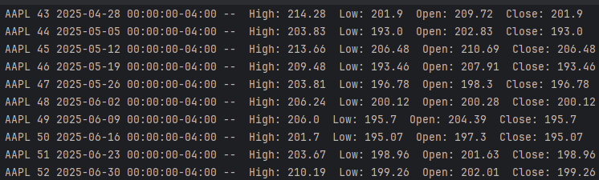
A total of 52 individual weeks of data was returned – consistent with what I was expecting, since 1 year of data with 1 week intervals should yield 52 weeks of data.

However, inputting a space leads to the previous stock being loaded. In this case, as AAPL is input first, then an input of a single space is entered, then the same data is loaded. This is unnecessary and may cause errors in my program.
After further testing, I found that inputting whitespace will result in the same stock being reloaded. I can avoid this by further validating the user’s input. In the inputValidation function in the TextInput class, I have added:
if not userinput.strip():
print("invalid input - must not be whitespace")
return None
meaning that if there is whitespace, it will return an error message and will not allow the input to be used, hence the program will not unnecessarily reload the stock.

Finally, using a ticker name that is known to be incorrect results in the following error message

Set_period and set_interval functions:
When the period and interval buttons are clicked, they should change the set of data being output. Using “1mo” period and “1d” interval should yield less values, that are all within one month
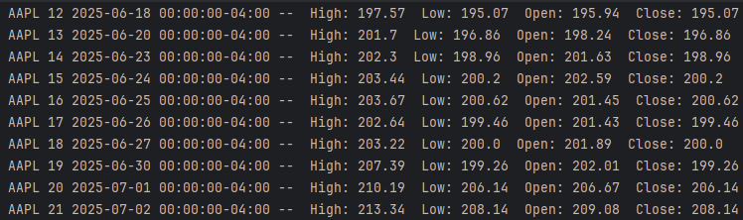
With some further testing, I have found that the buttons properly change the pointer values, and subsequently the period and interval values that are passed as parameters.

However, the text in the boxes don’t update to show which period and interval values have been selected. Therefore I can add a function to the boxes class
def updateText(self, text): # workaround for changing text in the period and interval buttons
self.text = text
and I can call this in the main program before drawing the text
self.stock_period.drawBox()
self.stock_period.updateText(f"Period = {self.data.period}")
self.stock_period.drawText()

self.stock_interval.drawBox()
self.stock_interval.updateText(f"Interval = {self.data.interval}")
self.stock_interval.drawText()
resulting in the values in the boxes changing
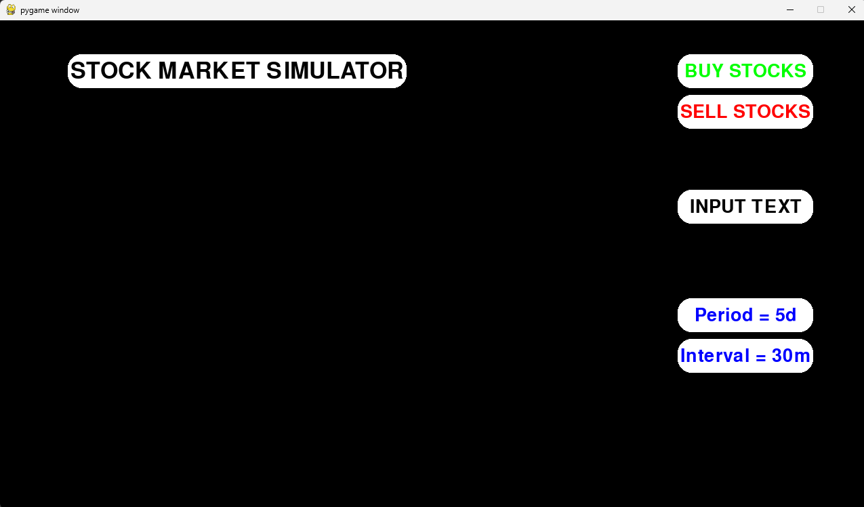

Graph

Design

Initially, when setting the requirements for my program, I outlined that there should be separate functions for creating the graph, axes, plots and more. After putting more thought into how to organise this section of code, I have concluded that adding all of these functions to one graph class will be more efficient to write and for performance. I can use a pygame rect to create a box that the graph will fit into. I can then extend this functionality by adding text box objects to label the axes. Inside the rect I can normalise position values for each of the plots.
Additionally, after a meeting with my stakeholders, they expressed that there is not much need for axes and labelling. This is because the graph will have a border around it, enclosing it, and the user will be able to input the period and interval, so the date axis will be of little use. The price, however, is a useful metric to have on the graph, so I will add values to the y axis.
Originally, I was going to make a class for the candlestick plots that will hold data about how to draw the plots – i.e. position, width, colour, etc. However, each object would need to have this data changed each frame, so the values would need to be recalculated regardless of if they’re a separate object or not. Therefore, rather than keeping an array with each object, then looping through the array to update object attributes, I will just loop through each index in the data and calculate the respective values straight away.
By making this a class, I can create multiple different graphs at once. This will aid me later when I create functionality for having multiple stock loaded at once, to allow the user to trade with multiple tickers simultaneously.

Algorithm
class Graph
procedure initialisation(screen, position, data)
self.screen = screen
self.position = position
self.data = data
self.data_minimum = minimum(self.data.low)
self.data_maximum = maximum(self.data.high)

endprocedure
function normalise_data_to_screen(data)
normalised_y_position = **normalised height calculation using data**
return normalised_y_position
endfunction
procedure draw
candle_spacing = **calculate candle spacing**
candle_width = **calculate candle width**
for i = 0 to **number of items in the data**
**calculate vertical position of candlestick using normalise_data_to_screen**
// calculate if price is higher/lower and change colour
if self.data.close[i] >= self.data.open[i]
candle_colour = (green)
else
candle_colour = (red)
endif
**draw a vertical line - high/low**
**draw a rect - open/close**
next i
endprocedure
endclass

Variables

Variable name | Description | Data type
Self.screen | Stores the screen
Self.position | A rect that stores the position of the graph itself | Tuple of Int
Self.data | A data indexer that contains arrays of stock prices | Array of Int
Self.data_minimum | The smallest value in the data – allows for setting the y scale | Int
Self.data_maximum | The largest value in the data – for setting the y scale | Int
Normalised_y_position | Calculates where the candlestick should be positioned relative to the graph’s position | Int
Candle_spacing | The distance between each plot | Int
Candle_width | A value for how wide each candle should be | Int
Candle_colour | A tuple of ints representing RGB values | Tuple of Ints

Data structures
Data structure | Where in code | Use
Tuples | For positions and colours | Immutable, so the values cannot change, meaning there is no risk of changing them. Keeping values together in a single variable is good for readability and maintainability.
Array | For data steams | Keeps data in one variable whilst also indexing it based on time.

Class diagram
Graph
Self.screen
Self.position
Self.data
Self.data_minimum
Self.data_maximum
Normalised_y_position
Candle_spacing
Candle_width
Candle_colour
Initialisation()
Normalise_data_to_screen()
Draw()

Test data
Variable/function | Explanation of how it will be tested | Test data
Self.position | I will have a few tests, changing the rect values for the position. The position value will most likely be fixed to a single point regardless of game mode, etc. However functionality for moving it may prove useful in the future | Self.position =  (100, 150, 800, 400)  (200, 300, 400, 200)
Self.data | This should be working properly, however I can simply print some of the data it should provide to ensure it is successfully being passed as a parameter. | Print(self.data.low) – observe that the data is correct
Self.data_minimum and maximum | I can observe that these values are the max/min of the data provided by checking the printed data | Print(self.data_minimum, self.data_maximum) – observe if it is correct
Normalise_data_to_screen() | The y position of the candlesticks needs to be accurate to reflect the stock price, so I can verify that they are calculated correctly. | Observe that the candlesticks are in the correct position.
Draw() and all other variables | For practical purposes, the width and spacing of the candlesticks only needs to look correct, so we can observe that alongside the colour. All of these variables are calculated and used in the draw function, so I will effectively be testing the entire function here. | Observe that the widths and spacings are even, and that the colours are correct. Being able to observe any drawn candlesticks verifies that draw() works

Implementation

class Graph:
def __init__(self, screen, rect, data):
self.screen = screen
self.rect = pygame.Rect(rect)
self.data = data
self.num_items = len(self.data.low)
self.data_min = min(self.data.low)
self.data_max = max(self.data.high)
range = self.data_max - self.data_min
margin = range * 0.1
self.data_min -= margin
self.data_max += margin
def data_to_screen(self, data_value):
normalised_y = ((data_value - self.data_min) / (self.data_max - self.data_min))
normalised_y = 1.0 - normalised_y
screen_y = self.rect.y + (normalised_y * self.rect.height)
return screen_y
def draw(self):
graph_width = self.rect.width
candle_margin = 2
candle_spacing = np.trunc(graph_width / self.num_items)
candle_width = np.trunc(candle_spacing - candle_margin)
bg_colour = (5, 70, 120)
pygame.draw.rect(self.screen, bg_colour, self.rect) # adds a background colour to the graph rect
for i in range(self.num_items):
x = np.trunc(self.rect.left + (candle_spacing * i))
#pygame.draw.rect(self.screen, (0,0,255), (x, self.rect.y, candle_width, self.rect.height)) # background of candles - shows spacing between candles
open_y = self.data_to_screen(self.data.open[i])
close_y = self.data_to_screen(self.data.close[i])
high_y = self.data_to_screen(self.data.high[i])
low_y = self.data_to_screen(self.data.low[i])
mid_x = x + (candle_width / 2)
if self.data.close[i] >= self.data.open[i]:
candle_colour = (0, 220, 32)
else:
candle_colour = (255, 64, 0)
pygame.draw.line(self.screen, candle_colour, (mid_x, low_y), (mid_x , high_y), width=2) # high-low line
candle_height = max(1, close_y - open_y) # ensures the candle height isnt too small to see
pygame.draw.rect(self.screen, candle_colour, (x, open_y, candle_width, candle_height)) # open-close box

the graph is initialised with the following, in the init_simulator function in the stockmarketsimulator class
self.graph = None
a new self.load_graph function is made and passed into a text input button
self.stock_name_input.interaction(mousepos, event, self.stock_name_input.input(event, self.load_graph, 5, "string"))

def load_graph(self, stock):
self.data.initialise(stock)
self.graph = Graph(self.screen, (100, 150, 800, 400), self.data)
to draw the graph (if it’s loaded) the following code is used
if self.graph:
self.graph.draw()

During implementation, I added a few additional features that were not outlined in the original design.
Firstly, I added a margin by reducing the maximum and increasing the minimum y positions for the candlesticks, meaning there is a space between the highest/lowest candlestick and the top/bottom of the graph’s rect.
I also added a background colour variable and drew the graph’s rect to create a distinct background for the graph.

Testing
Draw() and other variables, normalise_data_to_screen()
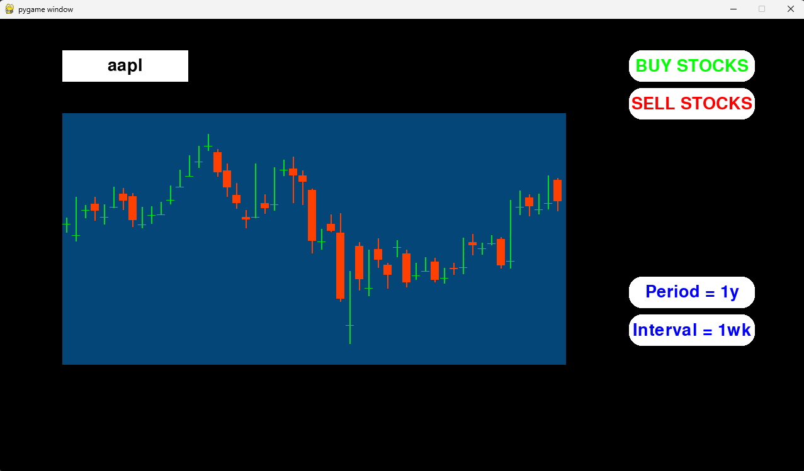
The graph is being drawn correctly, being similar to real life stock graphs. This proves that the draw function is working as intended, with each candlestick having the same width and gap between them. The colour also correctly displays whether the stock’s price has increased or decreased during that time period. The y position of the candlesticks is also relatively correct, showing a general pattern of the price. Later I can add labels to the y axis to allow the user to see stock prices.
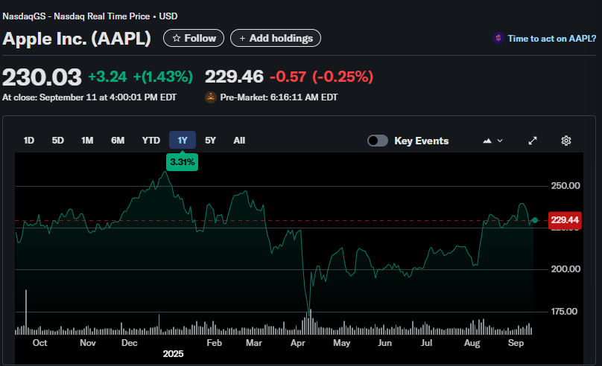Image taken from https://finance.yahoo.com/quote/AAPL/
When changing the interval to get more data, the graph becomes more accurate to the yahoo finance one. 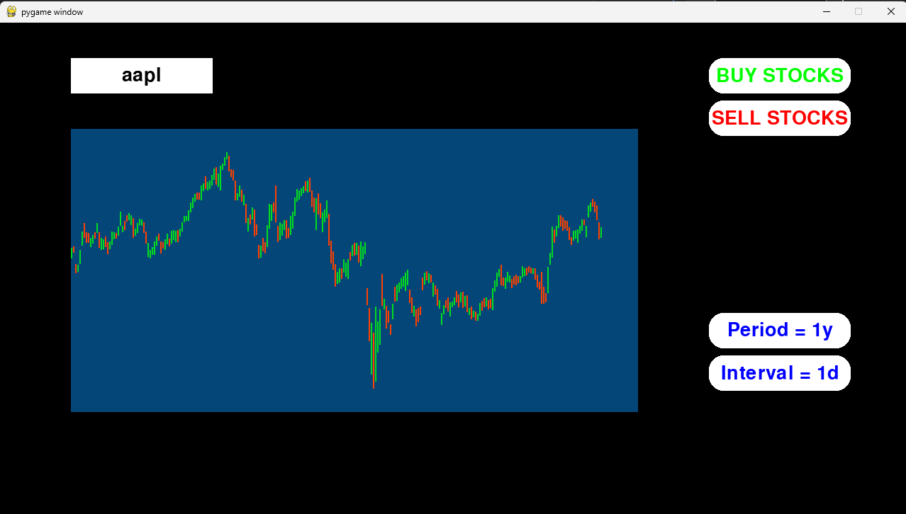
However, this raises an issue with how the spacing is calculated. Sometimes, there is a large gap between the final candlestick and the end of the graph’s rect. I believe this is due to rounding in my calculations. Any decimal values for positions must be rounded, since it is not possible to draw to an accuracy of less than a pixel, so the drawn positions are all slightly off from where they should be. I think this means that the total error accumulates at the end of the graph, creating this gap. In future iterations of my graph, I will attempt to address this problem.
Additionally, with a large number of candlesticks, it becomes hard to distinguish between the high/low line and the open/close box. I can fix this by changing the candle colour variable to a high/low candle colour variable, then add another that controls the open/close colour. This change can be seen in the following screenshots. It is a subtle difference, with the high/low line being just slightly darker than the open/close box
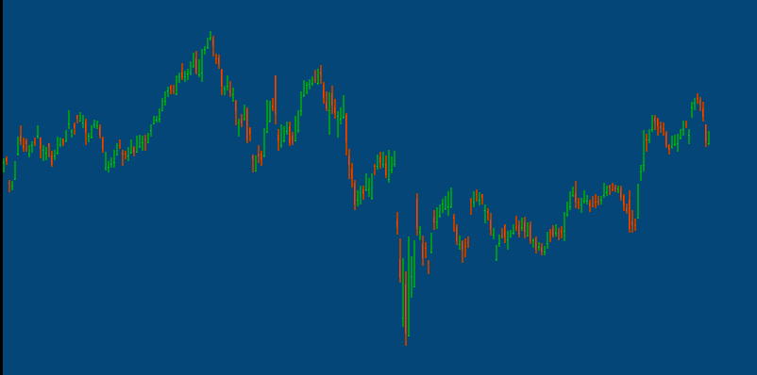
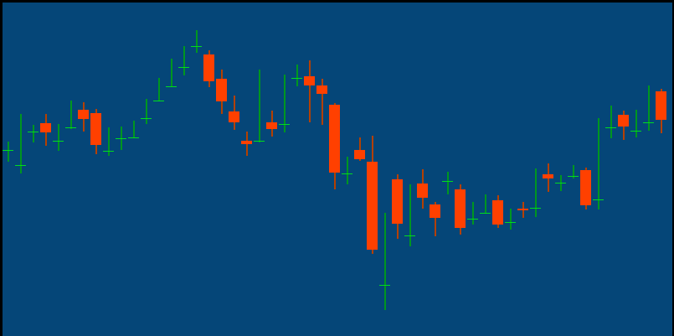

Self.position (self.rect)
I changed some of the variable names to better reflect what they are, or to save time typing.
The first screenshot makes use of the rect (100, 150, 800, 400).
Another test with the rect (200, 300, 400, 200) provides the following result
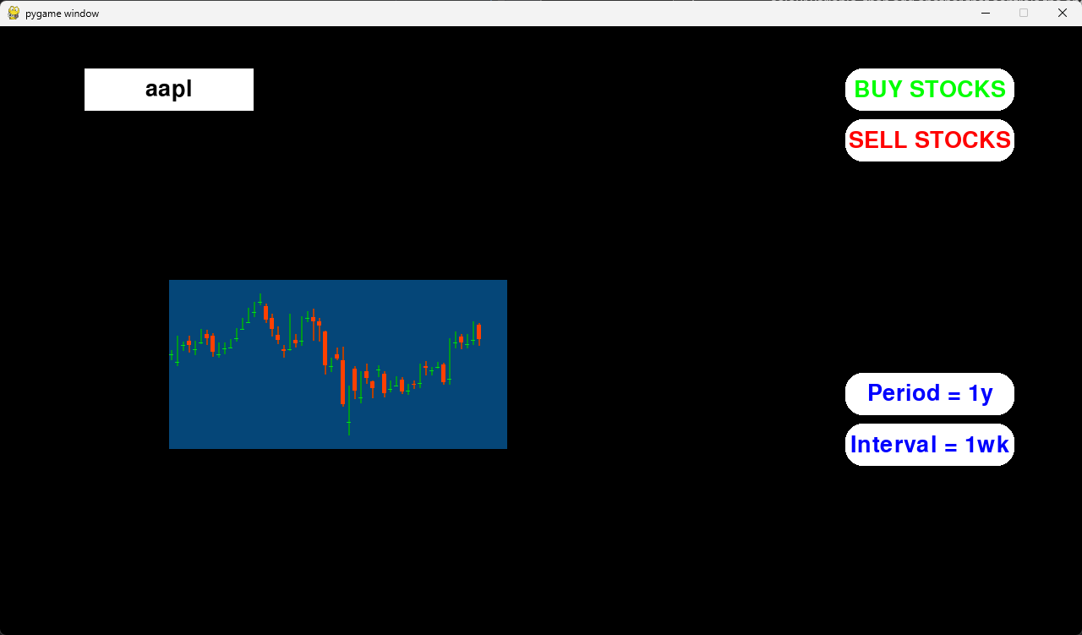
Both the position and size have been changed in this test. Changing the position of the graph has not changed any of the functionality. However, changing the size of the rect has made the resultant graph deviate from the result I want. The high/low line is slightly off-centre. Again, I believe this is caused by rounding errors. This is inconsequential though, as I will be keeping the rect at a constant value of (100, 150, 800, 400) and I do not plan to change that, so I will only look into this issue further if I require functionality for changing the graph size in future elements of my project.

Self.data and self.min/max
I can add one line two lines to the initialisation function. One will print self.data.high and self.data.low and the other will print self.data_max and self.data_min. I can then look through the data to see if the values match, which they do.
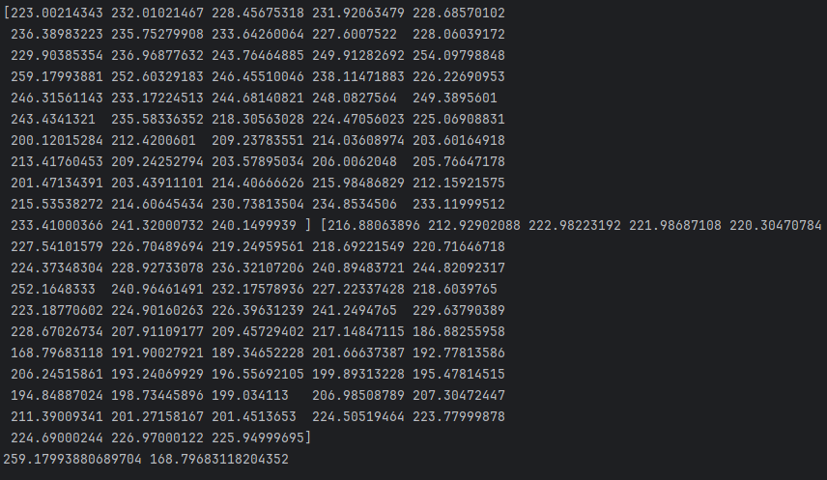

Whilst the graph class has passed all of its tests, there are still improvements to be made to it that I did not think of during the design section.
Firstly, I can integrate the additional displays of information into this class, to load alongside the graph. This will save me passing all of the stock data into another class. Furthermore, to give correct data for each candlestick as it is drawn, the additional displays will need to know which candlestick is being drawn – an index for how far through the data the candlestick’s drawing function is. A solution to pass this index to a different class would be complex and time consuming compared to simply adding the display boxes to the graph class. Therefore, in my next iteration of the graph class, I will include these displays
Secondly, and more importantly, the graph class currently draws all of the candlesticks at once, rather than drawing one at a time with a delay between. I quickly tried using time.sleep() to add a delay, but this halts the entire program and as such is unsuitable. Currently, I am thinking of using a framerate based solution, adding a counter to increment every frame, then drawing every 30 or 60 frames. I will go into more detail in the design section of the second iteration of the graph class.
Thirdly, for clarity, I can add values to the y axis. On further thought into the design of the axes, labelling the x axis will only serve to feed the user information that they do not need, or can easily infer through other means. The date will most likely not be useful to most users and will probably cause more confusion than aid. If users believe that the date is important, they can quickly work out when it is using their period and interval values. The y axis on the other hand is very important, showing the price of the stocks. To reduce visual clutter, I will only include the maximum and minimum values, as the user will already have the price of the latest candlestick, alongside a multitude of additional price data.

Graph – Second Iteration

Design
Some of the design for this section was completed at the end of the first graph iteration’s testing section.

Algorithm
For the additional displays of data, I can instantiate display boxes in the graph initialisation function, then draw and update their text in the graph’s draw function.
** initialise 7 boxes, one for each piece of data, and one for a background **
** draw all 7 boxes and update text for the 6 data displays **

To allow the graph to draw another candlestick after an interval, I can add a variable in the stockmarketsimulator class that increments every frame. I can pass in the current frame as a parameter, then check if it is a multiple of some value, dictating whether the graph can draw or not. My game is currently capped to 30 fps, so checking if the current frame is a multiple of 60 would mean the graph would draw a new candlestick every 2 seconds.
(in initialisation function)
Self.frame_timer = frame timer
(in draw function)
Pass the current frame as a parameter
** calculate the number of items to draw using current frame % self.frame_timer **
** check that the current frame % self.frame_timer isn’t larger than the size of the data array **

To add values to the axes, I can do the same as the additional displays of data, creating display boxes.
** initialise two boxes using data_min and data_max variables in the initialisation function **
** call their draw function in the graph’s draw function **

Variables

Variable name | Description | Data type
Self.stats_background | A box object – used for creating a solid colour background | Object
Self.open_display_box | A box object for displaying the current open price | Object
Self.close_display_box | A box object for displaying the current close price | Object
Self.high_display_box | A box object for displaying the current high price | Object
Self.low_display_box | A box object for displaying the current low price | Object
Self.volume_display_box | A box object for displaying the current volume | Object
Self.dividends_display_box | A box object for displaying the current dividends | Object
Self.min_price_box | A box object for adding a scale to the y axis | Object
Self.max_price_box | A box object for adding a scale to the y axis | Object
Self.frame_timer | An integer value that is used as a timer | Int
Current_frame | Integer passed as a parameter into the draw function – used for the timer system. | Int

Test data
Variable/function | Explanation of how it will be tested | Test data
Self.stats_background | I will change the colour | (255, 0, 0)  (0, 255, 0)
All of the additional display boxes | Input a stock and verify that the values change each stock, and change to the correct values | Aapl  Goog
Max and min price boxes | These can be tested alongside the additional display boxes. I can observe that the max and min values are | Aapl  Goog
Self.frame_timer and current_frame | I can print the values for current frame to ensure it is being incremented once per frame. I can use a stopwatch to check that when setting frame timer to be a different value, it will change the amount of time between drawing a new candlestick. | Frame_timer = 10, 30, 60

Implementation

class Graph:
def __init__(self, screen, rect, data, frame_timer):
self.screen = screen
self.rect = pygame.Rect(rect)
self.frame_timer = frame_timer
self.num_items = 1
self.data = data
self.data_min = min(self.data.low)
self.data_max = max(self.data.high)
range = self.data_max - self.data_min
margin = range * 0.1
self.data_min -= margin
self.data_max += margin
self.min_price_box = Box(self.screen, (910, 540, 50, 20), (0,0,0), "consolas", 20, f"${np.round(self.data_min, 2)}", (255,255,255))
self.max_price_box = Box(self.screen, (910, 140, 50, 20), (0,0,0), "consolas", 20, f"${np.round(self.data_max, 2)}", (255,255,255))
self.stats_background = Box(self.screen, (100, 562.5, 800, 145), (255, 0, 0), "david", 40, "", (0, 0, 0))
self.open_display_box = Box(self.screen, (110, 575, 253.3, 50), (255, 255, 255), "david", 40, "Open Display", (0, 0, 0))
self.close_display_box = Box(self.screen, (110, 645, 253.3, 50), (255, 255, 255), "david", 40, "Close Display", (0, 0, 0))
self.high_display_box = Box(self.screen, (373.3, 575, 253.3, 50), (255, 255, 255), "david", 40, "High Display", (0, 0, 0))
self.low_display_box = Box(self.screen, (373.3, 645, 253.3, 50), (255, 255, 255), "david", 40, "Low Display", (0, 0, 0))
self.volume_display_box = Box(self.screen, (636.6, 575, 253.3, 50), (255, 255, 255), "david", 40, "Volume Display", (0, 0, 0))
self.dividends_display_box = Box(self.screen, (636.6, 645, 253.3, 50), (255, 255, 255), "david", 40, "Dividends Display", (0, 0, 0))
def data_to_screen(self, data_value):
normalised_y = ((data_value - self.data_min) / (self.data_max - self.data_min))
normalised_y = 1.0 - normalised_y
screen_y = self.rect.y + (normalised_y * self.rect.height)
return screen_y
def draw(self, current_frame):
if current_frame % self.frame_timer == 0:
self.num_items = min(int(current_frame / self.frame_timer) + 1, len(self.data.low))
graph_width = self.rect.width
candle_margin = 2
candle_spacing = np.trunc(graph_width / self.num_items)
candle_width = np.trunc(candle_spacing - candle_margin)
bg_colour = (5, 70, 120)
pygame.draw.rect(self.screen, bg_colour, self.rect) # adds a background colour to the graph rect
for i in range(self.num_items):
x = np.trunc(self.rect.left + (candle_spacing * i))
#pygame.draw.rect(self.screen, (0,0,255), (x, self.rect.y, candle_width, self.rect.height)) # background of candles - shows spacing between candles
open_y = self.data_to_screen(self.data.open[i])
close_y = self.data_to_screen(self.data.close[i])
high_y = self.data_to_screen(self.data.high[i])
low_y = self.data_to_screen(self.data.low[i])
mid_x = x + (candle_width / 2)
if self.data.close[i] >= self.data.open[i]:
candle_colour = (0, 220, 32)
else:
candle_colour = (255, 64, 0)
pygame.draw.line(self.screen, candle_colour, (mid_x, low_y), (mid_x , high_y), width=2) # high-low line
candle_height = max(1, close_y - open_y) # ensures the candle height isnt too small to see
pygame.draw.rect(self.screen, candle_colour, (x, open_y, candle_width, candle_height)) # open-close box
self.min_price_box.draw()
self.max_price_box.draw()
self.stats_background.draw()
self.open_display_box.draw()
self.open_display_box.updateText(f"Open: {np.round(self.data.open[i], 2)}") # could have put all of this in a for loop but i added the boxes at different times so didnt work out in practice
self.close_display_box.draw()
self.close_display_box.updateText(f"Close: {np.round(self.data.close[i], 2)}")
self.high_display_box.draw()
self.high_display_box.updateText(f"High: {np.round(self.data.high[i], 2)}")
self.low_display_box.draw()
self.low_display_box.updateText(f"Low: {np.round(self.data.low[i], 2)}")
self.volume_display_box.draw()
self.volume_display_box.updateText(f"Vol (k): {self.data.volume[i] / 1000}") # /1000 allows text to fit in the box even with high volumes
self.dividends_display_box.draw()
self.dividends_display_box.updateText(f"Dividends: {self.data.dividends[i]}") # probably a useless metric but i have space for 6 boxes - ask stakeholders for feedback
During implementation, I noticed that all of the values were too long to fit inside their box. To resolve this issue, most of the values have been truncated or rounded, or even divided.

Testing
Stock = appl, colour = (255,0, 0)
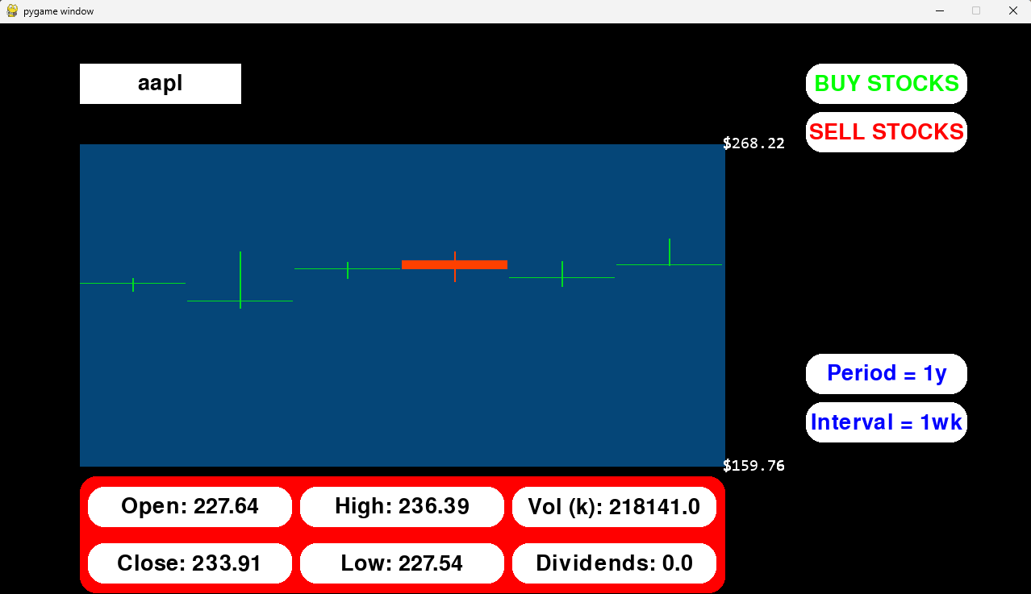
The display boxes for the stats background, displays of data, and the y axis are working. Additionally, the candlesticks are being drawn one at a time now, with the current frame counter working properly. The counter is a new variable created in the stockmarketsimulator class initialiser
self.current_frame = 0
which increments by 1 each frame – in the main loop:
self.current_frame += 1
Stock = goog, colour = (0, 255, 0)
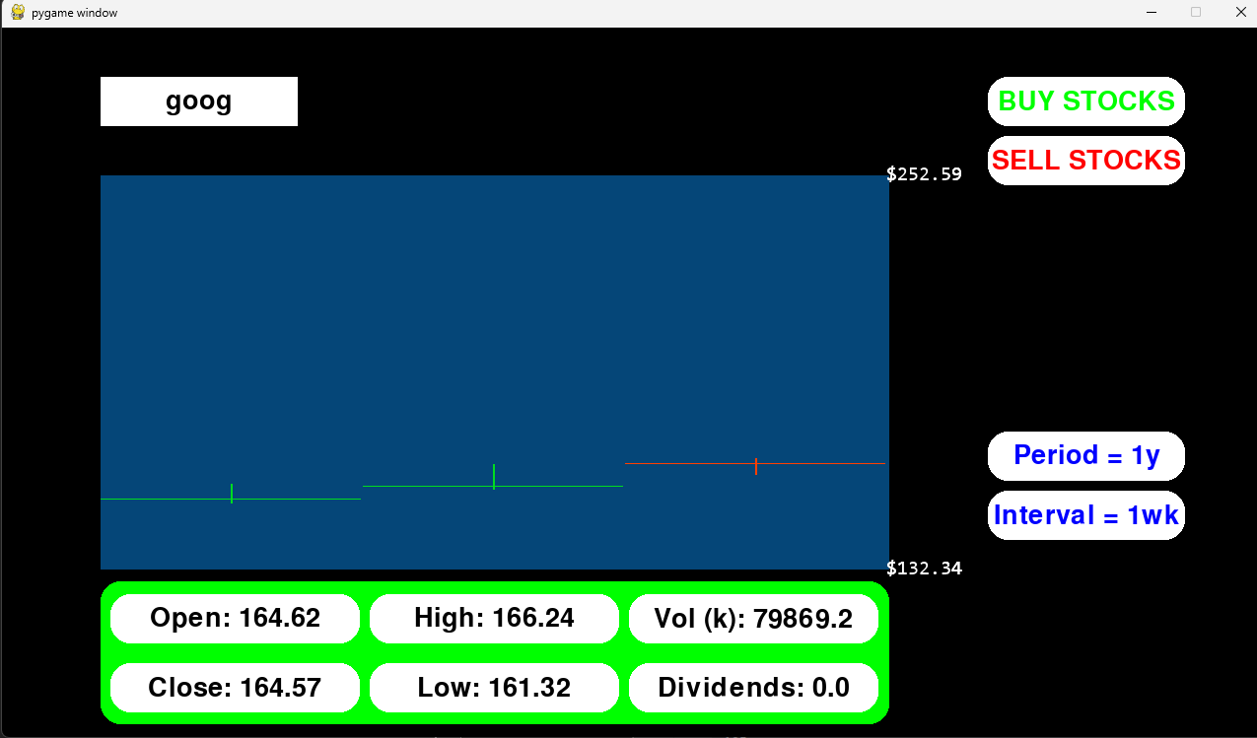
Again, all of the newly created features are, at the base level, working. However, there are a few logic errors in my code. Firstly, the additional displays of data are not displaying the correct values. On first load, the values do not change until the third candlestick has loaded, at which point, the values are not as they should be. On further inspection of my code, I found that the index I used for the updateText function of each box is incorrect – instead of being [i], it should be [self.num_items – 1].
Secondly, I have forgotten to normalise the frame timer. As it currently works, when the graph is loaded, it uses the current frame value to draw a certain number of candlesticks. If the current frame resets when the graph loads, then it will load one candlestick, then two, etc. However, currently its starting value is whatever the current frame value is. This means that if the user waits before loading the graph, the graph may load multiple candlesticks on startup. For example, if the user waits 10 seconds before loading the graph, then on load, the graph will start out by drawing 10 candlesticks. To fix this, I can pass the current frame into the graph’s initialisation function, then take this value away from the current frame passed into the draw function – effectively resetting the frame number to 0 every time a new stock is loaded.
First_loaded_frame is passed to the __init__ function
self.first_loaded_frame = first_loaded_frame

and now normalised_current_frame is used in the calculation to find self.num_items.
normalised_current_frame = current_frame - self.first_loaded_frame
if normalised_current_frame % self.frame_timer == 0:
self.num_items = min(int(normalised_current_frame / self.frame_timer) + 1, len(self.data.low))

Changing values for self.frame_timer:
when frame_timer = 10, there are 3 new candlesticks drawn per second, when frame_timer = 30, one is drawn per second, and when frame_timer = 60, one is drawn every two seconds.
Final code for the graph class:
class Graph:
def __init__(self, screen, rect, data, first_loaded_frame, frame_timer):
self.screen = screen
self.rect = pygame.Rect(rect)
self.first_loaded_frame = first_loaded_frame
self.frame_timer = frame_timer
self.num_items = 1
self.data = data
self.data_min = min(self.data.low)
self.data_max = max(self.data.high)
range = self.data_max - self.data_min
margin = range * 0.1
self.data_min -= margin
self.data_max += margin
self.min_price_box = Box(self.screen, (910, 540, 50, 20), (0,0,0), "consolas", 20, f"${np.round(self.data_min, 2)}", (255,255,255))
self.max_price_box = Box(self.screen, (910, 140, 50, 20), (0,0,0), "consolas", 20, f"${np.round(self.data_max, 2)}", (255,255,255))
self.stock_price = self.data.open[1] # stock price based on the closing price for each data index - more variation than open, but less random like high/low
self.stats_background = Box(self.screen, (100, 562.5, 800, 145), (0, 255, 0), "david", 40, "", (0, 0, 0))
self.open_display_box = Box(self.screen, (110, 575, 253.3, 50), (255, 255, 255), "david", 40, "Open Display", (0, 0, 0))
self.close_display_box = Box(self.screen, (110, 645, 253.3, 50), (255, 255, 255), "david", 40, "Close Display", (0, 0, 0))
self.high_display_box = Box(self.screen, (373.3, 575, 253.3, 50), (255, 255, 255), "david", 40, "High Display", (0, 0, 0))
self.low_display_box = Box(self.screen, (373.3, 645, 253.3, 50), (255, 255, 255), "david", 40, "Low Display", (0, 0, 0))
self.volume_display_box = Box(self.screen, (636.6, 575, 253.3, 50), (255, 255, 255), "david", 40, "Volume Display", (0, 0, 0))
self.dividends_display_box = Box(self.screen, (636.6, 645, 253.3, 50), (255, 255, 255), "david", 40, "Dividends Display", (0, 0, 0))
def data_to_screen(self, data_value):
normalised_y = ((data_value - self.data_min) / (self.data_max - self.data_min))
normalised_y = 1.0 - normalised_y
screen_y = self.rect.y + (normalised_y * self.rect.height)
return screen_y
def draw(self, current_frame):
normalised_current_frame = current_frame - self.first_loaded_frame
if normalised_current_frame % self.frame_timer == 0:
self.num_items = min(int(normalised_current_frame / self.frame_timer) + 1, len(self.data.low))
graph_width = self.rect.width
candle_margin = 2
candle_spacing = np.trunc(graph_width / self.num_items)
candle_width = np.trunc(candle_spacing - candle_margin)
bg_colour = (5, 70, 120)
pygame.draw.rect(self.screen, bg_colour, self.rect) # adds a background colour to the graph rect
for i in range(self.num_items):
x = np.trunc(self.rect.left + (candle_spacing * i))
#pygame.draw.rect(self.screen, (0,0,255), (x, self.rect.y, candle_width, self.rect.height)) # background of candles - shows spacing between candles
open_y = self.data_to_screen(self.data.open[i])
close_y = self.data_to_screen(self.data.close[i])
high_y = self.data_to_screen(self.data.high[i])
low_y = self.data_to_screen(self.data.low[i])
mid_x = x + (candle_width / 2)
if self.data.close[i] >= self.data.open[i]:
candle_colour = (0, 220, 32)
else:
candle_colour = (255, 64, 0)
pygame.draw.line(self.screen, candle_colour, (mid_x, low_y), (mid_x , high_y), width=2) # high-low line
candle_height = max(1, close_y - open_y) # ensures the candle height isnt too small to see
pygame.draw.rect(self.screen, candle_colour, (x, open_y, candle_width, candle_height)) # open-close box
self.min_price_box.draw()
self.max_price_box.draw()
self.stats_background.draw()
self.open_display_box.draw()
self.open_display_box.updateText(f"Open: {np.round(self.data.open[self.num_items - 1], 2)}") # could have put all of this in a for loop but i added the boxes at different times so didnt work out in practice
self.close_display_box.draw()
self.close_display_box.updateText(f"Close: {np.round(self.data.close[self.num_items - 1], 2)}")
self.high_display_box.draw()
self.high_display_box.updateText(f"High: {np.round(self.data.high[self.num_items - 1], 2)}")
self.low_display_box.draw()
self.low_display_box.updateText(f"Low: {np.round(self.data.low[self.num_items - 1], 2)}")
self.volume_display_box.draw()
self.volume_display_box.updateText(f"Vol (k): {self.data.volume[self.num_items - 1] / 1000}") # /1000 allows text to fit in the box even with high volumes
self.dividends_display_box.draw()
self.dividends_display_box.updateText(f"Dividends: {self.data.dividends[self.num_items - 1]}") # probably a useless metric but i have space for 6 boxes - ask stakeholders for feedback
self.stock_price = np.round(self.data.open[self.num_items - 1], 2)

File Organisation
Up until now, I have been neglecting my initial idea of splitting classes into separate files, implementing each feature in the same python file, separating sections of code using classes and whitespace. While this simplistic approach may be appropriate for projects of smaller scope, it is beginning to become confusing and unmaintainable for my more sizeable program. Before I implement more, adding to the amount I will need to separate into different files, I will divide my code into an organised set of files. To do this, I will create appropriately named files for each class and then copy and paste the corresponding code. I will then import whichever libraries and other classes from other files that the file needs. For example, the textinput file will need to import the library pygame for rects and text input, but it will also need to import the button class from the button file to inherit its attributes and methods.
File/Class | Changes
Main | Created a main file which imports pygame and the stockmarketsimulator class. It initialises pygame and the simulator.
StockMarketSimulator | Contains the code for the stockmarketsimulator class. Imports all of the other classes.
Box | Contains the code for the box class. It imports pygame.
Button | Contains the code for the button class. It imports pygame and the box class from the box file to allow button to inherit from box.
TextInput | Contains the code for the textinput class. It imports pygame and the button class
Data | Contains code for the data class. It imports yfinance. I have moved the global period and interval tuples to be global variables in this file, as they are needed for the data class to load data properly.
Graph | Contains code for the graph class. It imports pygame, numpy and box for calculations and drawing.
MainBackup | The previous main file containing all of the code in one file – no changes have been made, but its purpose has been changed to that of an additional backup in case files are lost locally and on my backup server.
I have tested the functionality of my new organised files by successfully loading graphs for multiple stocks. Functionality for basic functionality such as drawing every object properly, correct button and text input. More advanced functionality like drawing the graphs for different stocks with different periods and intervals also remains.
Overall, this makes my code much easier to read and much easier to maintain. It is also more secure, as I can now no longer accidentally edit the code for completed classes – their files will not be opened, so cannot be edited.
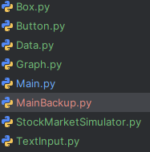

Loading Multiple Stocks

Design
Initially, I planned for each additional stock to be accessible through buttons on a side menu. After giving this more thought, this approach seems impractical. If the user loads too many stocks, then there will not be enough space for all of the buttons to appear on screen, limiting the amount of trading users can do before needing to reset the program. Additionally, my stakeholders Alex and Lydia pointed out that more buttons would clutter the screen and make the program more confusing to use. For ease of use, I will instead adopt the approach of using a singular button to step to the next stock that’s been loaded. Additionally, one button will serve to reduce the amount of visual clutter in the program, making the UI easier to understand and more practical.

Algorithm
This will be a modification of already existing classes - such as the data, graph and stockmarketsimulator classes – not its own separate class. I already have functionality to load data and draw graphs for different stocks, however I need functionality for changing between which stock is drawn. I believe I can do this by adding each loaded stock to an array, then use an indexer attached to a button that changes the current index in the array. The index will point to the current stock whose draw function should run. I should be able to use similar logic to the set_period and set_interval functions in the data class.
global stock_array = []

** inside StockMarketSimulator **

** inside initialisation function **
self.stock_array_pointer = 0

function change_stock
stock_array_pointer = (stock_array_pointer + 1) % len(stock_array)
self.graph = stock_array[stock_array_pointer]
endfunction

** inside the init_simulator function **
** initialise a button **

** inside the run function **
** allow the button to run with the set function change_stock **

** inside StockMarketSimulator load_graph **
stock_array.append(self.graph)

Variables
In StockMarketSimulator
Variable name | Description | Data type
Global_stocks | An initially empty list that will hold the stock objects when they are loaded | List of objects
Self.stock_pointer | An integer value that points to an index in the global_stocks list | Int
Self.button_change_stock | A button object that when pressed increments | Object

Data structures
Data structure | Where in code | Use
list | Global_stocks | A list that holds all of the loaded stock objects

Test data
Variable/function | Explanation of how it will be tested | Test data
Global_stocks, self.stock_pointer and self.button_change_stock | The button will be pressed, resulting in print statements showing the current stock pointer index. The graphs should visually change to the correct stock. | Input “aapl” and “goog” as stocks. Press the button twice.

Implementation
In the global space in the StockMarketSimulator file, and in the class’ initialisation function, ive added the following.
global_stocks = []

self.stock_pointer = 0

A new function in the StockMarketSimulator class
def change_stock(self):
if not global_stocks:
print("no stocks loaded")
else:
self.stock_pointer = (self.stock_pointer + 1) % len(global_stocks)
self.graph = global_stocks[self.stock_pointer]
print(self.stock_pointer)

in the usual init_simulator and run function ive added functionality for the change stock button
self.button_change_stock = Button(self.screen, (1000, 170, 200, 50), (255, 255, 255), "david", 40, "STOCK", (0, 0, 0), (180, 180, 180), (0, 255, 0))

self.button_change_stock.interaction(mousepos, event, self.change_stock)

finally, in StockMarketSimulator’s load_graph function
global_stocks.append(self.graph)

Testing

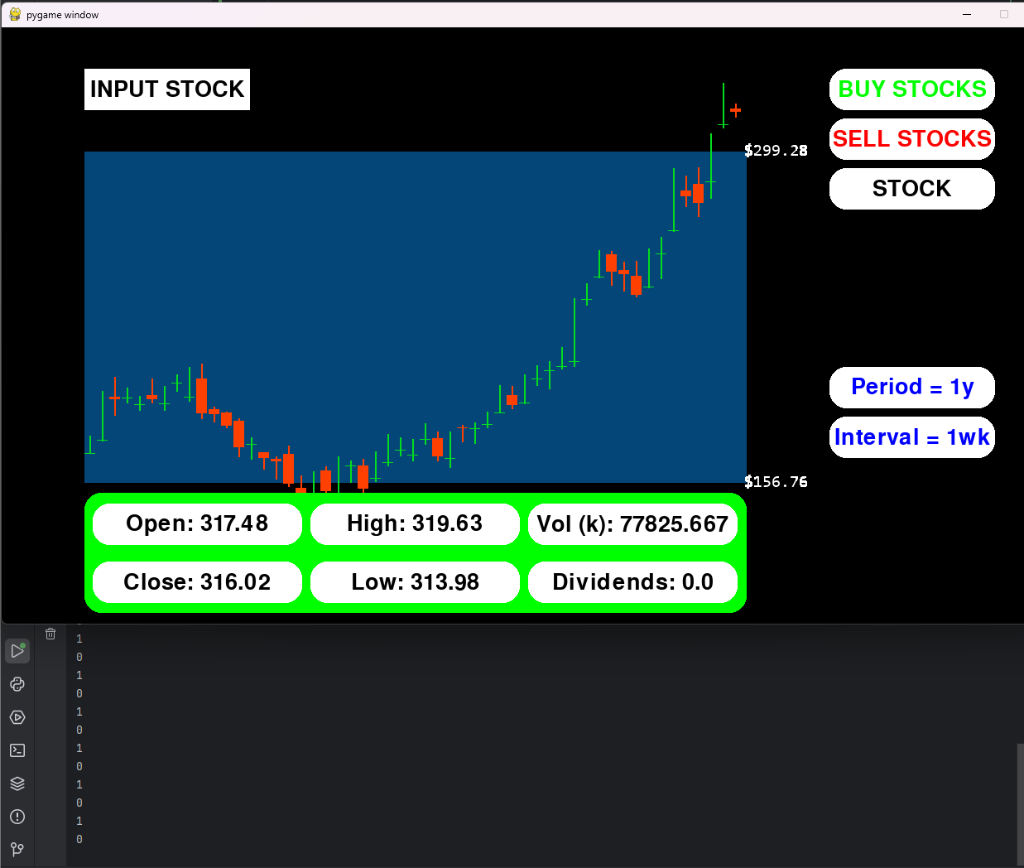
With an input of goog and aapl for the stocks, switching between them updates the stock_pointer variable as desired. It also initially seems to be loading the additional stocks correctly, however on switching them, it is clear that there is some error as the y axis scaling is incorrect. On further investigation, I found that the graphs have the same shape, meaning that the actual data of the first stock is changed to the second, whilst the y scaling is kept consistent with the corresponding stock. The reason why this is happening is because I have one data object to load all of the data. When the data object is changed to load a new stock, the data it holds is also changed, hence changing the data in each of the graph objects. To fix this I can create a new data object for each graph that has to be loaded
I can add this line of code to the load_graph function in the StockMarketSimulator class
self.data = Data()
which gives the desired result
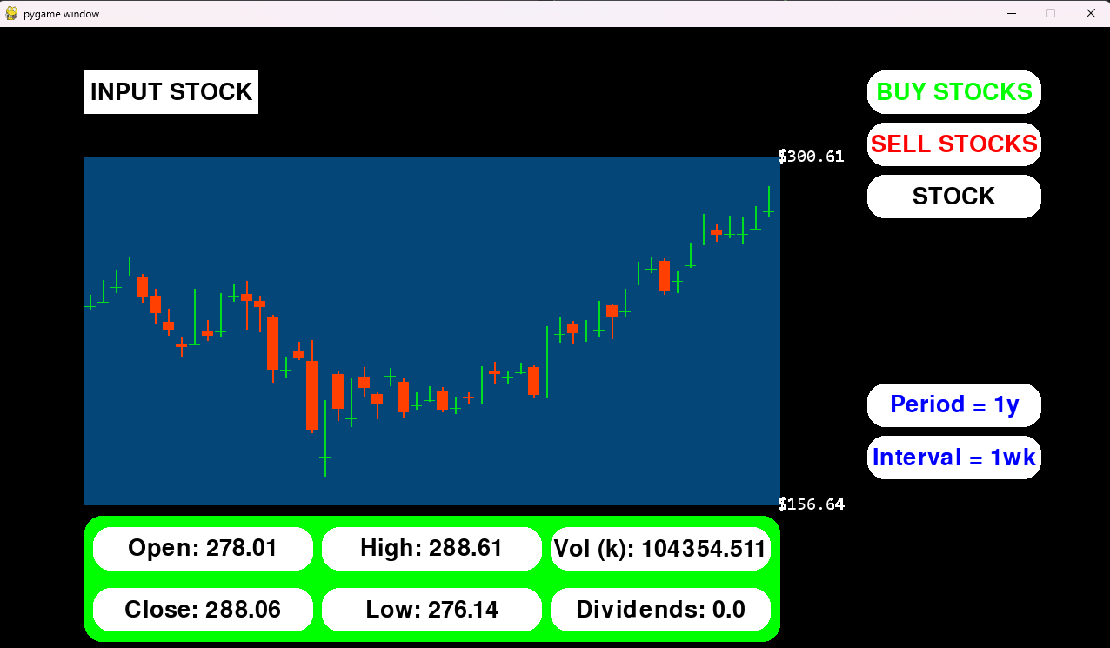

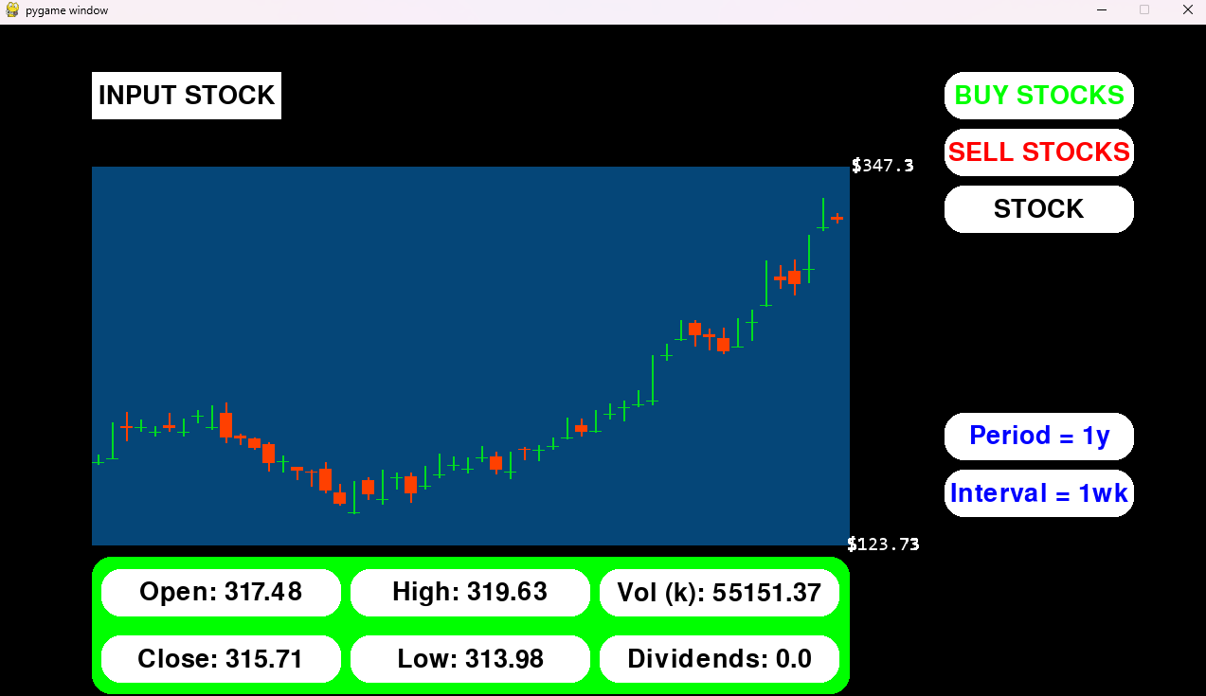
I also then added an additional line of code in the run function by the graph drawing function call to update the text in the stock name box (STOCK box in image above) to display the name of the currently loaded stock. I also moved the draw button call to this section.
self.button_change_stock.updateText(self.graph.data.stockname)
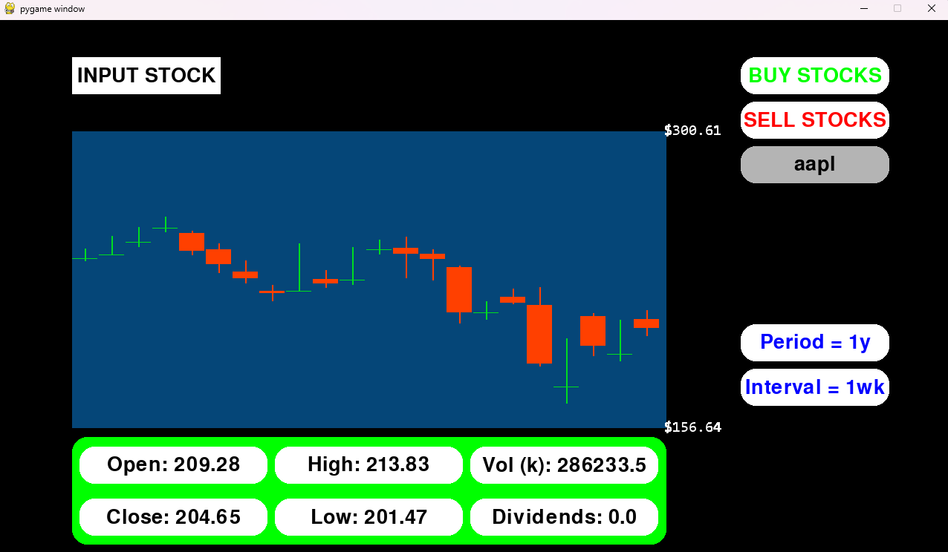

Buying and Selling Stocks

Design
Algorithm
Again, this will be a modification of existing classes, mainly the graph class.
For buying, I can create variables in the graph class that holds the number of shares owned by the user for each stock. I can make a new buying function, where the amount of money the user currently has and the amount of stock they’re buying can be passed. This can then be used in calculations to check they have enough money to buy the stock, then update their total cash and stocks owned. To allow this to work, I can add another attribute to the StockMarketSimulator class, being the total amount of money the user has.
For selling, I follow the buying stock logic but in reverse, converting the number of stocks they’re selling into cash, then adding it to their total cash, while subtracting the stocks sold from their stock total.
To allow the user to buy/sell in different volumes, I will include a button similar to the change period and interval buttons, allowing the user to set the amount of shares to buy.
I will also add another display that shows the total value of the user’s shares across all their stocks.

** inside graph **
** inside initialisation function **
Self.money = 10000
** volume array and pointer allowing for switching volumes **
Self.shares = 0
Self.worth = 0 (later calculate shares * stock price)

** inside buy function **
(passes money and volume as parameters)
Price = self.stock_price * volume
If money >= price:
self.shares += volume
money -= price

** create a sell function with opposite logic to the buy function **

** inside stockmarketsimulator **
** inside initialisation function **
Self.money = (amount of starting money)

** buy and sell functions that link to the graph’s buy and sell **
** portfolio worth function that loops through global_stocks and sums worth values **
** in the rest of the class, create buttons and a function for switching volume, with a display for current money **

Variables
Graph class
Variable name | Description | Data type
Self.shares | An integer value holding the amount of stock owned by the user. Increments when buying stock, decrements when selling. | Int
Self.worth | Holds the total value of shares – share price * shares owned | Float
Self.volume_array and pointer | An array and integer pointer value to point to values in the array. The array will hold strings for different volumes. | Str, Int
Money | A parameter passed into the buy/sell functions that contains data for the user’s current cash amount | Float
Volume | A parameter passed into the buy/sell functions that contains data for the amount of stock the user wishes to buy in one transaction | Int

Data structures
Data structure | Where in code | Use
Self.volume_array | Initialisation in stockmarketsimulator class | Allows for switching between volumes, using a pointer.

Test data
Variable/function | Explanation of how it will be tested | Test data
Buy / sell functions | The user’s current money and stocks will be displayed in boxes | Buy 1 stock of aapl  Sell 1 stock of aapl
Volume | Set the volume to different values using the button, then buy and sell with different values | Buy/ sell with 1, 10, 100 and max stocks
Changing stocks and saving shares owned | Input multiple stocks and check that the amount of stocks bought is consistent | Buy 1 stock of aapl  Load goog  Switch to aapl and observe the amount of stocks owned
Total portfolio worth | Buy shares from multiple stocks and check the total is increasing | Buy stocks from aapl and goog, then sell and observe the change in the portfolio worth value.

Implementation
StockMarketSimulator
self.money = 10000.00
self.volume = "1"
self.volume_array = ["1", "10", "100", "max"]
self.volume_pointer = 0

self.button_change_stock = Button(self.screen, (325, 50, 350, 50), (255, 255, 255), "david", 40, "STOCK", (0, 0, 0), (180, 180, 180), (0, 255, 0))
self.shares_display = Box(self.screen, (700, 50, 200, 50), (255, 255, 255), "david", 40, "SHARES", (0, 0, 0))
self.portfolio_worth_display = Button(self.screen, (1000, 360, 200, 50), (255, 255, 255), "david", 40, "WORTH", (0, 0, 255), (180, 180, 180), (255, 0, 0))

def buy_stocks(self):
self.money = np.round(self.graph.buy(self.money, self.volume), 2)
def sell_stocks(self):
self.money = np.round(self.graph.sell(self.money, self.volume), 2)
def set_volume(self):
self.volume_pointer = (self.volume_pointer + 1) % len(self.volume_array)
self.volume = self.volume_array[self.volume_pointer]
print(self.volume)

def get_portfolio_worth(self):
total_worth = 0
for stock in global_stocks:
total_worth += stock.worth
return total_worth

self.button_buy.interaction(mousepos, event, self.buy_stocks)
self.button_sell.interaction(mousepos, event, self.sell_stocks)
self.button_change_volume.interaction(mousepos, event, self.set_volume)

self.shares_display.updateText(f"SHARES: {self.graph.shares}")
self.shares_display.draw()
self.money_display.updateText(f"MONEY: {self.money}")
self.money_display.draw()
total_money = np.round(self.get_portfolio_worth(), 2)
self.portfolio_worth_display.updateText(f"{total_money}")
self.portfolio_worth_display.draw()

Graph
self.stock_price = self.data.open[1] # stock price based on the closing price for each data index - more variation than open, but less random like high/low
self.shares = 0
self.worth = 0

self.stock_price = np.round(self.data.open[self.num_items - 1], 2)
self.worth = self.shares * self.stock_price

def buy(self, money, volume):
if volume == "max":
volume = money // self.stock_price
price = volume * self.stock_price
else:
price = self.stock_price * int(volume)
if money >= price:
self.shares += int(volume)
money -= price
return money
def sell(self, money, volume):
if volume == "max":
volume = self.shares
volume = int(volume)
revenue = self.stock_price * volume
if self.shares >= volume:
self.shares -= volume
money += revenue
return money
during iterative testing, I found that the volume wasn’t working for different values. This is because the volume values are stored as strings (allows for max value). Hence, I needed to cast volume to an integer.

Testing

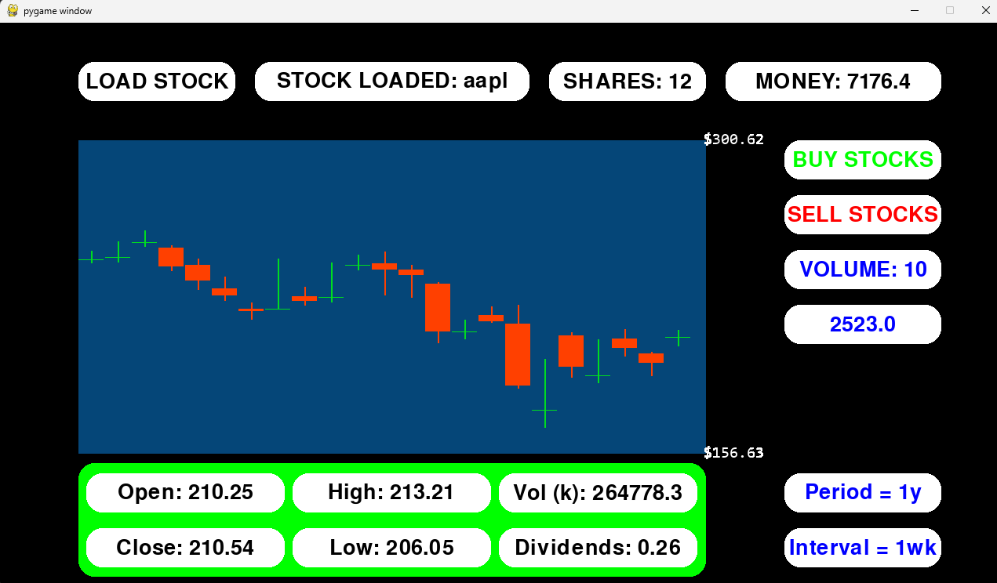
Buying and selling with different volumes works as intended, updating the shares, money and total portfolio worth values. The volume button rotates through values as intended, the same way the period and interval work.
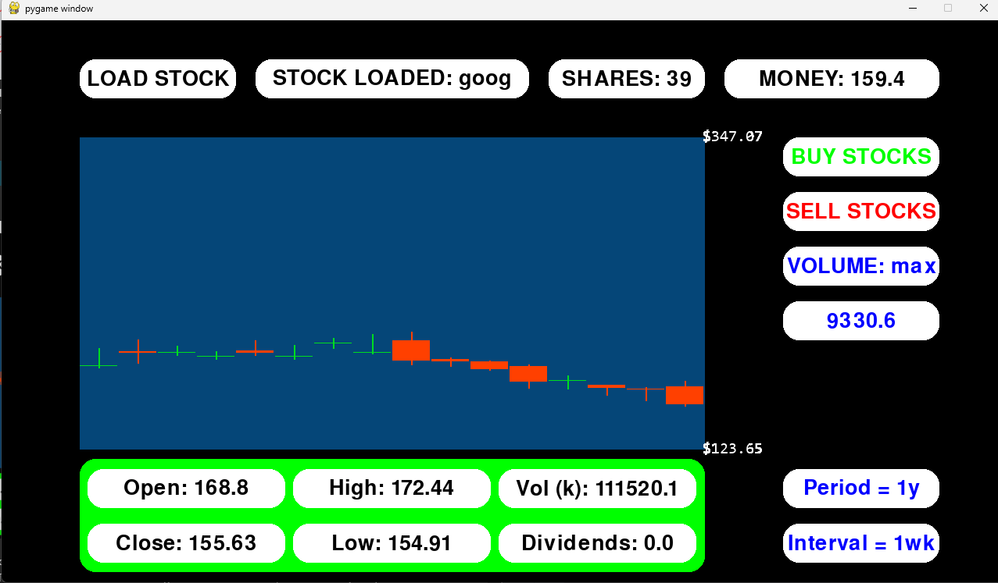
Loading different stocks still works as it did before, and individually the buying and selling works. With multiple stocks, the shares values are still consistent with what they should be (with 12 aapl shares bought before switching to goog). The total portfolio worth is also correctly updated to display the worth of all of the user’s shares if they were sold at that point in time.
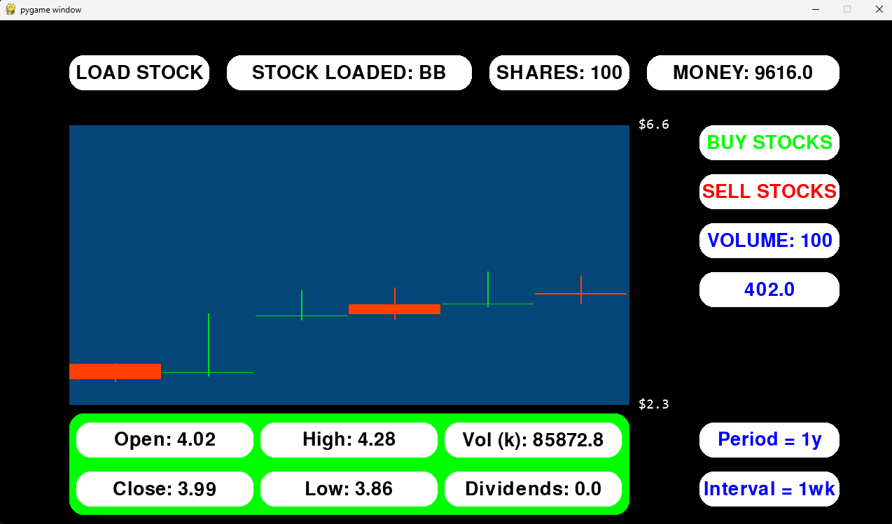
Volumes of 1, 10, 100 and max are all working correctly.

EVALUATION

Final Testing
For this section, I will go through each point in my success criteria, proving functionality of any completed sections. I will prove this through screenshots of the program working as intended, or stakeholder feedback.
I will lay out each test with a short description of what is being tested, followed by a table with the test data, test type (valid, boundary or erroneous), expected result and the result or stakeholder feedback. Any additional screenshots will be labelled and added below.
There will be a copy/paste of each section of the success criteria, with coloured highlighting. Green means completed, yellow means partially completed (completed in a different method to what was initially set), red means incomplete and purple means incomplete at the time of testing, but to be completed in the next iteration.

Initialisation

Initialising a window with pygame
Feature Number | Feature | Explanation
1 | Initialisation | Main simulator class:  - Create a window using pygame – allow for different resolutions  - Set the framerate  - Give the window a title  - Change the icon of the window  - Create the main loop  - Loop through pygame events  - Listen for keyboard and mouse input  - Handle exiting the program – clicking window’s X and esc hotkey

When the program is run, a new window should open, allowing other features to be drawn into the window.
The resolution of the window was initially a factor that I had wanted to change, however it was never implemented. In future iterations, I could add this feature, however in the program’s current state, I would have to change all of the position calculations to scale with resolution, meaning I would have to redo a significant portion of the program. This is not essential to the program’s usability either, as my stakeholders all have 1080p screens, meaning they will be able to view the entire window without issues.
Test data / method | Test type | Intended result | Result
Run the main program | valid | A new window will open | A new window opens (displaying anything drawn to the screen)
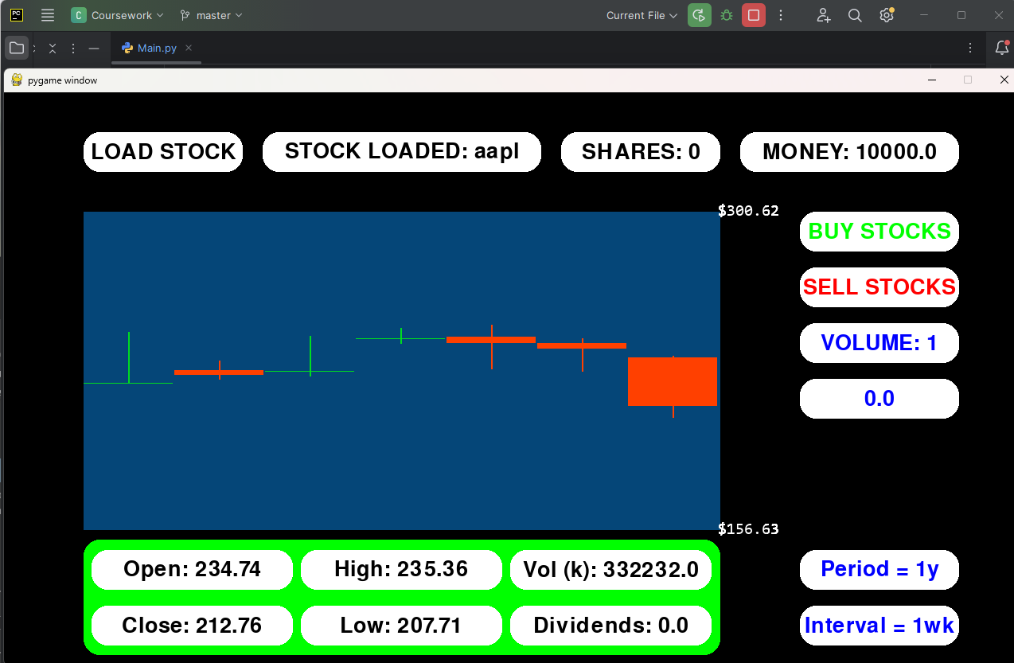

Setting the framerate
By changing the value of the framerate parameter passed into the main simulator class, the framerate should be changed. This will allow for the program to be visually smoother, or more performant.
Test data / method | Test type | Intended result | Result
30 | Valid | The program will work as intended at 30fps | The program works as intended (the screenshot above for initialising a window was taken at 30fps)
240 | Valid | The program will work as intended at 240fps | The program does not run as intended. My stakeholder, Luca, noticed that when running at higher frame rates, the candlesticks load in much faster. The first screenshot below was taken after a similar amount of runtime as the screenshot for 30fps but has loaded many more candles. This is because new candles are drawn in intervals of frames rather than time. Therefore, as more frames are being run per second, more candles are being loaded. See the actions section for the solution I found.
0 | Boundary | Pygame clock.tick(0) allows the framerate to be uncapped, however framerate = 0 might lead to errors in calculations, crashing the program | The program runs as intended until a stock ticker is input. When this happens, calculations using the framerate take place, resulting in modulus by 0 and the program exiting.
-1 | Erroneous | The program will not execute | The program actually runs, displaying everything aside from the contents of the graph, which won’t load as a negative frame would need to be reached to draw a new candle.
for 240fps
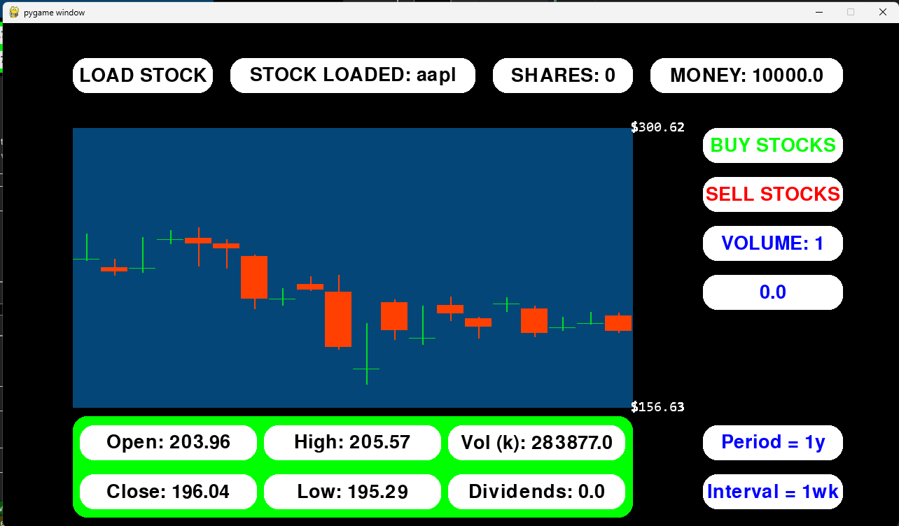
For 0fps
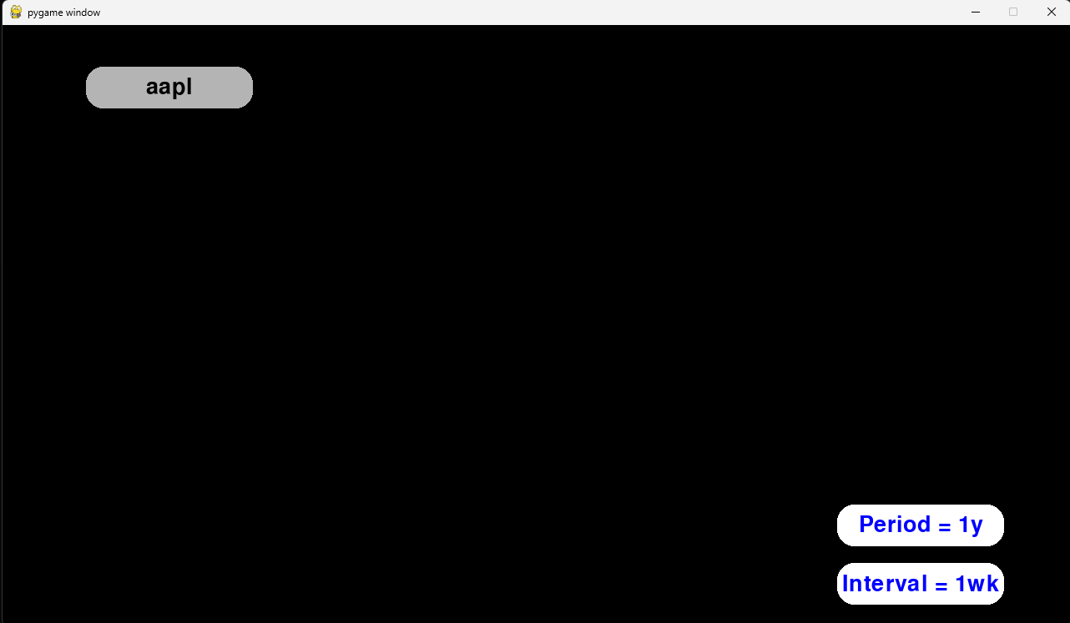
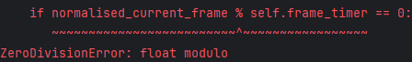
For -1fps
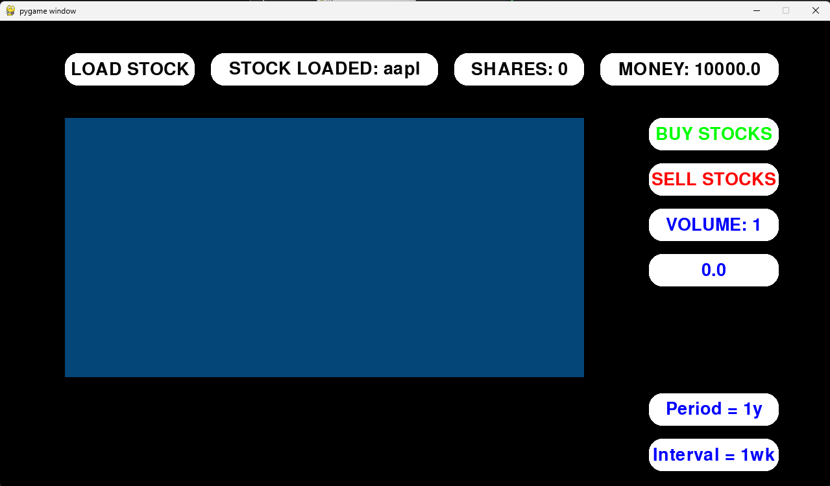

Give the window a title and icon
The icon and text in the top left of the opened pygame window should change to reflect that the program being run is a stock market simulator.
Unfortunately, due to shifting my focus to more essential parts of my project, I have not implemented this yet. However, I can introduce this feature in the future, documenting it in the actions section below, accompanied by a final test.

Create the main loop and loop through pygame events
The program should continue to run when opened, and any functions executed within the loop should be repeated once per frame. Anything being interacted with in the events loop should work as intended.
Test data / method | Test type | Intended result | Result
Run the main program and print self.current_frame | Valid | A new window will open and stay open, with self.current_frame incrementing each frame, showing the loop runs once per frame | The window opens and stays open. Self.current_frame is updated each frame – each time the loop is run – and it’s value is printed, showing how it increments.
Hover over the period selection button | Valid | The colour of the button should change, showing that the events loop is running and checking for interactions | The colour changes as intended.
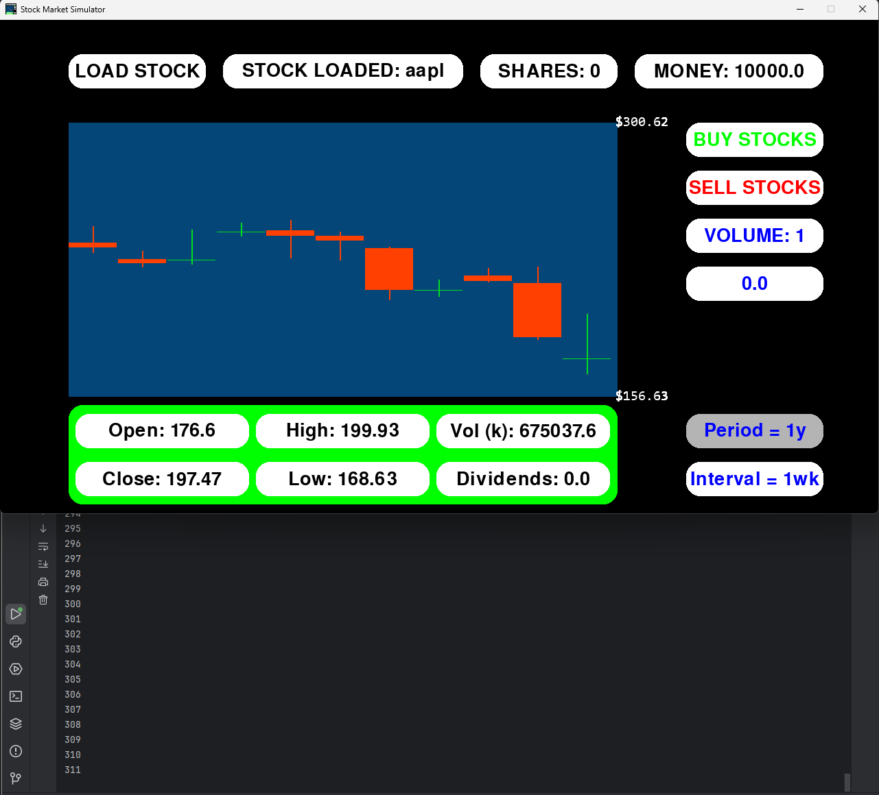
Above, the values for self.current_frame are being printed, showing the loop is running and continually performing functions (in this case being adding 1 to self.current_frame). Additionally, the mouse is hovering over the period button (mouse not captured in screenshot), causing its colour to change, showing the events loop is running.

Listen for keyboard and mouse input
The program should listen for keyboard and mouse input, producing results when certain inputs are given.
Test data / method | Test type | Intended result | Result
Hover over and click the stock input button | Valid | The button will change colour on hover, then the text will disappear on click. | Works as intended
Type text into the clicked stock input button – every key on the keyboard | Valid | The program will listen to the keypresses, adding text to the input box | Works as intended
For mouse hover
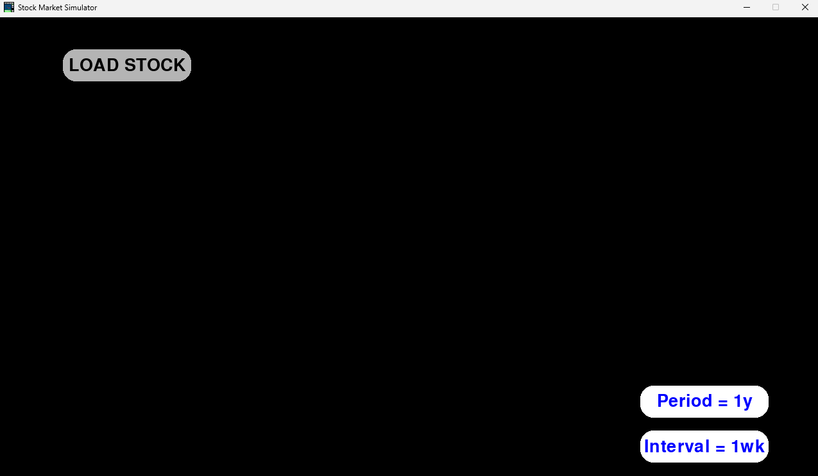
For mouse click
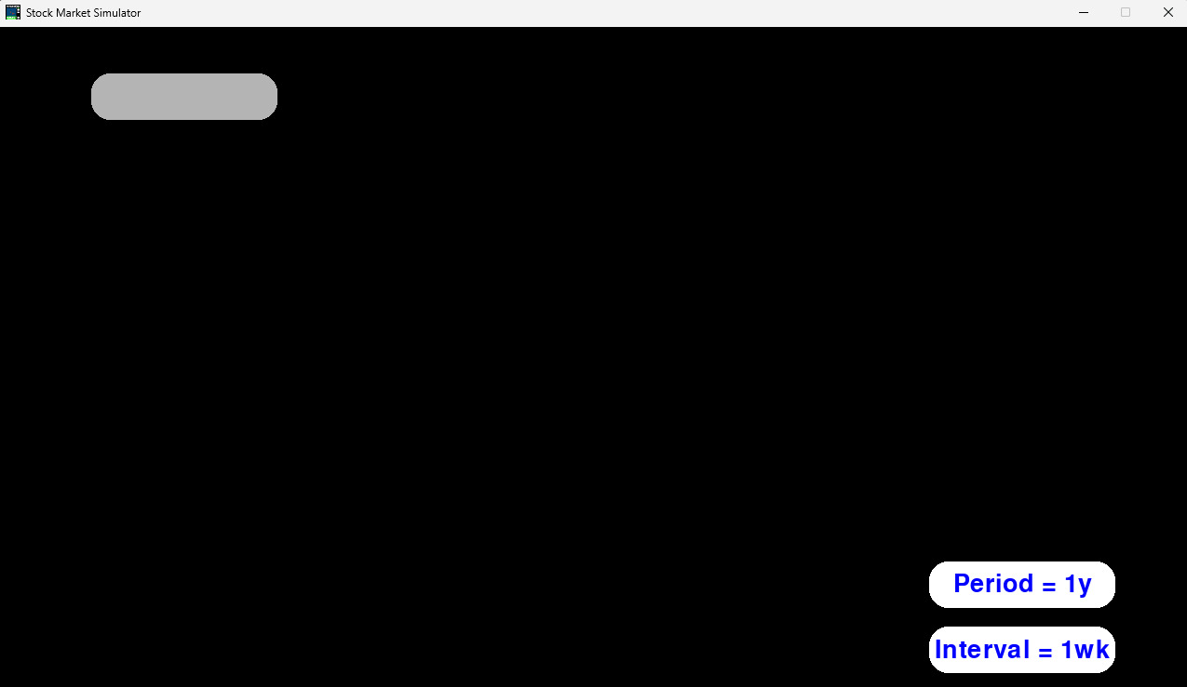
For keyboard input
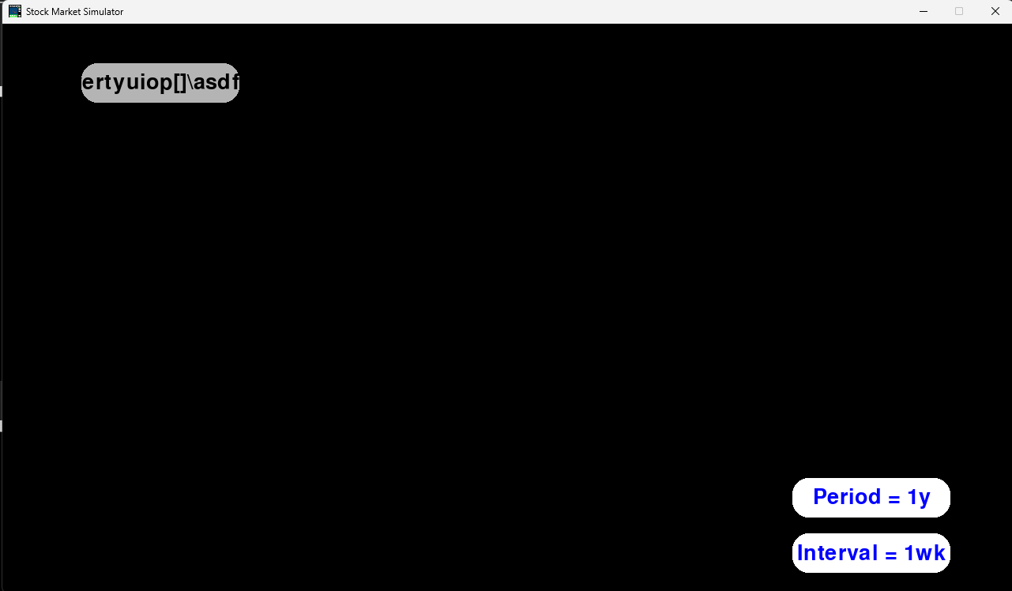
The text box doesn’t visually fit all of the text that has been input, however all keyboard characters will work.

Exiting the program
The program should exit when the X in the corner is clicked, or when the esc key is pressed.
Test data / method | Test type | Intended result | Result
Click the X in the corner of the window | Valid | The program will exit | Works as intended
Press esc on the keyboard | Valid | The program will exit | Works as intended
Unfortunately I cannot provide screenshots, as the program closes, however my stakeholder Mr Etherton has provided feedback on top of my own testing – “Your program closes quickly when clicking the X or pressing the escape key. Also, the escape key makes it much easier to close the window!”. I have also discussed the usability of this feature with my other stakeholders, who have all reassured me that this is working properly, and easy to understand.

Text Boxes

2 | Text boxes | Text box superclass must have functionality for:  - Drawing a box of different size, position and colour  - Adding text of different fonts, sizes and colours

Drawing boxes
A box should be drawn, allowing for different sizes, positions and colours.
I have also added functionality for rounding the edges of the boxes.
For each of the following tests I will instantiate a new box, initialising in the init_simulator function and drawing in the main run function.
Test data / method | Test type | Intended result | Result
Rect (200, 200, 500, 500)  Boxcolour = (255, 0 , 0)  Border_radius = 0 | Valid | This will draw a box of width and length 500 at pixel (200,200). It will be a square with no rounded corners | Works as intended
Rect (200, 200, 100, 200)  Boxcolour = (0, 255, 0)  Border_radius = 20 | Valid | A rectangular box of rounded corners, same position but smaller size | Works as intended
Rect (200, 200, 0, 0)  Boxcolour = (0, 0, 255)  Border_radius = 20 | Boundary | A box will be initialised, but it won’t be visually displayed as it is too small to draw | Works as intended – cannot be seen but causes no errors
Rect (200, 200, -100, -100)  Boxcolour = (255, 255, 255)  Border_radius = 20 | Erroneous | Either the program will crash, it will not display a box, or it will be drawn “backwards”. I think the program will not run. | Actually works, drawing “backwards”.
All boxes implemented
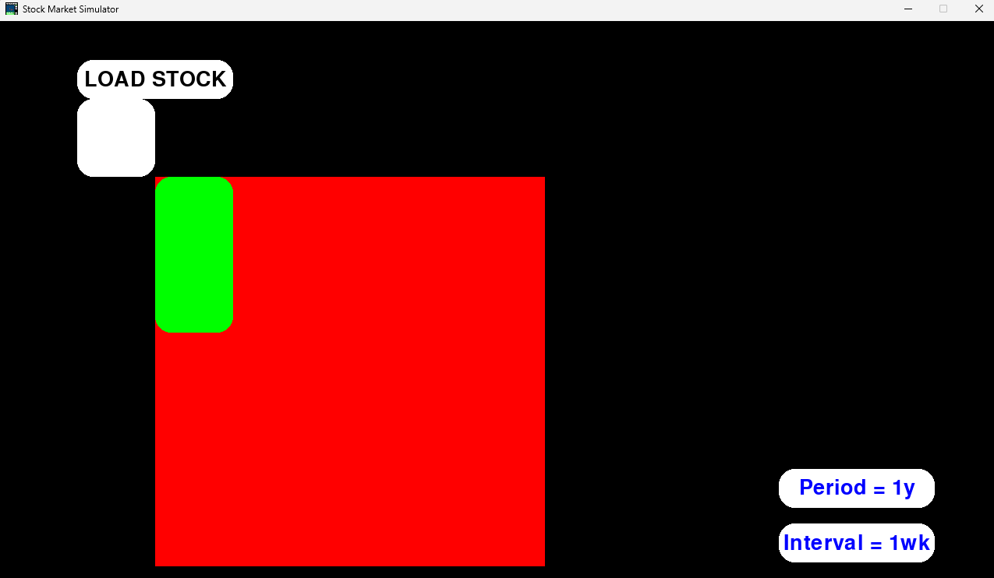

Drawing text
A box should be able to contain text of different fonts, sizes and colours. Different boxes should be able to contain different text.
Above shows boxes with no text (text = “”), so I will not test for no text, as it already works.
Test data / method | Test type | Intended result | Result
Text=”FirstTestText”  Font=”Aptos”  TextSize=100  TextColour=(0, 0, 0) | Valid | The red box will contain the text “FirstTestText” in black with Aptos font and size 100 | Works as intended
Text=”Test2!”  Font=”Algerian”  TextSize=20  TextColour=(255, 255, 255) | Valid | The green box will contain the text “Test2!” in white with Algerian font and size 20 | Works as intended
Text=”NoFont :(“  Font=””  TextSize=100  TextColour=(0, 255, 0) | Boundary | (new test) the red box’s text has no specified font, so will default to the original | Works as intended
Text=”InvalidFont?”  Font=”notafont”  TextSize=100  TextColour=(0,255,0) | Erroneous | An error will be produced, crashing the program. | Actually works, defaulting to the original font
Text=”TooSmallToSee”  Font=”David”  TextSize=0  TextColour=(0,255,0) | Boundary | The text will be drawn but it will be too small to see. | It is actually visible, but only a few pixels, so is unreadable
Text=”FarTooSmallToSee”  Font=”David”  TextSize=-100  TextColour=(0,255,0) | Erroneous | An error will be produced | Produces the same result as small text size

For the first 2 tests
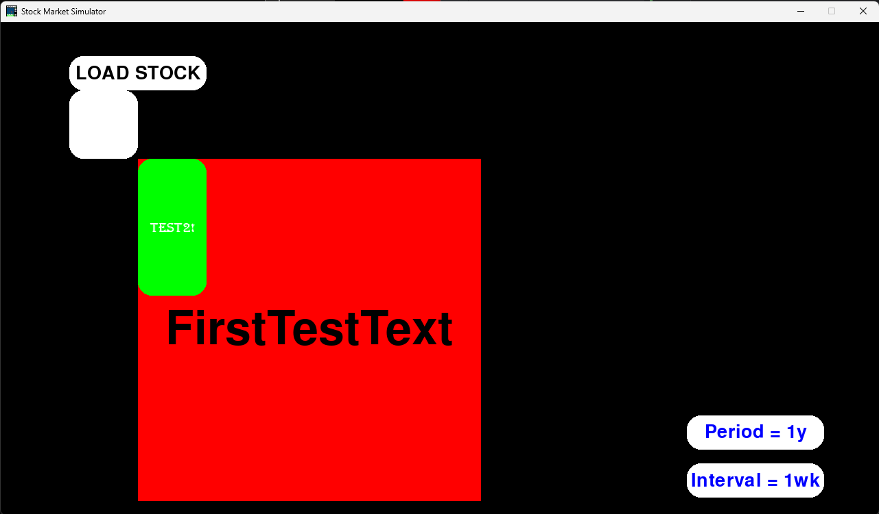
For no font
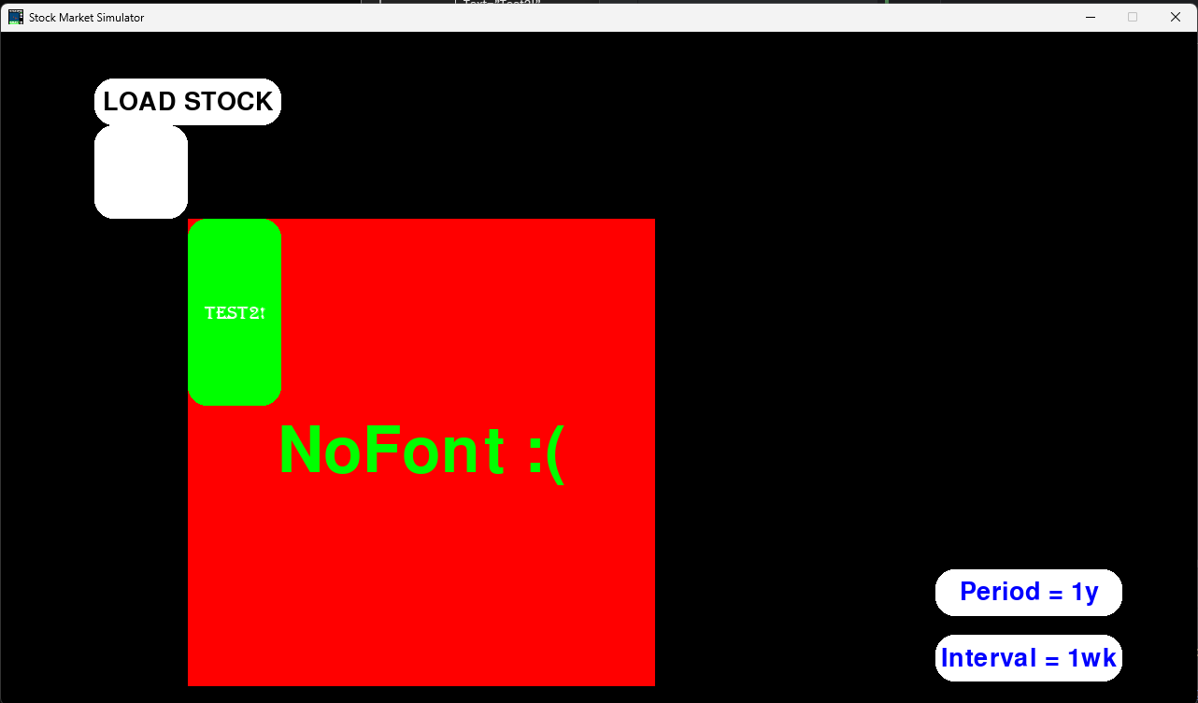
For an invalid font
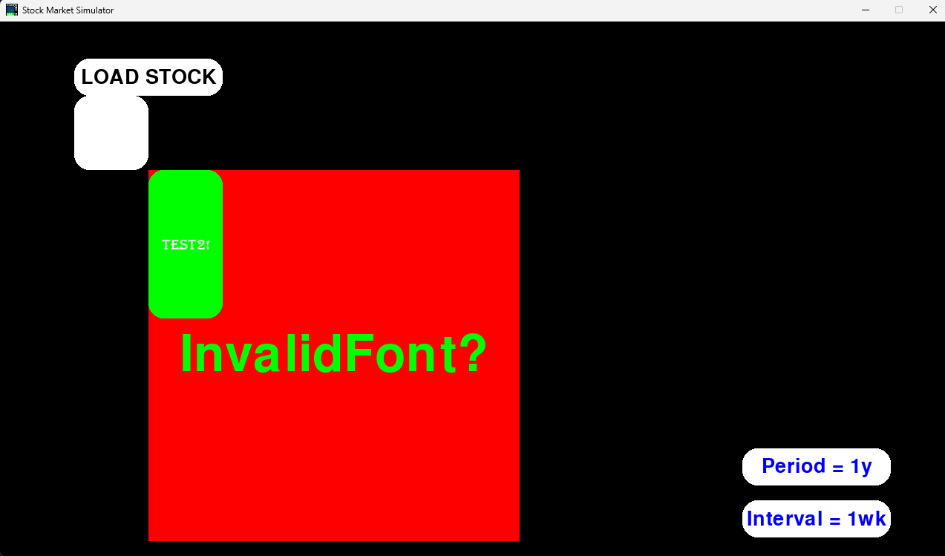
For small text
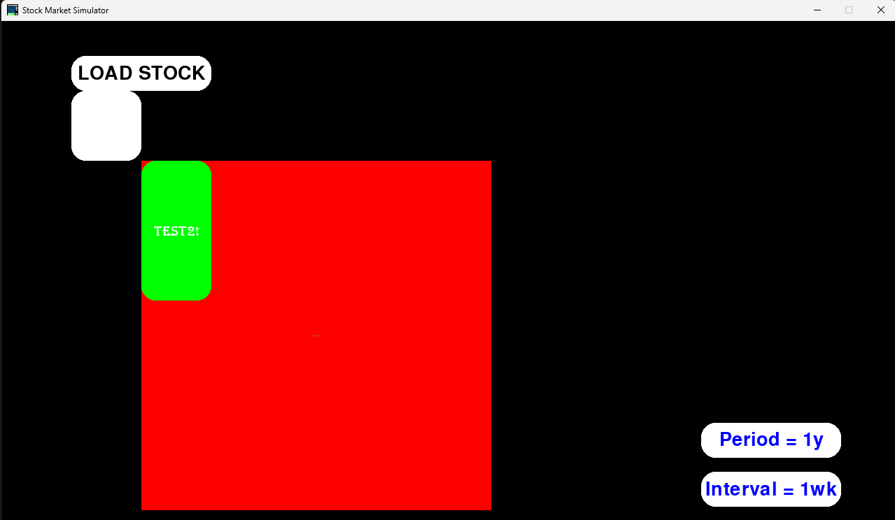
For negative text size
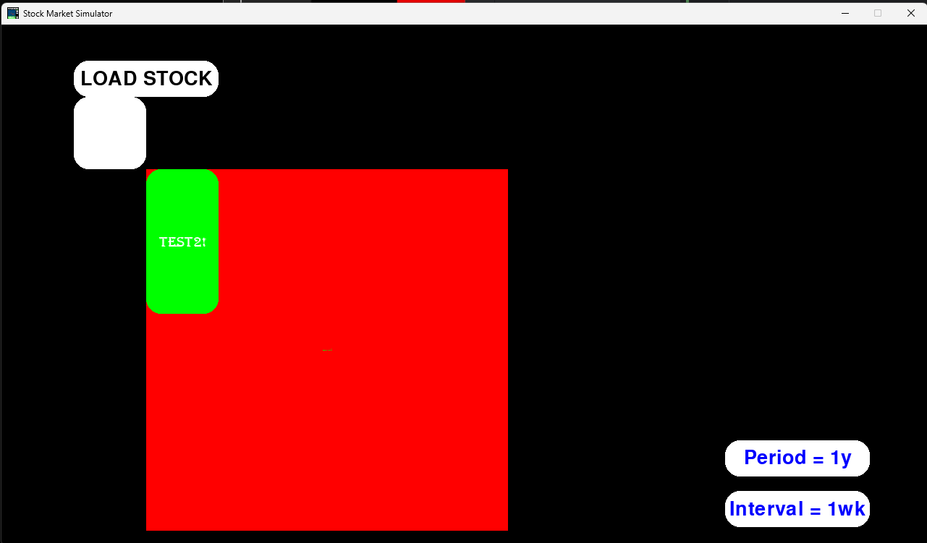

Buttons

Buttons | Buttons can inherit from the text box class, meaning they must have the same base functionality. On top of the text box functions, buttons must have:  - Collision detection with the mouse, creating a hover over effect  - Click detection, creating a click effect and performing a function  I should be able to change:  - Box hover over colour  - Box click colour  - Box click function

Hover interaction – changing colour
When the mouse collides with a button, its box colour should change. It should change back once the mouse moves off the button.
Test data / method | Test type | Intended result | Result
BoxColour = (255,255,255)  HoverColour = (180, 180, 180) | Valid | The box will change colour to grey when hovered over by the user’s mouse. | Works as intended

Before collision
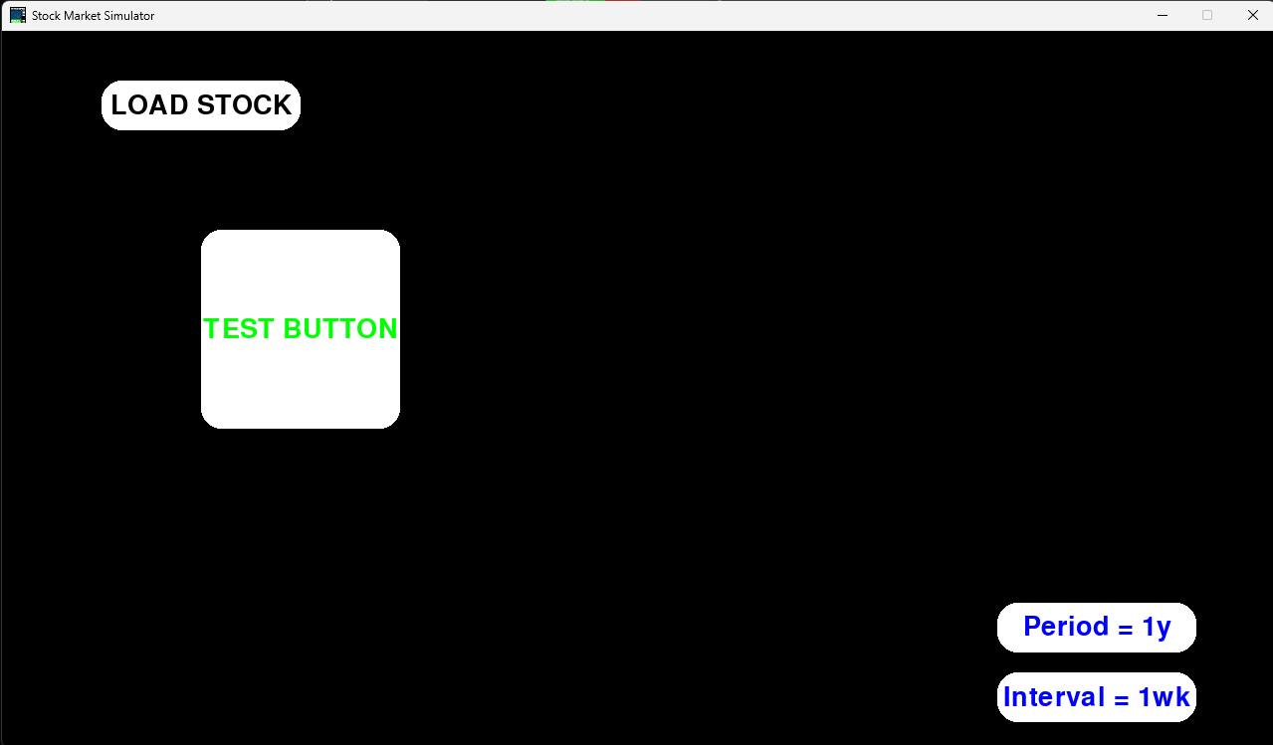

During collision
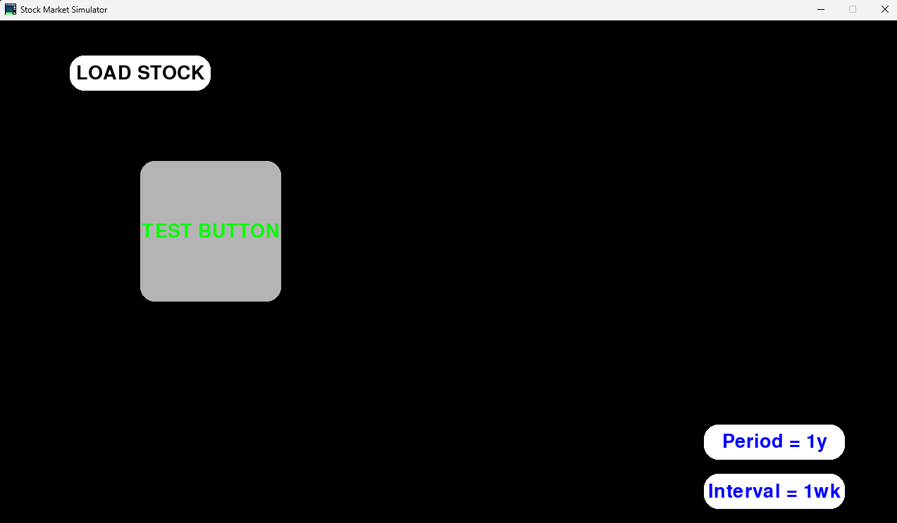
The buttons colour reverts to white after moving the mouse away.

Click interaction – changing colour and function
When a button is clicked, the box colour should change. Additionally, any function the button is set to perform should execute.
Test data / method | Test type | Intended result | Result
ClickColour = (0, 255, 0)  Function = run print function | Valid | The box will change colour to green when clicked, and a function will be run, printing a message to the console | Works as intended. On each click, the button changes to green for the duration of the click. Additionally, the function is executed, printing a single message to the console.

I cant get a screenshot for when the button is clicked, but it does work.
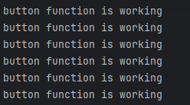

Text Input Boxes

4 | Text input | Similarly to buttons, text input can inherit from the text box class, building on its functionality. Text input boxes must have:  - Click detection, changing the colour of the box and allowing the user to type, updating the box with their text.  - Functionality for entering text. When a hotkey (enter) is pressed, the text typed should be taken as an input  I should be able to change:  - Text input box click colour  - Text input function  - Size, colour and font of text input

Click detection and typing
Input boxes, when clicked, should allow the user to type and input data into a function. They should be able to see what they are typing into the box.
Text input boxes inherit from the button class, which inherits from the box class, so all of the box and button functionality will also work.
Test data / method | Test type | Intended result | Result
Click on the box and type “Ab12#.” | Valid | Once clicked, I can type the text in, with it being displayed. The typed text will stay displayed until the mouse is no longer hovering, and the text will stay saved until deleted by the user. | Works as intended. Before clicking the box displays set text. Once clicked it displays the user’s text. Once the mouse is taken away, the original text returns, but if it is clicked again, the user’s text reappears.

Before clicking and typing
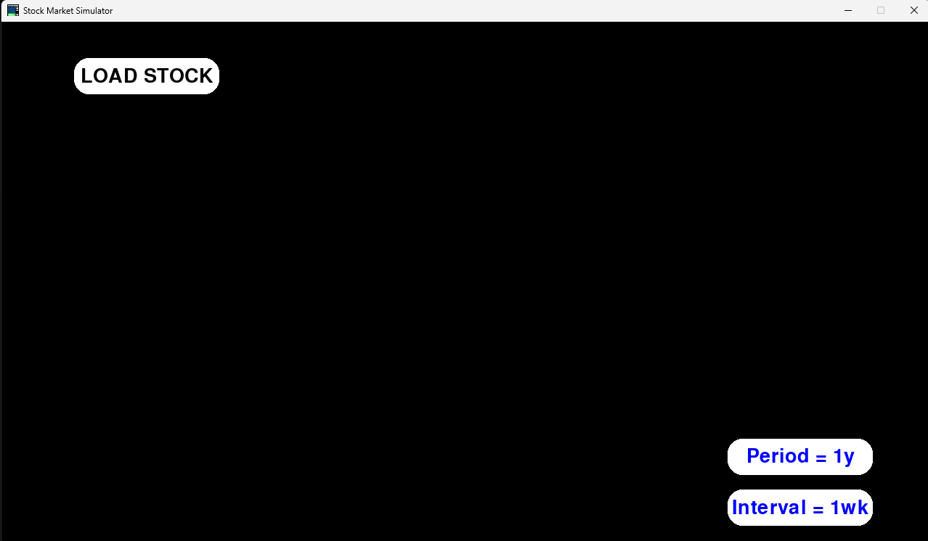

After clicking and typing
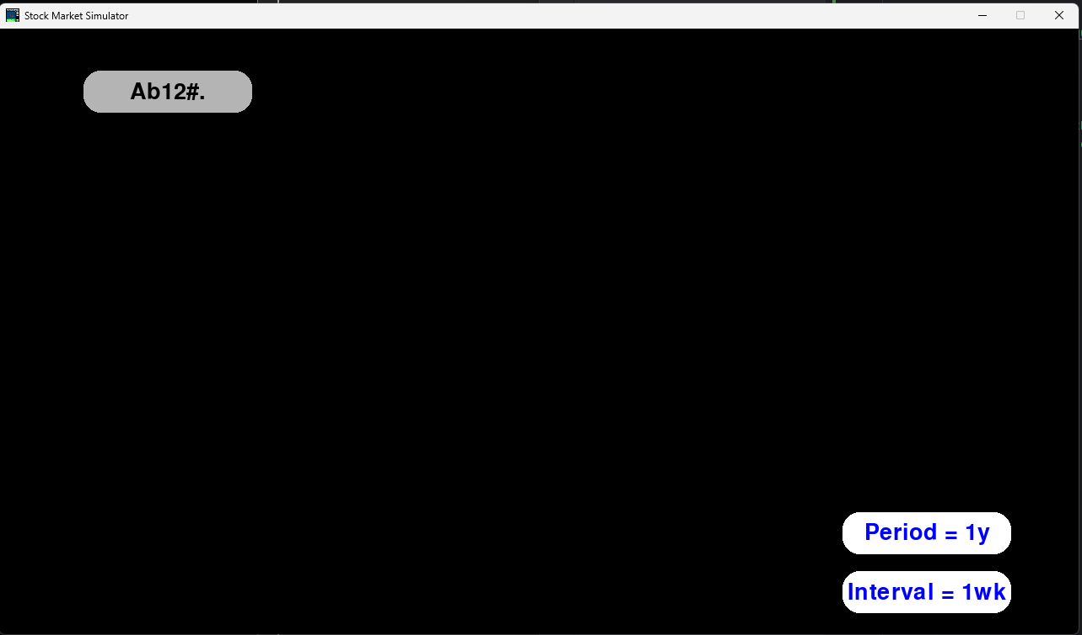

Entering text as an input to a function
The user should be able to press the enter key after typing into a text box, inputting that data into a function. Optional validation has been added to this
Test data / method | Test type | Intended result | Result
Function = load graph  Input = “aapl”  Max input length = 5 | Valid | The graph for apple will load | Works as intended, loading the graph for apple stock.
Same function for the rest  Input = “thisinputistoolong” | Erroneous | An error message will be printed to the console and the input wont go through | Works as intended, stopping the input and sending an error message
Input = “” | Erroneous | Same result as previous test | Works as intended, same as above
Input = “12345” | Boundary | Allows for input, as it doesn’t exceed the maximum input size | Works as intended

For a valid input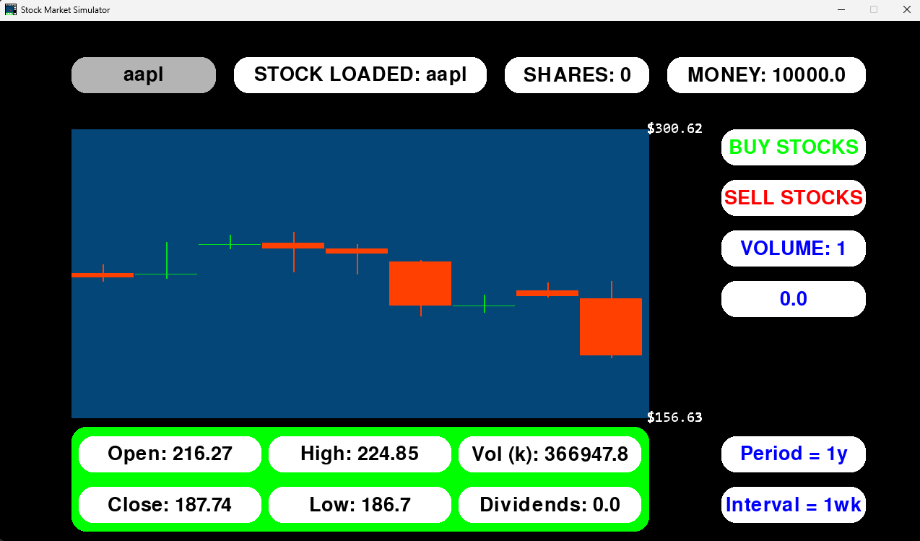

For invalid inputs
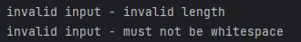

Data Retrieval

5 | Loading ticker data | Class for data retrieval should allow for:  - Different tickers  - Different time frames  - Different intervals  It should return the data in an array.

Different tickers, time frames and intervals
The data class should be able to retrieve data for different stocks, spanning different time frames and intervals.
Test data / method | Test type | Intended result | Result
Stock=”aapl”  Period=”1yr”  Interval=”1wk” | Valid | The data for apple stock will be fetched – 52 pieces of data spanning a year | Works as intended. The last few loaded pieces of data are displayed below
Stock=”meta”  Period=”1mo”  Interval=”1d” | Valid | The data for meta stock will be fetched – 30 pieces of data spanning a month | Works as intended after fixing a few bugs (in actions)
Stock=”P5KG”  Period=”1y”  Interval=”1wk” | Erroneous | P5KG is an invalid ticker, so the program will return an error message to console and wont retrieve data. | Works as intended after fixing a bug
Stock=”aapl”  Period=”1mo”  Interval=”3mo” | Erroneous | The period is less than the interval, so no data will load. | Works as intended

For aapl stock
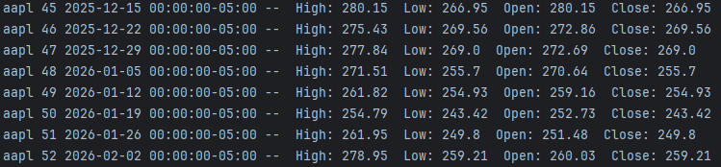

For meta stock (there are sometimes less values in a month so not full 30/31)
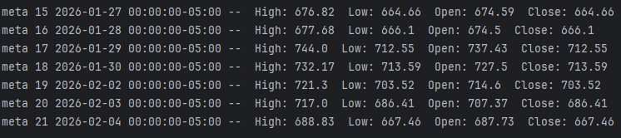

For invalid stock name

Graph

6 | Drawing axes | A method in the graph drawing class that draws an x and y axis of specified:  - Positions  - Lengths  - Widths  - Colours
7 | Labelling axes | Another part of the graph class.  Should be able to:  - Add titles to the axes (potentially using text boxes)  - Add labelling to the axes, determining correct spacing and values to display (for example, if the y axis goes up in 100 or 10,000, and if each label is 10 pixels apart or 50)
8 | Candlestick plots | Separate class that the graph class calls. It needs to use data gathered to:  - Display open, close, low and high data for the specific time it is placed at.  It should be able to:  - Change position  - Change size  - Change colour (to display if the price is increasing or decreasing)
9 | Drawing plots | Part of the graph class. Needs to ensure:  - Plots are placed in the correct time relative to the x axis and are spaced correctly, filling the whole space of the graph, but not exceeding it.  - The height of the candlestick plots is correct, matching the y axis labels.  - The width of the candlestick plots are correct, making sure they don’t overlap.
10 | Additional display of information | Using text boxes, more data fetched using the data loader class can be displayed. For example, this could include volume, range, market cap and more.
11 | Side menu for navigating stocks | Buttons can be added to the side of the screen to switch between any loaded stocks. A button should be created when a new stock is loaded. Aspects of the button that should change are:  - The position (lower as more stocks are loaded)  - The text inside the box displaying the stock that is loaded
12 | Ability to buy/sell, with different volumes | The user should be able to change the amount of stocks they buy at once. This should be implemented as:  - A number of buttons that change a variable in the buy/sell function (for example, from 1 to 10, meaning the amount of stocks bought will be 1 * 10 = 10)  - Specifically, there should be a 1x, 10x, 100x, max and text input button. 1-100x buys/sells that many stocks, with the max one trading the highest amount possible with current cash/stocks owned. Text input will allow users to trade exactly how much they would like at once.  For buying and selling there must be functions that:  - Take the value of the volume variable and multiply the price of one stock by that number to calculate total buy/sell price  - If buying, there should be checks to ensure the user has enough money to buy the number of stocks they want. If not, it should return an error message, However, if they have the funds, they should gain stocks and lose the correct amount of money.  - If selling, there should be a check to ensure the user has enough stocks to sell. If they don’t, return an error, otherwise, give them the correct amount of money in return for the correct number of stocks
13 | Current portfolio price tracker | A specific text box display that shows the user their total current balance, total number of stocks, and the total price of their stocks if they were to sell at that point in time. The text in the box should be able to change colour, indicating overall profit/loss.

Drawing axes
The axes for the graph should be able to be drawn with different positions, lengths, widths and colours.
In my final approach to the graph, I changed my criteria for what would result in a polished product. I determined that axes were unnecessary and a complex solution to a simple problem. As such, I took a different approach, instead giving the graph’s rect a solid colour to show the borders of the graph. Even with this method, it is possible to change the position, length and colour, alongside the width if the code is slightly altered. I will test for all of these for the graph background
Test data / method | Test type | Intended result | Result
Rect=(100,150,800,400)  Colour=(255,0,0) | Valid | The graph background will be drawn with the rect dimensions and colour red | Works as intended
Rect=(150,50,400,200)  Colour=(0,255,0) | Valid | The graph background will be drawn with the rect dimensions and colour green | Works as intended
Rect(100,150,800,400)  Colour=(0,0,255)  Width=2 | Valid | By adding a width parameter to the draw.rect, it will only draw a blue border | Works as intended

For red background
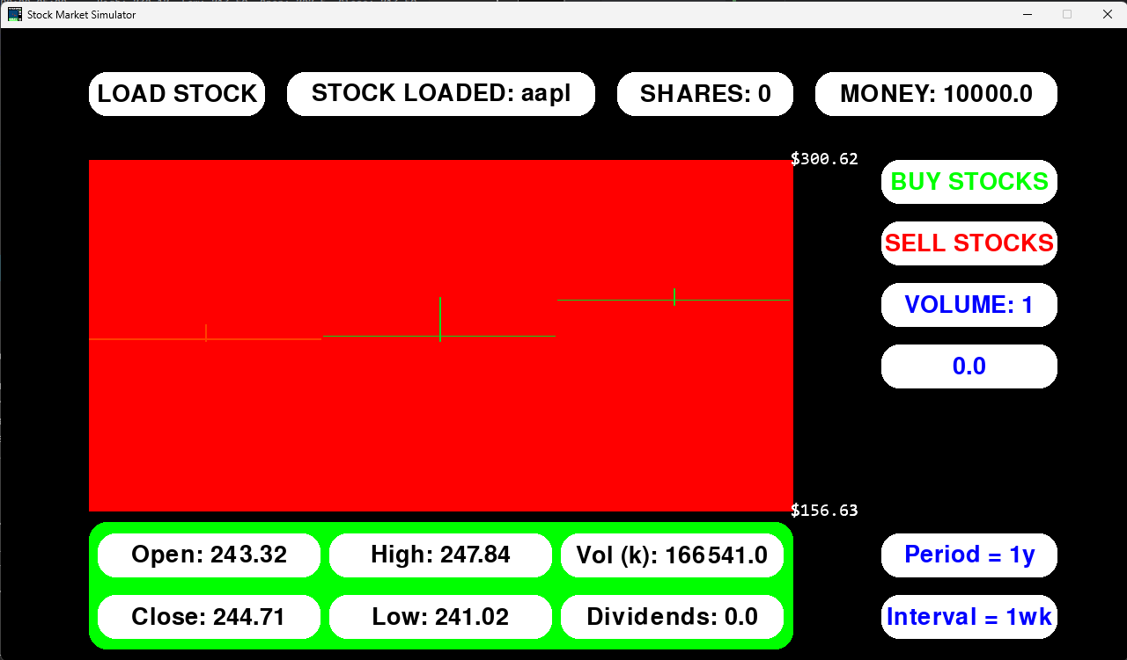

For green background
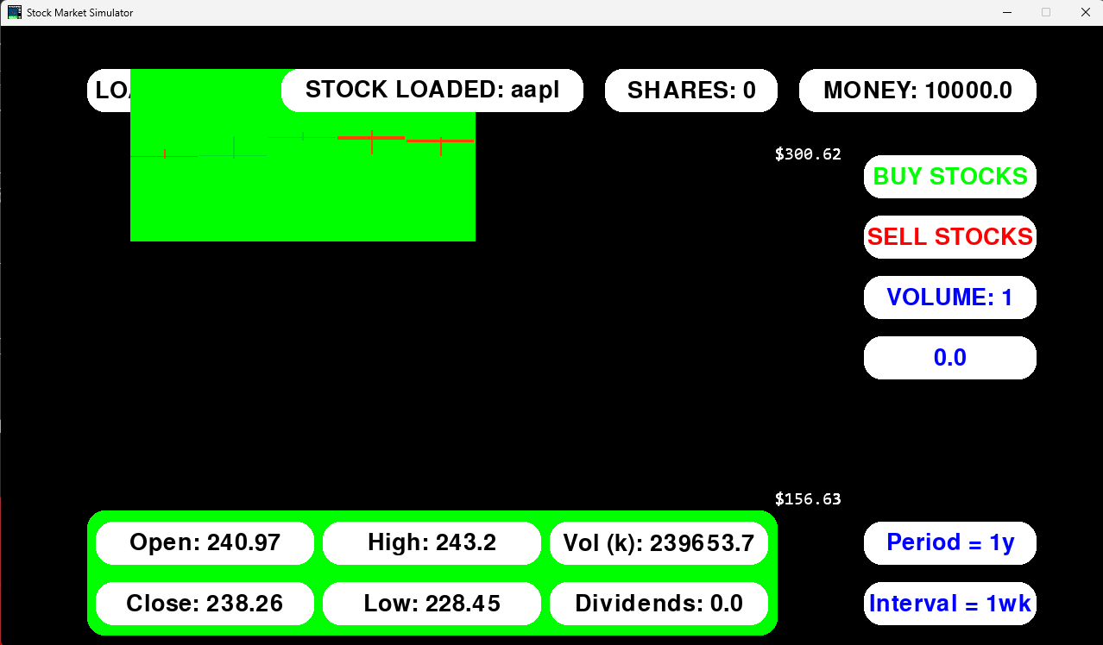

For blue background
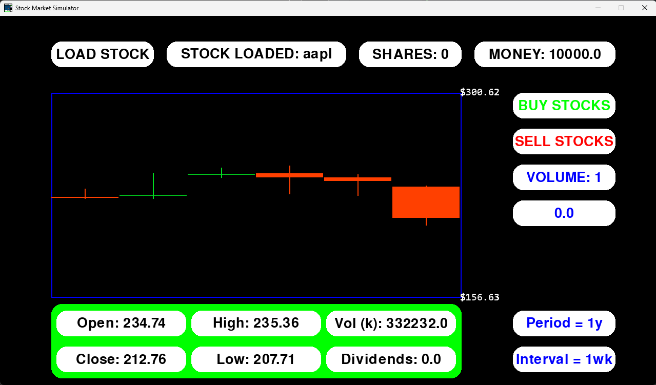

Labelling axes
The axes should have titles and spaced labelling.
This is another feature that I have implemented in a different way to how I initially planned. Since the x axis and y axis will always be displaying time and stock price, I felt it was unnecessary to include axis labels, as they would only serve to clutter the screen with useless information, making the program more confusing and harder to use.
Likewise, labels for the x axis are not important, as a stock price at a specific time is not useful to my stakeholders. Regardless, they can deduce the date using the set period and interval values should they feel a need to use it.
On the other hand, labels for the y axis are very important, giving the user an idea of how the price is changing over time. However, to keep the program simple to use and easy to look at, I decided to include only a maximum and minimum price label, to show the range of price values. Alongside the graph’s visual representation of the price, my stakeholders have expressed that this is enough information to make informed decisions, without sacrificing on information or visual clarity.
Hence, I will test for if the max and min price boxes load properly with different stocks
Test data / method | Test type | Intended result | Result
Stock=”aapl” | Valid | It will display correct max/min prices | Works as intended
Stock=”meta” | Valid | It will display correct max/min prices | Works as intended

For aapl
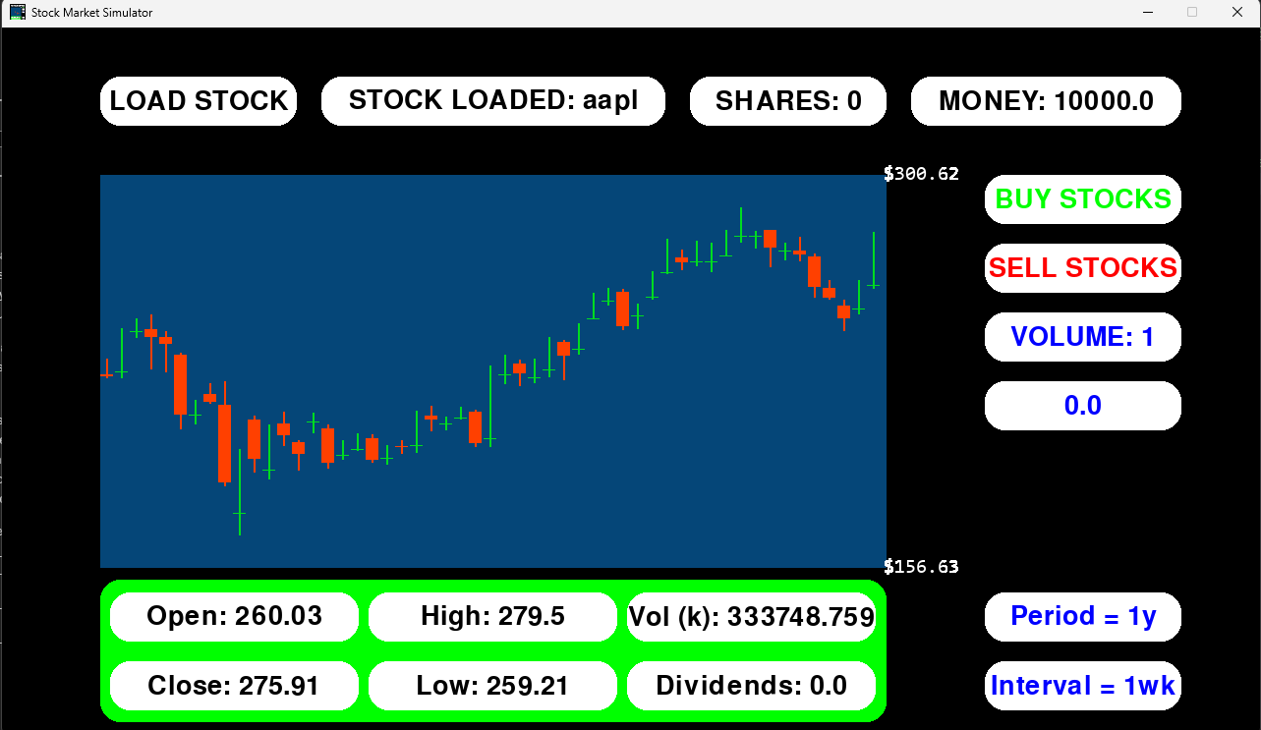

For meta
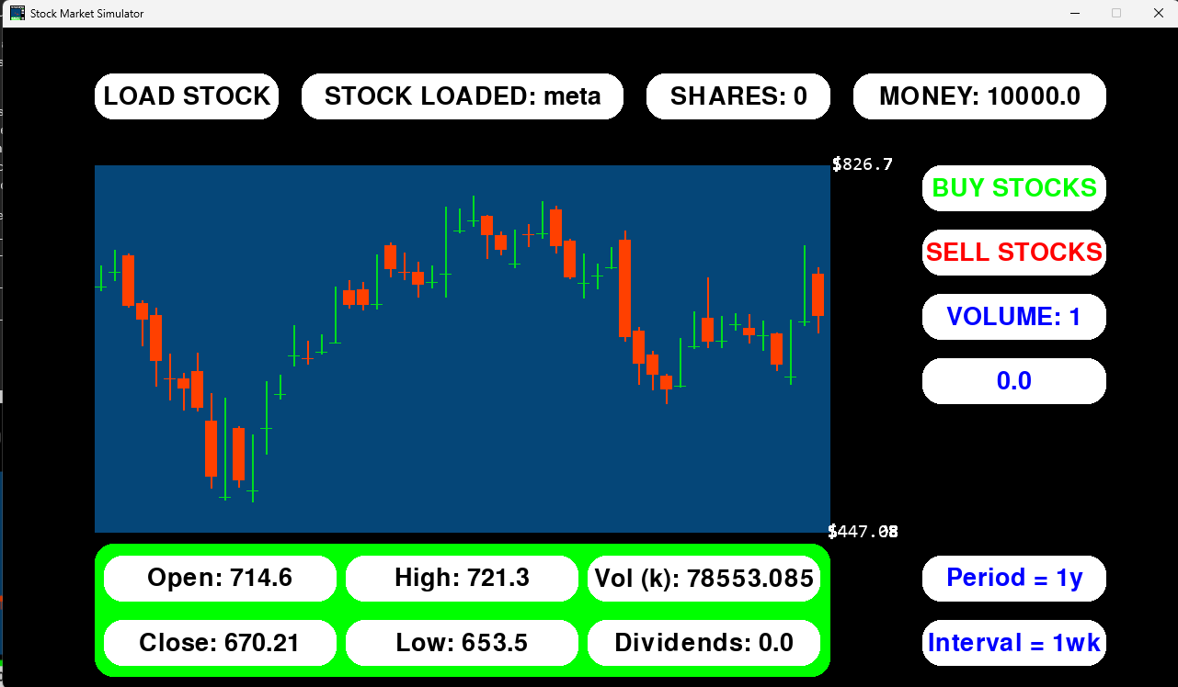

Candlestick plots
The candlestick plots should be able to change position and size relative to the x and y axis. They should also be able to change colour depending on if the price is increasing or decreasing over time.
Test data / method | Test type | Intended result | Result
Load aapl stock (for each test)  observe each newly loaded candlestick is spaced evenly across the x axis | Valid | There should be equal space between the candlesticks. There may be a gap at the end of the graph due to decimal values not aligning with screen pixels. | Works as intended – although with a slight unavoidable bug. First screenshot shows it working properly, with second showing the slight spacing at the right end of the x axis.
Observe that the candlesticks portray the correct data – size correlates to data in boxes below | Valid | The heights of the features of each candle should align with the data it holds. | Works as intended.
Observe that candlesticks change colour (green/red) to display if the price is increasing or decreasing during that time frame | Valid | If the open is greater than the close, then it should be red, otherwise it should be green. | Works as intended.

For observing the x axis spacing
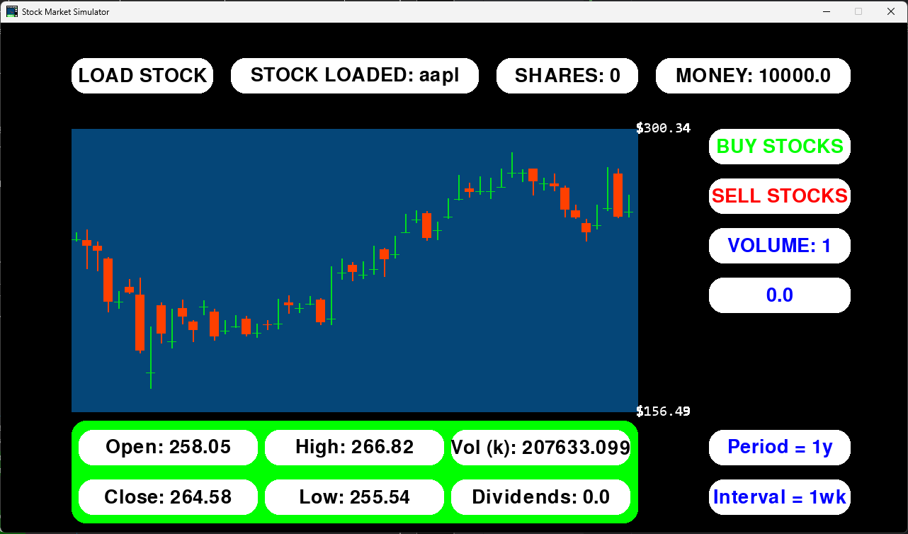
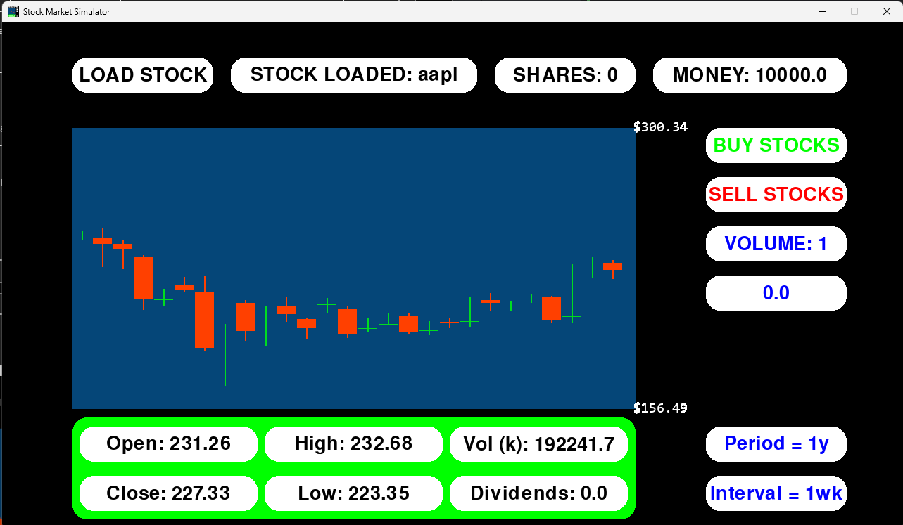

For candlestick size
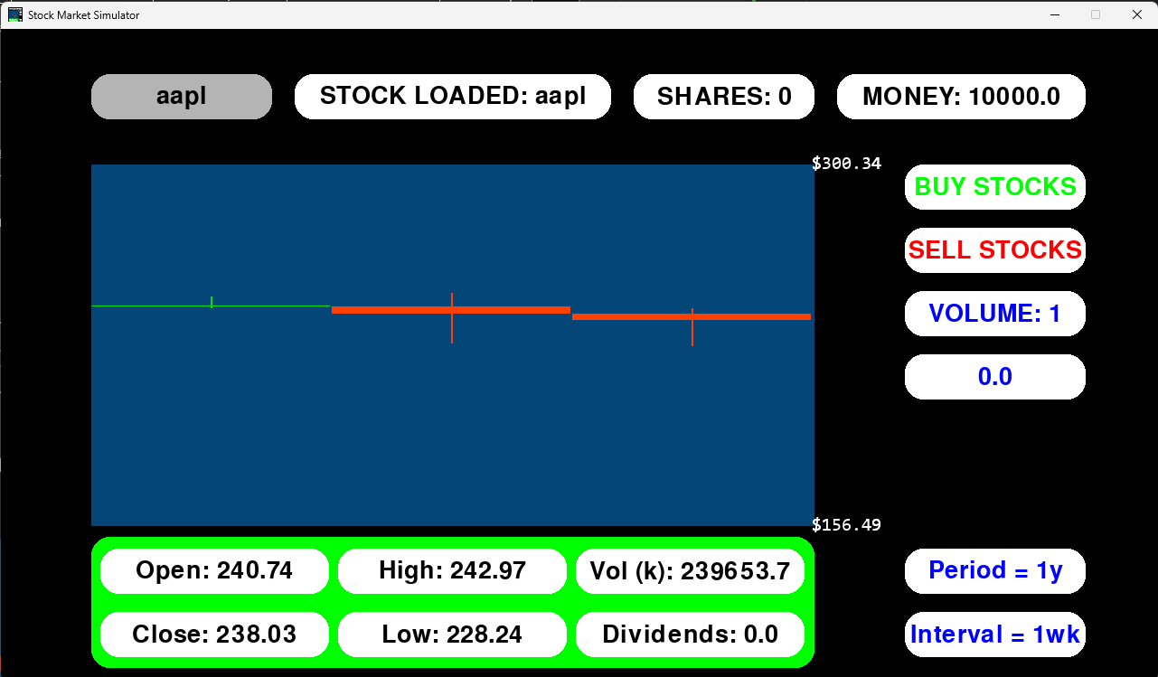

For candlestick colour – 1st screenshot close>open so final candlestick green, 2nd close<open so red
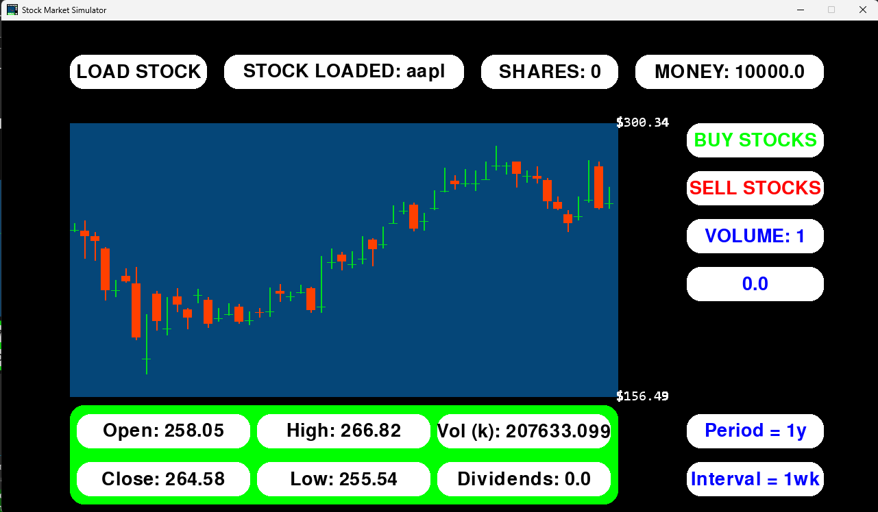
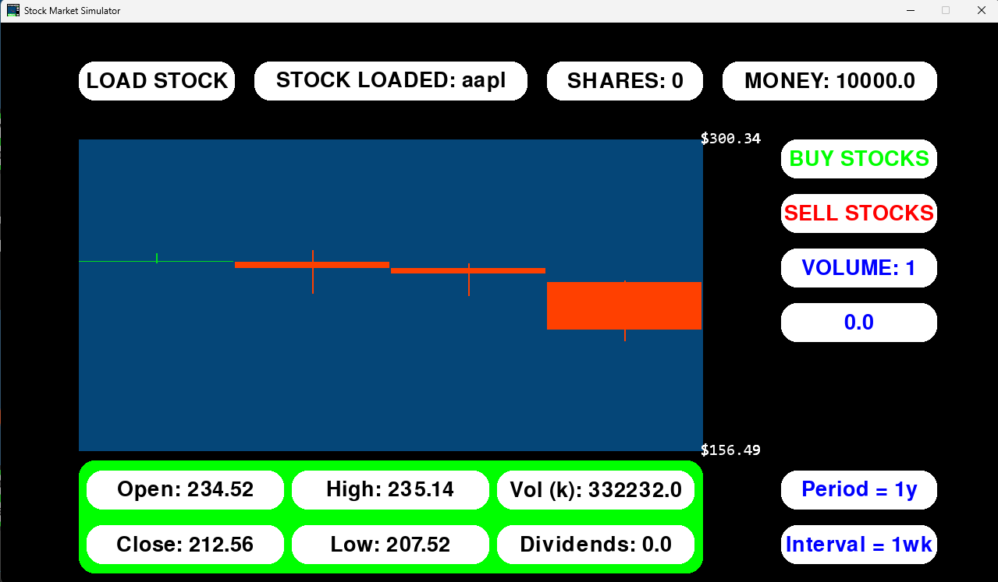

Additional display of information
Additional data fetched using yfinance should be displayed under the graph using text boxes. It should display data for the most recently loaded candlestick.
Test data / method | Test type | Intended result | Result
Observe that the boxes are being drawn to the screen and that the data is correct | Valid | Seven boxes will be drawn, with one as a background and six with data being displayed and updating for each new candlestick. | Works as intended.
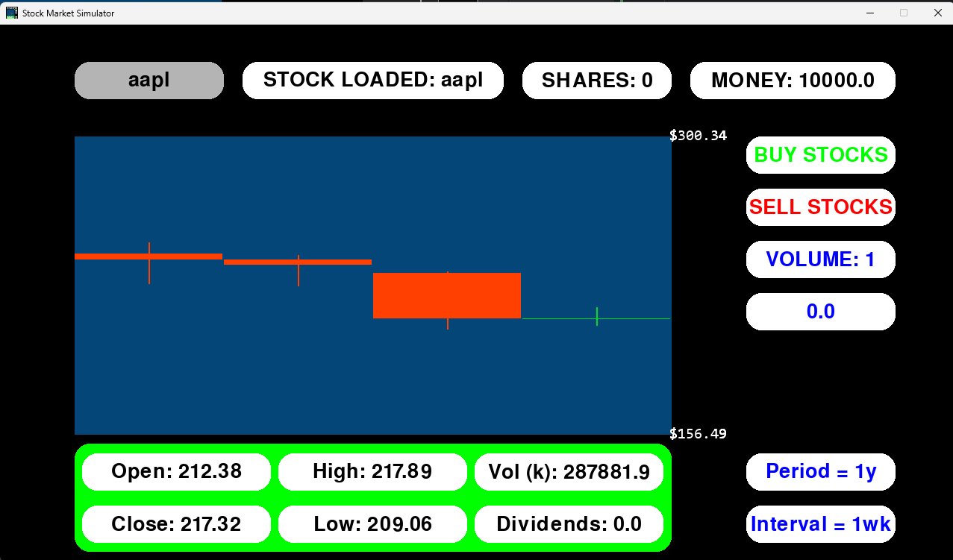
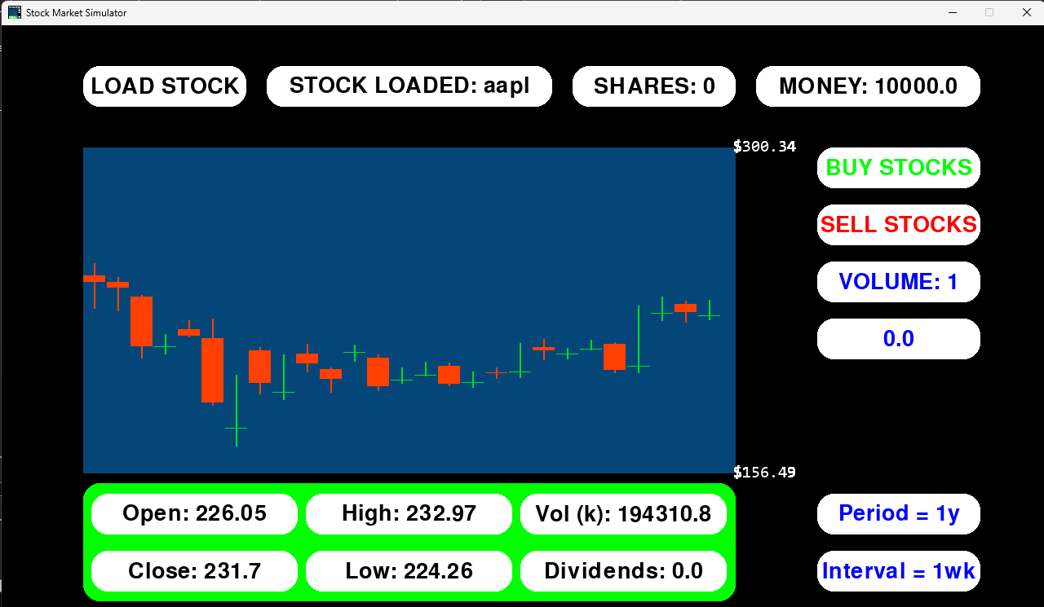

Navigating stocks
The user should be able to switch between currently loaded stocks. When a stock is loaded, a new button should be added to the GUI that allows the user to select that stock.
In the final implementation, I took a different approach. Adding a new button down the side each time is impractical, as the number of stocks that can be loaded is limited by the number of buttons that can fit on the screen. Additionally, my stakeholders gave feedback that this approach clutters the screen and makes the program more confusing. Therefore I adopted my approach of using one button that rotates through a list of loaded stocks. Since I have used this solution, I will not be able to test the “changing positions” success criteria for navigating stocks.
Test data / method | Test type | Intended result | Result
Stocks = “aapl”, “meta”  Observe that the button changes text to that of the loaded stock, and that the graph displays the correct stock’s data | Valid | When pressing the button, its text should change to the correct stock and its corresponding graph should be drawn. | Works as intended. Also if only one stock is loaded, the button does nothing – only displays stock name.

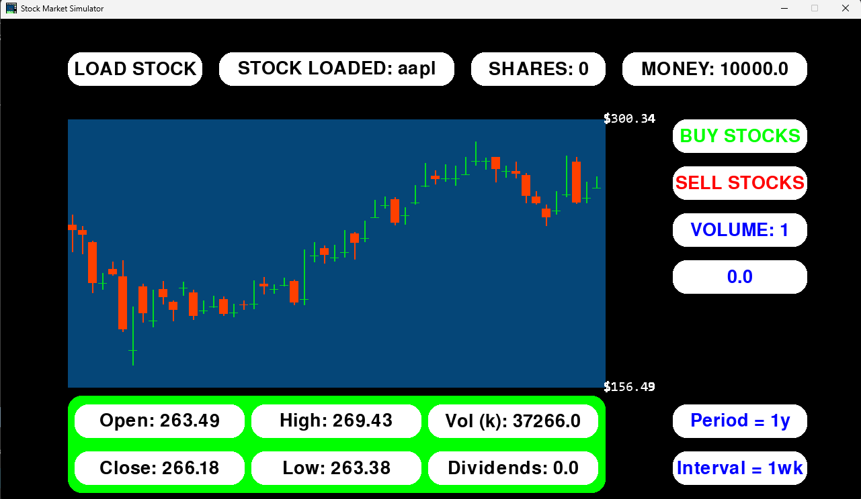
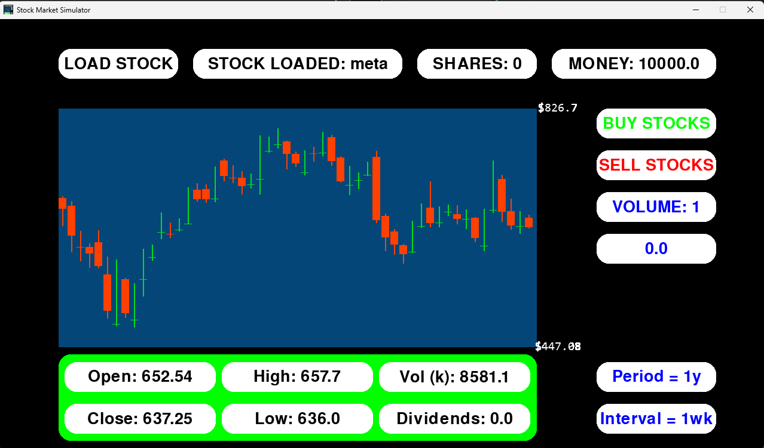

Buying and selling stocks
There should be buttons to buy and sell stocks, with other buttons for changing the volume of stocks sold. The buy and sell functions should validate that the user has enough money/stocks to buy/sell at any point in time for the specified volume.
In the final implementation, I again opted to use one button to change the stock volume rather than many for visual simplicity. I also omitted the text input box for specific amounts of stock, as the denominations given were adequate for my stakeholders’ needs.
Test data / method | Test type | Intended result | Result
Stock=”gsk”, wait for the stock to finish loading fully, then buy and sell in denominations of 1, 10, 100 and max | Valid | Gsk is a cheap stock so 111 + max can be bought with £10000 starting money. The money the user has will decrease, while the shares number will increase. The graph will stop loading new stocks eventually, so I can buy and sell stocks at the same price, showing the conversions of money to stock and vice versa works. | Works as intended.

For buying 1, 10, 100
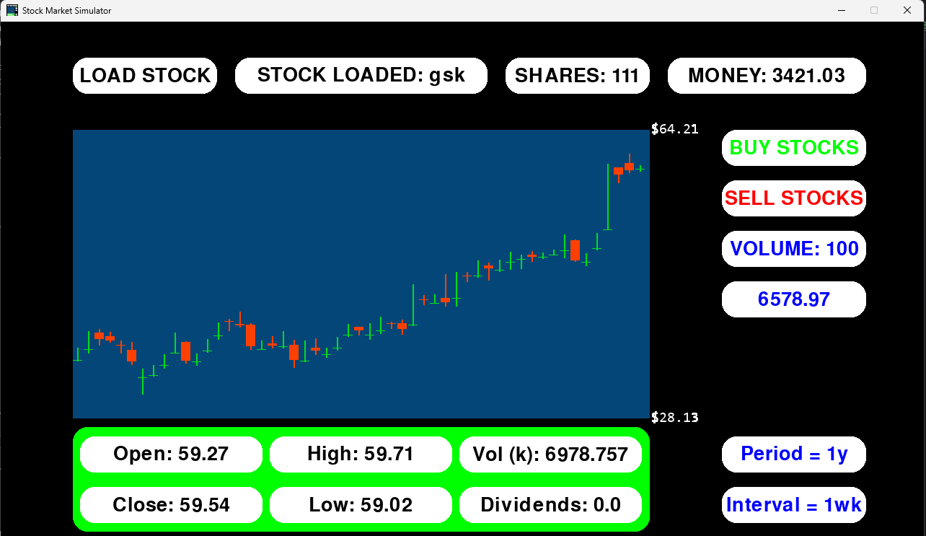

For selling 1, 10, 100
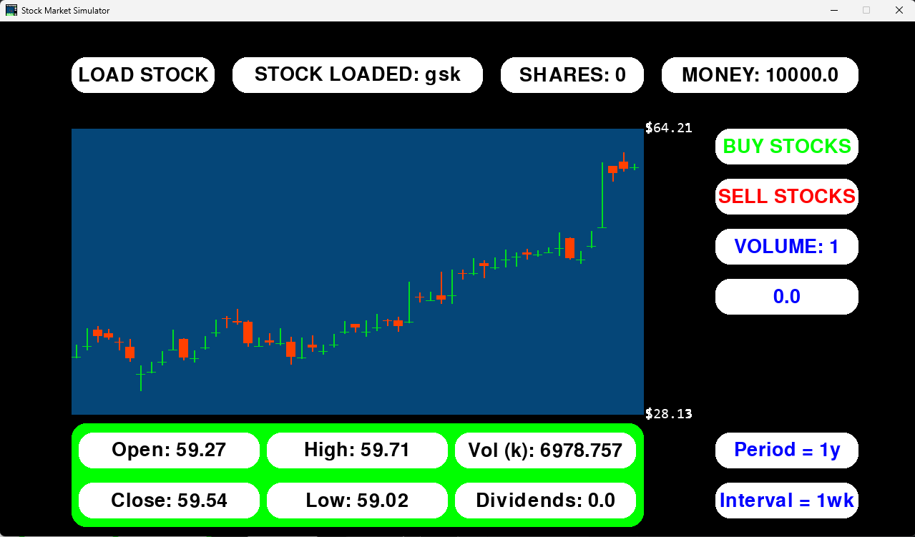

For buying max
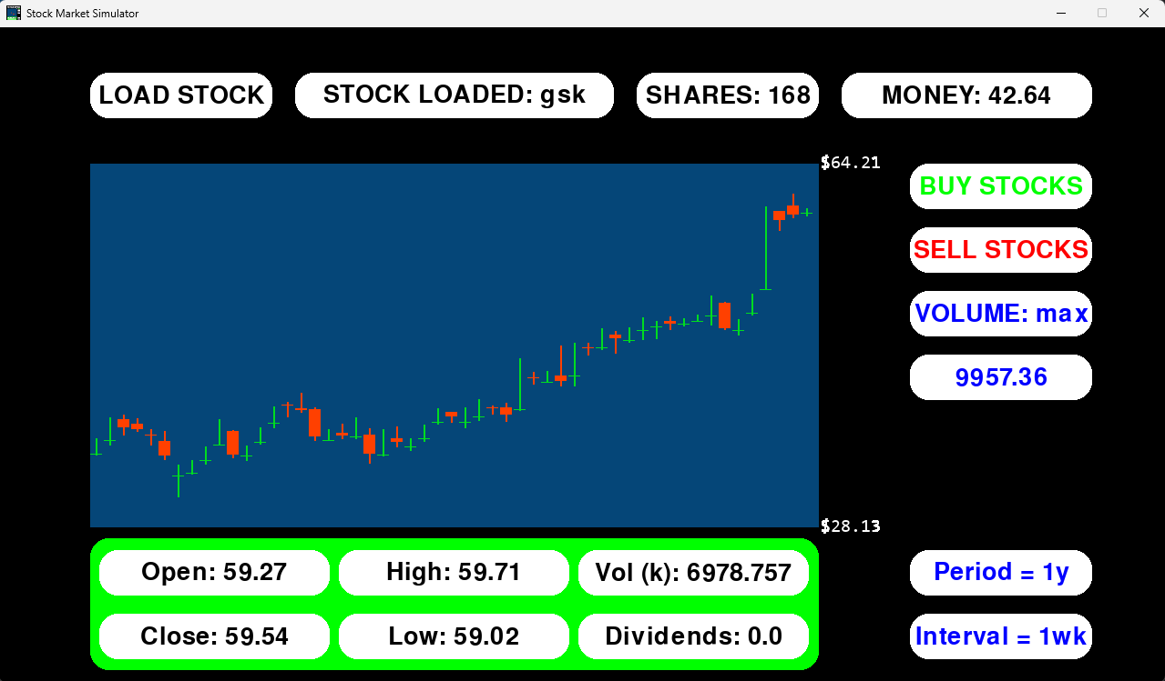

For selling max
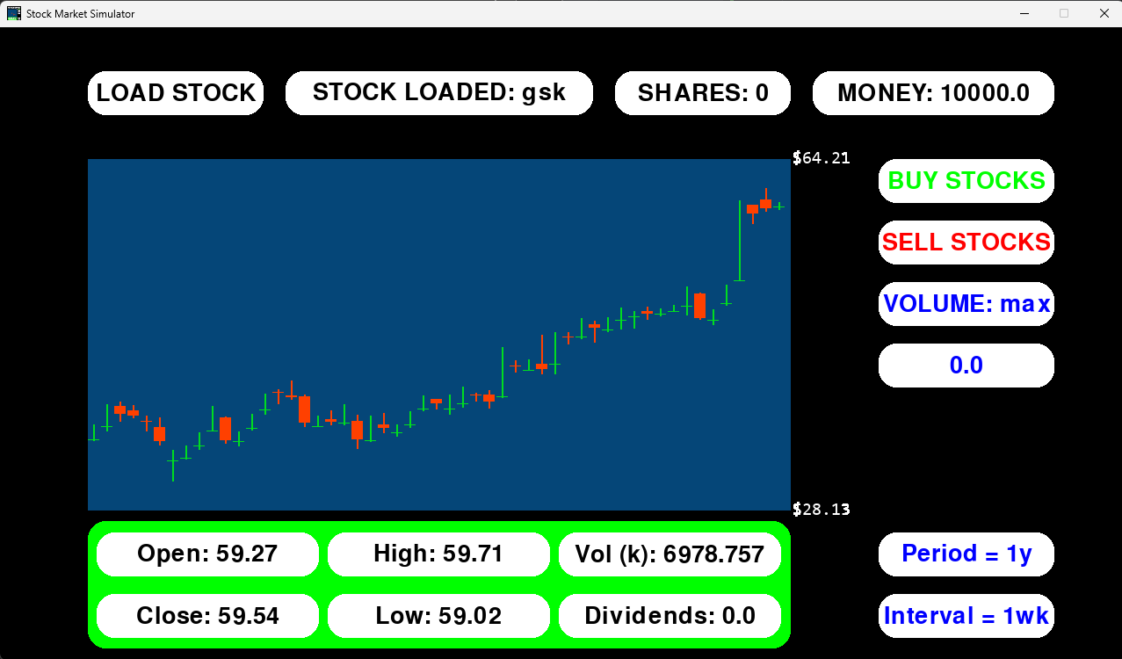

Portfolio price tracker
The current price of the user’s stocks should be summed and displayed in a text box.
Test data / method | Test type | Intended result | Result
Buy 10 stocks from aapl and meta, then observe how the total price changes | Valid | The portfolio price value will change depending on the current price of both aapl and meta stock | Works as intended.

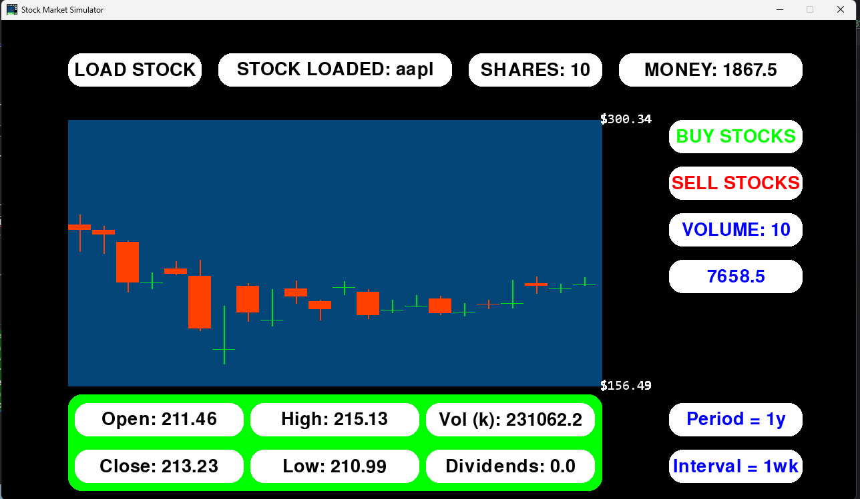
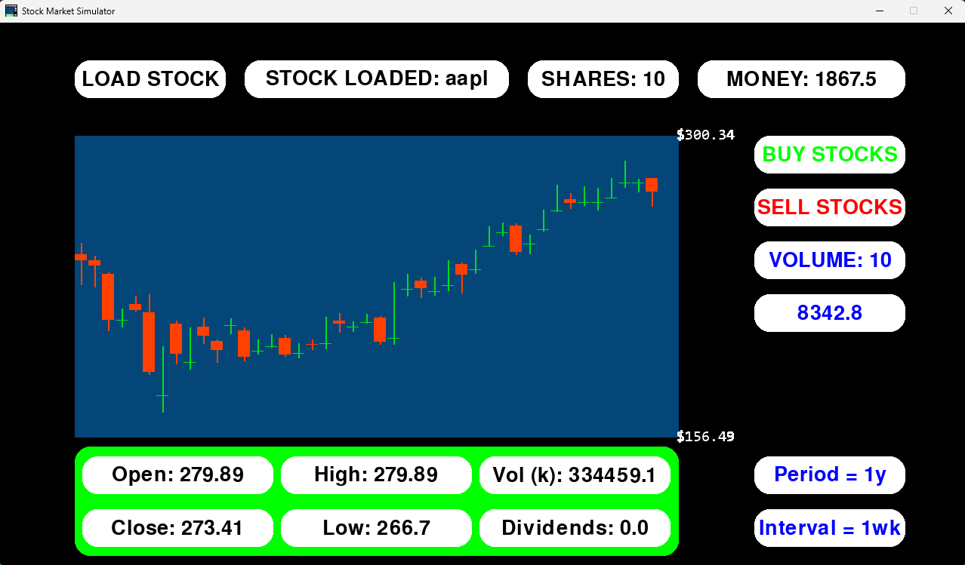
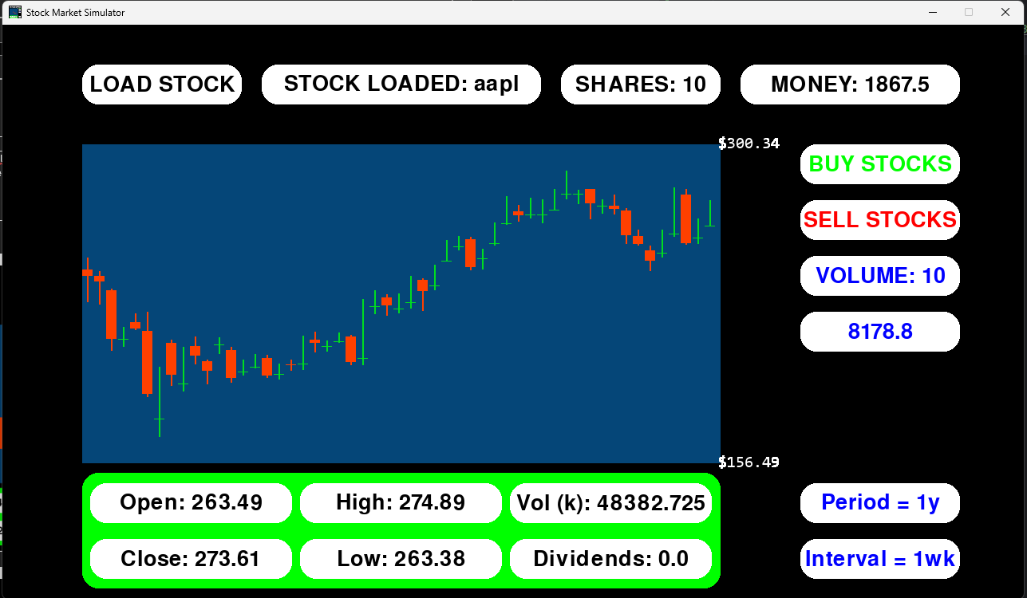

Unmet Success Criteria
The rest of the success criteria have not been met. In the following sections, I will explain how each criteria could be implemented in future iterations of my program.
I plan to implement some of these features in the next iteration of my program, the following success criteria will be added in the actions section.
1 | Creating an account | In the account sign up/ sign in page there should be:  - A title text box  - Text input boxes for creating a new account name and password  - Text input boxes for signing into an account  - A button to input typed data / enter hotkey
2 | Permanently saving account data | Data will need to be permanently saved. To do this, account data can be saved to a file, with an individual one (or section in one) for each new account created. For security reasons, the password should be passed through a hash function before being saved.
3 | Displaying data in account menu | Account data can be fetched from where it was saved and displayed using text boxes.

6 | Sound effects/music | When buttons are pressed:  - A specific sound can play to emphasise clicks  - A specific sound can play when a successful transaction is made  - A specific sound can play when a transaction isn’t successful  When new menus / games are opened:  - The general music can play

Price Predictor

To implement this, I would need to do more research into how I would make the model and what data to train it with. I currently think I could use a LSTM model to predict future values based on previous ones. However, I am unsure of which libraries I would need to make use of to both create and train the models. I may be able to use my current data collection process to gather large amounts of data, then format it into a useable dataset for the model. Regardless, I am coding my project in python, so there are many libraries I can make use of.
To display it graphically, I can use my current graphing system but change the colours. I could simplify it further by using single points rather than candlesticks – only use the y value for one of the data points rather than all four.

Menus

Buttons that link to other menus
Creating the buttons and linking them to a change menu function is simple as I can use my preexisting button class. On the other hand, loading a new menu may prove more challenging. My first thought was to separate each screen into its own class, which would then be called in a main run function. In each menu class I would need to follow a similar structure to my StockMarketSimulator class. The only difference would be that I would make the run function into a more local one that handles the interactions and drawing for only that menu. There would be a new run function in the main program that then runs the intended class’s run function depending on which menu is loaded.

Main, Game modes, Accounts and Settings menus
Each of these menus would consist of features I have already made. From my visual design, you can see that it is made up of only boxes, buttons and text input, meaning I would only need to instantiate a few objects, rather than write any new classes or functions.

Accounts

Generally, I would need to make a system for writing to and reading from a file. I would also need to research what type of file I use, for example, csv or json, etc.

Creating an account and saving data
I can allow the user to create a new account or log on using text input boxes. I can use a button with a custom function to save data as well.
Creating and saving data for an account would be difficult though, as I would need to permanently save data. For each new account made, my plan was to create a new file which could be edited using python file handling functions. I could save data such as username, password and total money
I would have to ensure that the data input into the text boxes are valid. I could check for things like if the username and hashed password are correct, if they are appropriate length and datatype, etc..
For checking if username and password are correct, I can compare the user’s input to the saved values by reading from the file. I can hash the user’s input password to compare it to the saved hashed password.
I can also make use of my current text input box validation to ensure correct input length, datatype and more.
Displaying account data
For accounts menu and scoreboards.
Since the data is stored permanently in files, I can read the files and assign variables to each value being read, then allowing me to use my boxes to display the data.

Settings
Again, I can save these to a user’s account file. I can use things other than text input, like buttons using Boolean values. To extend my program, I could try to implement new forms of user input depending on what is required, such as sliders or checkboxes.

Game Modes

Timer system and pausing
I could use my framerate based system to make a timer. It could count to a maximum framerate, representing time, and when it is reached, the program will display a game over screen. I can implement pausing by simply stopping the framerate counter from incrementing each frame.
Additionally, I could try to find a library or implement a new solution that doesn’t tie time to framerate, as it would be a more robust solution that wont rely on hardware.

Saving games
I can save game data using the same system as saving account data. I can save the current frame for each stock loaded, the overall current frame and other data like money and stock, etc. Then I can ensure the program can reload and set its variables to hold this data, carrying on from where the user left.

Upgrades and abilities
In an additional menu I could add upgrades for the game. I could use buttons and then modify the code to use multipliers in the buying and selling functions. For example, there could be an upgrade that costs 10,000 but multiplies any stocks sold by 1.1x, stacking with each purchase of the upgrade.
Abilities could be added randomly through using python’s random library, giving positive and potentially negative multipliers. I could add pop-up buttons that randomly spawn that, when clicked, give upgrades that are displayed to the user in a side menu, then activated on click.

Game over screen
I can use my menus code to add a game over screen that displays user stats for that game, then links to the main menu. It can be initialised on users running out of time or when their money reaches a threshold that is too low/high.

Sound and music
I would have to research into how to play sound using pygame, however I could add additional parameters to things like the buttons and menus classes.

Scoreboards
I can add another menu for the scoreboard. When it is loaded, I can read through all of the user account files and add all of the data to arrays to compare it, using sorting algorithms. I can then rank the users based on different factors, displaying it in different scoreboards.

Actions
Here, I will add any amendments to my code that I did not include in my initial implementation. It will be ordered in sections, the same way that the final testing was.

Initialisation
Framerate bug
The code that adds a time interval between each new candlestick being added to the draw list uses the framerate rather than an actual timer. When the graph is loaded, the frame it was loaded on is passed in, then it can check if any step of x frames has been made since the graph is loaded to add another candle to the list. By default, the value of x was set to 30 frames, meaning that at 30fps, a new candle would appear every second. However, at 240fps, there are 8x as many frames being drawn, meaning the candlesticks are drawn 8x faster than intended. To normalize the time regardless of framerate, I can change the line of code loading the graph to this:
self.graph = Graph(self.screen, (100, 150, 800, 400), self.data, self.current_frame, (60 * (self.framerate / 60)))
the important part of this is the (60 * (self.framerate / 60)), with this entire expression being the fame timer value passed into the graph. The first integer 60 is the amount of time to spend between drawing each candle, with 60 being 1 second. The following part multiplies the amount of frames needed to load another candle according to the framerate. For example, if the framerate is 30, 30/60 = 0.5, 0.5 * 60 = 30, so only 30 frames will need to pass to draw another candle, equating to 1 second. Likewise for 240, 240 frames will need to pass before a new candle is drawn. This solution is not entirely robust as if the user’s device is not running the program at the maximum frame rate then it may take longer to load another candle, however Luca has given feedback that the program runs consistently at 30fps on his school device.

Window title and icon
I can use pygame’s built in functions to set the window title and icon. For the title, I can add the following into the init_simulator function in the StockMarketSimulator class
pygame.display.set_caption("Stock Market Simulator")

For the icon, I have to save an image and add it to the directory of my code. I can then load this image and set it as the icon. This is implemented in the same section of code as the title.
pygame.display.set_icon(pygame.image.load("StockMarketSim.png"))
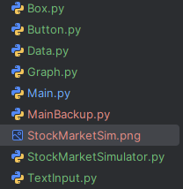
Together this sets the title to “Stock Market Simulator” and the icon to a screenshot of the program

Data Retrieval
Button text bug
I will include this in this section, since I found the bug whilst testing this section – keeps the actions in chronological order.
When taking the mouse away from buttons whose values rotate, the displayed value will return to the starting value, displaying the wrong value. For example, for the period and interval buttons, they display 1yr and 1wk by default. When they are clicked, they update to display the correct value, but when the mouse stops colliding with the box, the text defaults to the original.
The reason why this occurs is because I wanted this effect to work with text input boxes, so they display the function of the box rather than what the user has input to make the GUI clearer to read and understand. To implement this, I added an else statement to the collision logic in the button class, which the text boxes inherit from and would benefit from. However, this breaks the logic for the buttons. I only need this to apply to the text boxes, so I have added an else statement to text box’s if self.active check, with the following code being moved from the buttons class
else:
# for text input later, to display the original "click here to input text type text on a text box, and stopping typing into the box when not clicked.
self.text = self.originaltext

Period and interval bug
When loading a stock, changing the period and interval using the buttons would still result in a period and interval of 1yr, 1wk. This was because I made a new data object for each new loaded graph. I forgot to pass the current self.period and self.interval values into the new data object, so it would just use the default instead. In the load graph function I have amended the following line of code:
self.data = Data(period=self.data.period, interval=self.data.interval)

Stock loading crash bug
When an invalid ticker was input, the program would crash. To validate the ticker is correct, I can contain the contents of the load graph function in the stockmarketsimulator class in a try except loop, returning an error if the graph fails to initialise. If an incorrect ticker is used now, an error is given by my program and yfinance, letting the user know the ticker is invalid.

Accounts and Saving/Loading Data
I would like to touch on the next iteration of my project by adding the most important feature. I will simplify my solution to implementing accounts by focusing only on the accounts, not additional features alongside it. By this, I mean that I will fully implement the accounts, saving and loading data, but I will not implement things like the accounts menu, settings, scoreboards, etc.
Since I wont be using menus, I will use input into the console. I may later decide to add a button or text input box to input account name and password or save/load data.
I will create a new class that will have functions to create a new json file with user data, consisting of username, hashed password, current total portfolio worth, etc. I will need functions to write to the json file, updating any of the additional pieces of data that need to be saved. There will need to be another file to read from the json file and update any corresponding values in the program.
Design
Algorithm
Class Accounts
Procedure initialisation()
Data = {“username”: “”} etc.
Filename = “”
Endprocedure

Procedure createAccounts(username, password)
Create a new json file
Hash the password
Add the username and password to the file
Endprocedure

Function login(username, password)
Open the json file and read the username and password
Check that the username and hashed password match
If they do return true
Else return false
Endfunction

Procedure writeAccount(username, password, any additional data to be saved)
If login is successful then write the additional data into the json file
If not print an error message
Endprocedure

Function readAccount(username, password)
If login is successful then read data from the json file
Return (data values that need to be fetched and updated)
Endfunction
endclass

Variables
Initialisation method
Variable name | Description | Data type
Self.data | A dictionary containing the username, password and money values | Dict of str and float
Self.filename | A path to the file | Str

Data structures
Data structure | Where in code | Use
Dictionary | Input into and returned from the json file | It is the common format of a json file, so is used to group data when saving and loading.

Class diagram
Account
Initialisation()
createAccount()
login()
writeAccount()
readAccount()
Self.data
Self.filename

Test data
Variable/function | Explanation of how it will be tested | Test data
Creating a file | Create a new file and open it to see it has saved correct values | Username = “testfile”  Password = “password”
Saving data | Once a file has been created, trade stocks to increase money, then save data | Same username and password, saving data
Loading data | Trade to get even more money, then load back to the last saved money | Same username and password, loading data
Correct password | Input an incorrect password to see if the validation works | Same username  Password = “incorrectpass”

Implementation
import hashlib
import json
import os
class Account:
def __init__(self):
# initialises starting values for file data
self.data = {
"username": "",
"password": "",
"money": 0
}
self.filename = ""
def writeData(self):
try: # tries to create a new file
with open(self.filename, "w") as file: # open the file and write all of the data in self.data
json.dump(self.data, file)
print("Data Saved")
except:
print("Error")
def loadData(self):
with open(self.filename, "r") as file: # open the file, then load all of the data as a dictionary
data = json.load(file)
return data["money"]
def accessAccount(self, username, password, mode, money=0):
self.filename = username.lower() + ".json" # path will be "username.json" to easily distinguish between users
mode = mode.lower() # user can input save, Save, SAVE, etc. setting here means i dont have to use .lower() twice for loading as well
self.data["username"] = username
self.data["password"] = hashlib.sha256(password.encode()).hexdigest() #hashes password. encoded password is turned into a sha256 object, which is then deconstructed into a string by hexdigest
self.data["money"] = money
if os.path.exists(self.filename): # checks if theres already a file with the same path
with open(self.filename, "r") as file: # if theres already an account, read the hashed password
hashed_password = json.load(file)["password"]
if self.data["password"] == hashed_password: # make sure the password matches
if mode == "save": # if saving data, then save data
self.writeData() # then save new data - password protecting it will stop other users accessing data that isnt theirs
elif mode == "load": # if loading data, load data
return self.loadData()
else:
print("mode is invalid - check code")
else:
print("Incorrect Password")
else: # if there isnt a file with that path, make a new one (no password check)
print(f"creating new file with path - {os.path.abspath(self.filename)}")
self.writeData() # same function as saving data but without a password check - cant pass as there is no password saved - no file yet.
Once I learned more about how creating, reading and writing to a json file worked, I changed my approach significantly.
Firstly, I found that I needed to import json to work with the libraries functions. Alongside this, I needed to import hashlib for hashing the password, and os to get the file’s path. All of these libraries can be run by my stakeholders and work for their devices.
Secondly, I found that my designed structure for the methods was incorrect. Json files are created the same way that data is saved to them, so I did not need a dedicated create and save functions. Instead, I decided to group them together into one to save rewriting code, then have another for reading from the file to load data. I then developed my initial idea of the login method, with one large accessAccount function that stops me from rewriting a lot of code. Mainly, if I didn’t check the file is present, then read the password and validate that it is correct in this function, then I would need the same code in both the save and load data functions, which I much less efficient.
Overall the logic remained the same – if there isn’t already a file with the specified username, then create one – otherwise check the password in the file to see if it matches – then continue to save/load data depending on mode, or exit if password was incorrect.

In the main program, I have created a new button that will get user input from the console, then run the accounts functions. If loading data, it will set the user’s money to their total money.
self.button_account = Button(self.screen, (1000, 430, 200, 50), (255, 255, 255), "david", 40, "ACCOUNT", (0, 0, 0), (180, 180, 180), (255, 0, 0))

self.button_account.interaction(mousepos, event, self.access_account)

self.button_account.draw()

def access_account(self):
money = np.round((self.get_portfolio_worth() + self.money), 2) # adds all stock worth and cash
username = input("Input Username: ") # gets data as console inputs
password = input("Input Password: ")
mode = input("Save or Load: ")
data = self.account.accessAccount(username, password, mode, money) # performs account creation / save / load
if data: # if data is loaded, it will return saved money - otherwise nothing will be returned.
self.money = data

Testing
Creating the file
The new button has been placed just below the total portfolio worth box
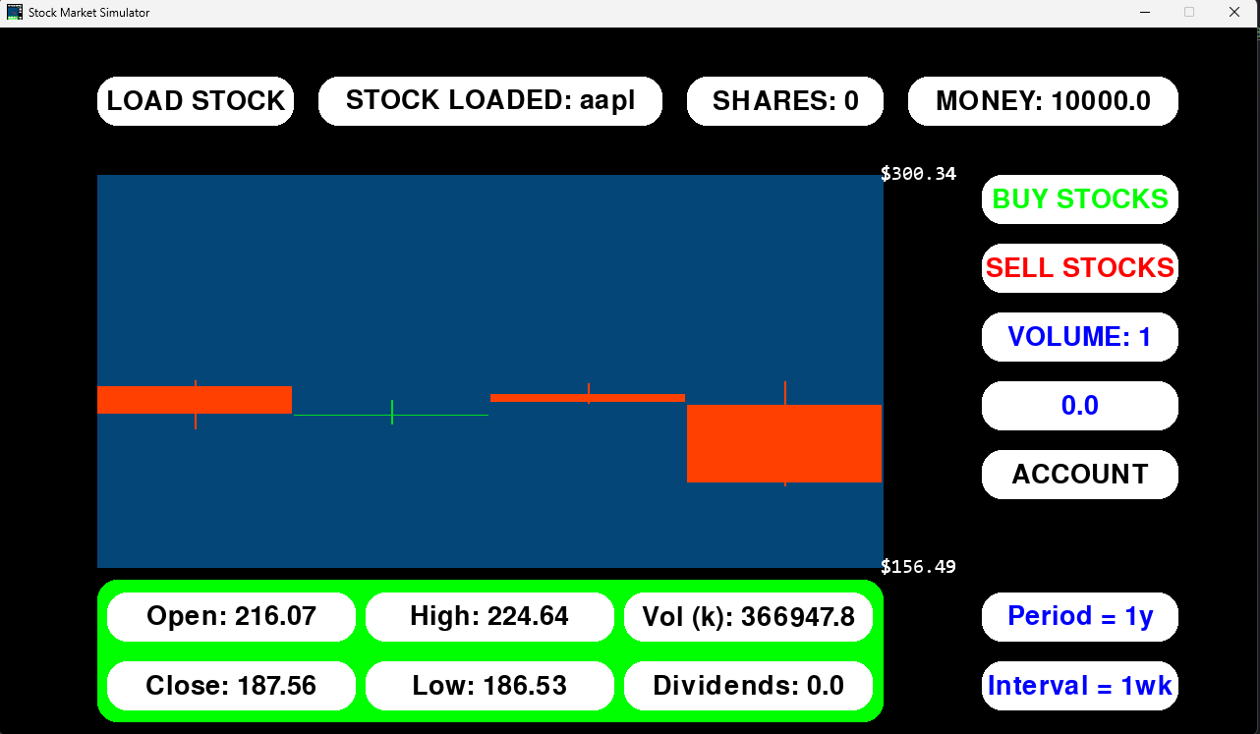
When the account button is pressed it allows the user to input their username, password and if they are reading or writing to the file. If the account is new, then the user can do either function to create an account.
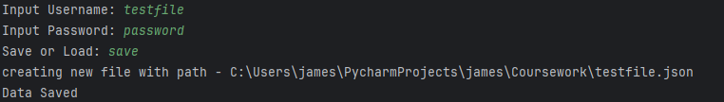
The result of this is that a new json file is created in the project file with the following data
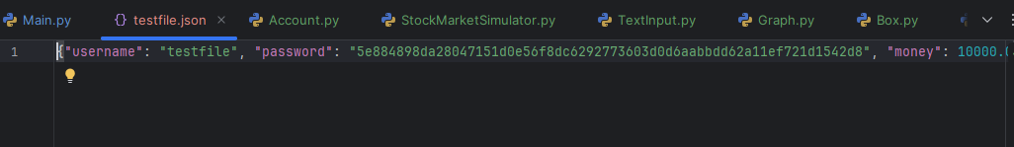
The username has been saved properly, with the hash of the password being saved as well. The 10000 I had as my total portfolio worth was also saved correctly, too.

Saving data
I have traded stocks to increase my money
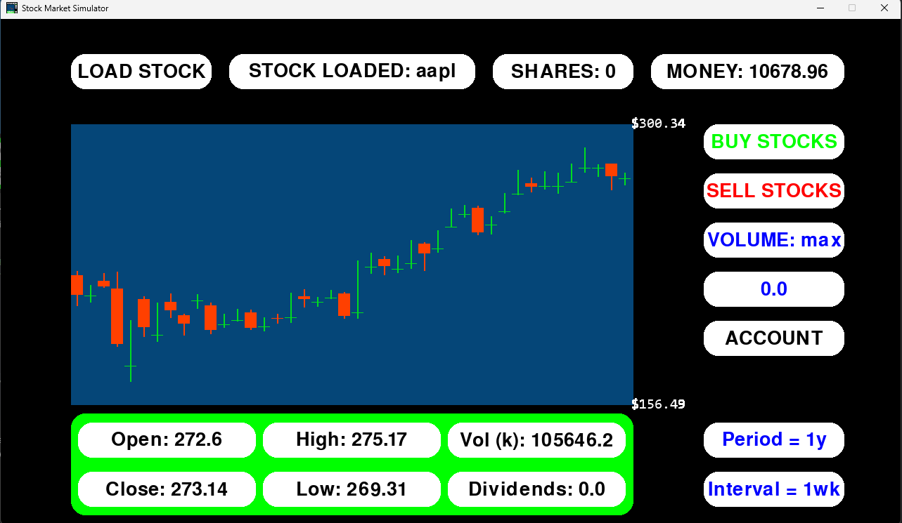
When saving this changes the money value in the file to
Also to demonstrate that the amount saved is stock worth + current cash:
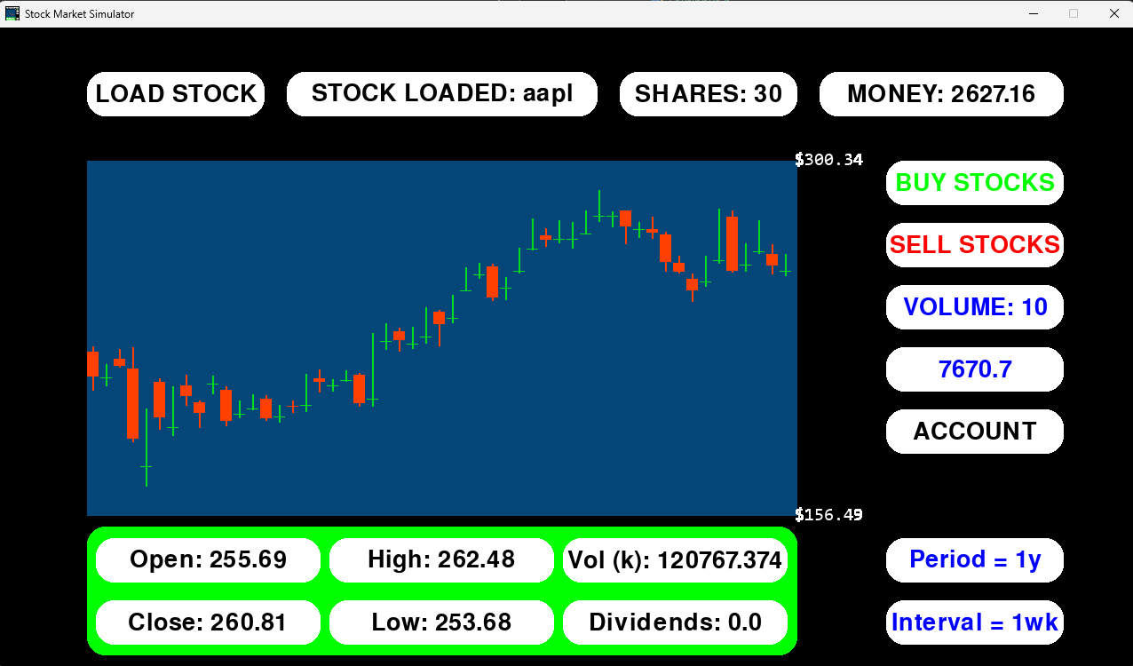
I also need to test if the mode input is correctly converted to lowercase using the .lower() function. This is so that the user can input save, Save, SAVE or any other combination without causing errors. I have used the same function for load as well.
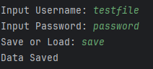
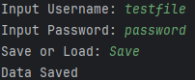
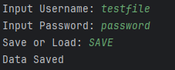

Loading data
I can save the money to be greater than the usual starting value of 10000
Then I can reload the program
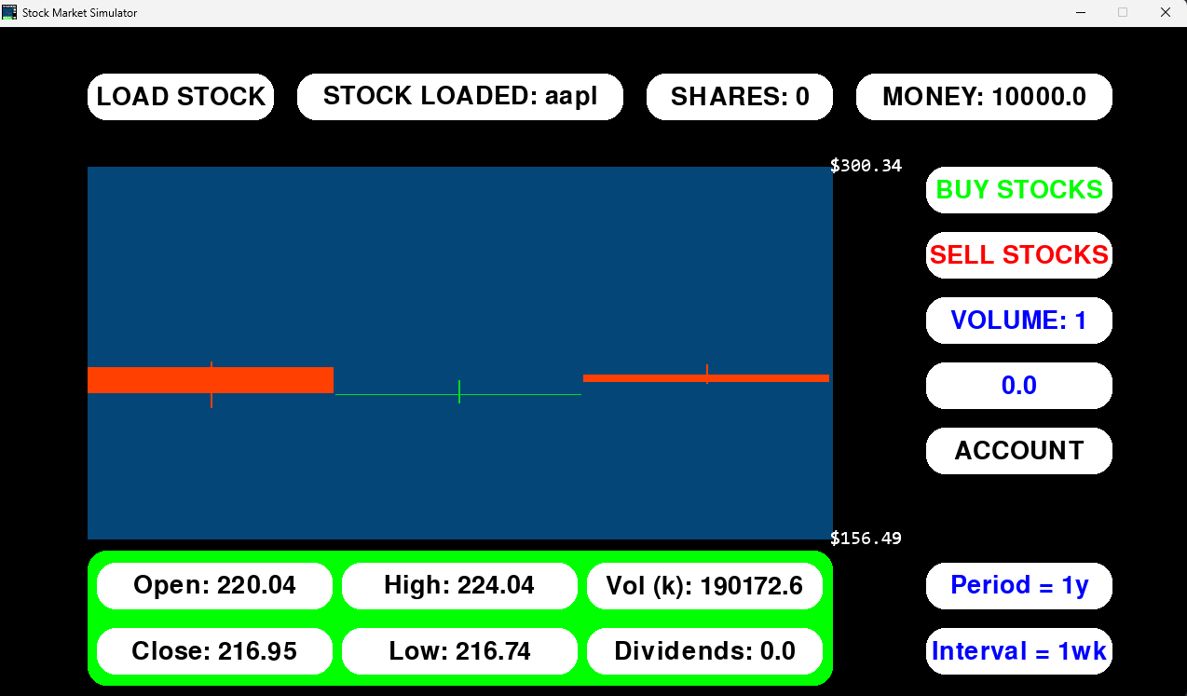
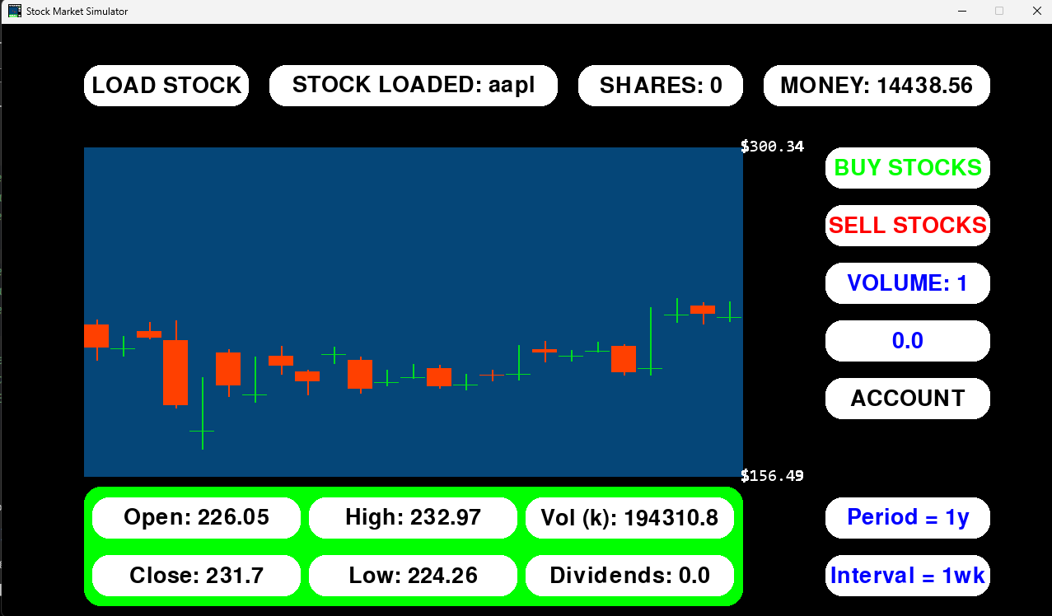
It has successfully loaded the money I previously had

Password validation
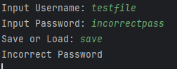
Anything that isn’t password wont work. The password saved into the file is the sha256 hash of “password”, being 5e884898da28047151d0e56f8dc6292773603d0d6aabbdd62a11ef721d1542d8. If the hash of the password is used instead of “password”, the user will not be able to gain access – it isn’t a correct password.
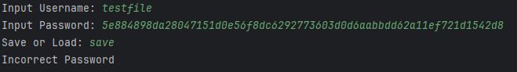

Music
I would also like to implement music. I found that pygame has a system to quickly add music to the program. All I have to do is add the load music and play music functions to the main program. In the initialisation function for the stockmarketsimulator class, I have added the following code
pygame.mixer.music.load("MotivationalStockTradingMusic.mp3") #load music
pygame.mixer.music.play(100, 0.0) # play music - loop 100 times
where “MotivationalStockTradingMusic.mp3” is the reference to the music file I have downloaded.
This works, playing the music file from the moment the program is opened. It will loop 100 times, providing music for a long time. If the user does happen to use the program for 200-300 minutes in one sitting and the music stops, they can save their data and reload the program to reset it.

Usability Features

Explanation of the program
To test how easy my program is to understand, I gave it to Ashley, Xi and Alex with no explanation of how the program works, aside from the initial stock input text box.
Ashley and Xi figured out how the program functions, with the buy, sell and volume buttons being self-explanatory. It took slightly longer for each of them to figure out how to load new stocks with different periods and intervals. They both found how to switch stocks. Xi also told me how he liked the way the program had been laid out, with similar functions being grouped together and others separated by whitespace.
On the other hand, Alex struggled to grasp how some of the features worked, as some buttons have no labels to tell him how to use them. The buy, sell and volume buttons were easy to understand, however loading additional stocks and switching between them took much longer than my other stakeholders. Alex gave the feedback that “there aren’t any headings or labels for some things so it didn’t make sense for a while […] adding something like that or a manual or something would make it easier for people to learn how it works”.
To make it slightly easier for users to adopt, I will add a short text file to the program files explaining what each thing the user can interact with does. This approach is better than adding labels into the program, since it wont clutter the screen with more information that will be ultimately useless once the user is familiar with the program.
The text file consists of the following:
Manual for StockMarketSimulator
Initialising Stocks:
To initialise a stock, type the stock ticker into the box in the top left, then press enter.
To change the overall time period and interval between new pieces of data loading, click on the labelled period and interval buttons in the bottom right.
To initialise more than one stock and swap between them, load a new stock, following the previous instructions, then click on the STOCK LOADED: button in the top/middle of the screen.
Buying and Selling:
Click on the buy or sell buttons. Ensure you have enough money to purchase / stocks to sell.
To change the amount of stocks bought/sold, click on the volume button until the desired amount is reached.
Account Creation, Saving and Loading:
Click on the ACCOUNT button. In the python console, input your username, password and if you are saving or loading data
to create an account, you can use any username and password. You can choose either save or load and it will create the account file
To save your data to your account, input the same username and password and it will save. Using the wrong password will not allow you to save. Using an incorrect username will create a new account under that name
The same works for loading, but choose load instead of save.

User input
All of my stakeholders gave feedback that the buttons and text input are easy to use, being similar to systems in other programs they are familiar with. There was a difference in opinion for the way the stock input button works, though. Luca said he disliked that the stock you last input stays in the text box, as needing to delete the ticker to then type a new one was eventually a “tedious” job. On the other hand, Xi said that it was helpful, as it allowed him to reload the same stock quickly so he could reanalyse how the prices changed, or load it for a different period and interval. In future iterations, I could add this to the settings, allowing the user to choose which of these two options they prefer.
Additionally, some users found that using one button to rotate through stocks, volume, period and interval was impractical, taking a long time to reach the value they desire, and easily overshooting and needing to click all the way through the list again. For example, Ben simultaneously loaded over 10 stocks. Switching between stocks to find a specific one to trade with took a “very long time and it took even longer whenever I would accidentally click again on the one I wanted”. In future iterations, I could add a setting that allows the user to choose between on button with rotating values, or other solutions such as my initial changing stock idea with additional buttons that are created on instantiating a new stock, or using custom textbox input.

Changes in colour
Mr Etherton was satisfied with the use of colours in the program, specifically “Showing how the stock price changes over time using colour was a great addition! It made it easy to decide if I should buy or sell at just a glance. […] This should make your game much easier for my students to understand.”

Layout of program
Initially some stakeholders found the layout confusing, but most adapted quickly, giving feedback that it is intuitive to use once you have settled into using the program. The only negative feedback was again from Alex, but once he discovered how it worked, said that the layout “makes sense with all the main buttons together”. The manual I added earlier should help users understand the layout of the program better.

Longevity

Lifespan of the project
Mostly, the program is built using tools such as python and pygame which are already designed to last for a long time, or permanently, without requiring updates. The problem my program faces is how long yfinance lasts. When yfinance is updated, the program will not work unless the version it is using has been updated. If the program is packaged using a version that will eventually become outdated, then the program will eventually stop working. This shouldn’t be an issue, as when the program is run, an error message will appear in the console telling the user to update the library, which can be easily done.
In the event that the library is totally discontinued or Yahoo finance shuts down, my software is open source, with my users having access to the source code. This means they will be able to implement a new alternative to gathering data. The rest of the program should work, so they would only need to find a new library, or import their own data they have downloaded.

Stakeholders adding code
If someone wishes to add more code to the project, they should be able to with ease. I have designed my project code to be easy manageable and maintainable, being readable and organised so users can quickly understand how different functions work.
I have split each class into its own file, reducing the amount of code cluttering each file. Each function in the class is clearly defined, spaced with whitespace to visually distinguish each from one another. Variable names have been carefully chosen to clearly convey what data the variable holds, with my code being much more readable as a result. Any areas with confusing or less readable code have comments added to give additional details. I also have some lines of code used to test certain features commented into the code, meaning that the user can quickly verify a function works by uncommenting a line of code. My current stakeholder know I am using PyCharm as my IDE and many of them use it themselves, so they will also be able to take advantage of IDE features such as syntax highlighting and debugging.
The main difficulty for a stakeholder to add additional code to the project is learning how the pygame, yfinance and numpy libraries work, as all of the custom functions I have added are easily understandable. Each library has extensive documentation, so learning how to use them effectively shouldn’t be too confusing or time consuming.

Limitations
Alongside issues explained in the usability features and longevity sections, the other main limitations of my software stem from my uncompleted success criteria.
The main limitation was the lack of competitive features. In the end I was unable to implement any kind of system that can compare the performance of players. In the next iteration of my program, I would seek to add a system that would allow players to compare their performance – whether with a scoreboard for accounts on one device, or on many through an online leaderboard.
Additionally, a game modes system would’ve made my program much more engaging for Mr Etherton’s students and my stakeholders who were interested in using it for entertainment. It could also tie into the competitive aspect of the program, with people competing both in the main mode and in the individual game modes.
For scoreboards, I could add the menus system then read through all of the account files, listing who has the most money. If there was some kind of online system then I could do the same thing, but getting the data from where it is stored online – potentially on one central server, which has every account uploaded to it.
For game modes, I can use my existing program, then add small features to it, such as a timer system or powerups. I could also create more menus for each of the game modes and for game over screens, displaying that game’s stats.

Final Project Code
I have added additional comments to make the code easier to read and maintain. Each section / class is its own individual python file.
Main
import pygame
from StockMarketSimulator import StockMarketSimulator
pygame.init()
# initialise simulator object and run
simulator = StockMarketSimulator((1280, 720), 30)
simulator.init_simulator()
simulator.run()
pygame.quit()

StockMarketSimulator
import pygame
import numpy as np
from Box import Box
from Button import Button
from TextInput import TextInput
from Data import Data
from Graph import Graph
from Account import Account
global_stocks = []
class StockMarketSimulator:
def __init__(self, resolution, framerate):
# initialise variables
self.WIDTH, self.HEIGHT = resolution
self.screen = pygame.display.set_mode(resolution)
self.clock = pygame.time.Clock()
self.framerate = framerate
self.current_frame = 0
self.stock_pointer = 0
self.money = 10000.00
self.volume = "1"
self.volume_array = ["1", "10", "100", "max"]
self.volume_pointer = 0
pygame.mixer.music.load("MotivationalStockTradingMusic.mp3") #load music
pygame.mixer.music.play(100, 0.0) # play music - loop 100 times
def init_simulator(self):
# initialising window title and icon
pygame.display.set_caption("Stock Market Simulator")
pygame.display.set_icon(pygame.image.load("StockMarketSim.png"))
# instantiating classes
self.data = Data()
self.account = Account()
self.money_display = Box(self.screen, (925, 50, 275, 50), (255, 255, 255), "david", 40, "MONEY", (0, 0, 0))
self.button_buy = Button(self.screen, (1000, 150, 200, 50), (255, 255, 255), "david", 40, "BUY STOCKS", (0, 255, 0), (180, 180, 180), (0, 255, 0))
self.button_sell = Button(self.screen, (1000, 220, 200, 50), (255, 255, 255), "david", 40, "SELL STOCKS", (255, 0, 0), (180, 180, 180), (255, 0, 0))
self.button_change_volume = Button(self.screen, (1000, 290, 200, 50), (255, 255, 255), "david", 40, "VOLUME", (0, 0, 255), (180, 180, 180), (255, 0, 0))
self.stock_name_input = TextInput(self.screen, (100, 50, 200, 50), (255, 255, 255), "david", 40, "LOAD STOCK", (0, 0, 0), (180, 180, 180), (255, 0, 0))
self.button_change_stock = Button(self.screen, (325, 50, 350, 50), (255, 255, 255), "david", 40, "STOCK", (0, 0, 0), (180, 180, 180), (0, 255, 0))
self.shares_display = Box(self.screen, (700, 50, 200, 50), (255, 255, 255), "david", 40, "SHARES", (0, 0, 0))
self.portfolio_worth_display = Button(self.screen, (1000, 360, 200, 50), (255, 255, 255), "david", 40, "WORTH", (0, 0, 255), (180, 180, 180), (255, 0, 0))
self.button_account = Button(self.screen, (1000, 430, 200, 50), (255, 255, 255), "david", 40, "ACCOUNT", (0, 0, 0), (180, 180, 180), (255, 0, 0))
self.stock_period = Button(self.screen, (1000, 575, 200, 50), (255, 255, 255), "david", 40, f"Period = {self.data.period}", (0, 0, 255), (180, 180, 180), (255, 0, 0))
self.stock_interval = Button(self.screen, (1000, 645, 200, 50), (255, 255, 255), "david", 40, f"Interval = {self.data.interval}", (0, 0, 255), (180, 180, 180), (255, 0, 0))
self.graph = None
def buy_stocks(self):
self.money = np.round(self.graph.buy(self.money, self.volume), 2) # runs buy function, rounding the amount to the nearest 1p
def sell_stocks(self):
self.money = np.round(self.graph.sell(self.money, self.volume), 2)
def set_volume(self):
self.volume_pointer = (self.volume_pointer + 1) % len(self.volume_array) # every time set_volume is run, increment the pointer but if it is at the end of the list then reset it
self.volume = self.volume_array[self.volume_pointer] # setting index
def change_stock(self):
if not global_stocks: # if no graphs have been loaded yet
print("no stocks loaded")
else:
self.stock_pointer = (self.stock_pointer + 1) % len(global_stocks) # same code as switching through volume
self.graph = global_stocks[self.stock_pointer]
def load_graph(self, stock):
try:
self.data = Data(period=self.data.period, interval=self.data.interval) # initialise a new data object every time a new graph is loaded - keeps data separate from other graphs
self.data.initialise(stock) # initialise the stock
self.graph = Graph(self.screen, (100,150,800,400), self.data, self.current_frame, (30 * (self.framerate / 60))) # initialise the graph using gathered data. Time between candlesticks is normalised
global_stocks.append(self.graph) # add to a list so user can swap between stocks
except:
return
def set_period(self): # this and the interval one just link to data class functions and update button text
self.data.set_period()
self.stock_period.updateText(f"Period = {self.data.period}")
def set_interval(self):
self.data.set_interval()
self.stock_interval.updateText(f"Interval = {self.data.interval}")
def get_portfolio_worth(self): # for every graph in the graph list, add the stocks owned * current price = total stock worth
total_worth = 0
for stock in global_stocks:
total_worth += stock.worth
return total_worth
def access_account(self):
money = np.round((self.get_portfolio_worth() + self.money), 2) # adds all stock worth and cash
username = input("Input Username: ") # gets data as console inputs
password = input("Input Password: ")
mode = input("Save or Load: ")
data = self.account.accessAccount(username, password, mode, money) # performs account creation / save / load
if data: # if data is loaded, it will return saved money - otherwise nothing will be returned.
self.money = data
def run(self):
run = True
while run: # main loop
self.current_frame += 1 # frame counter
mousepos = pygame.mouse.get_pos()
for event in pygame.event.get(): # get events
if event.type == pygame.QUIT: # if the X is pressed on the window, close program
run = False
# interactions have to go in event space - entire functions are passed in, allowing them to be run
self.button_buy.interaction(mousepos, event, self.buy_stocks)
self.button_sell.interaction(mousepos, event, self.sell_stocks)
self.button_change_volume.interaction(mousepos, event, self.set_volume)
self.button_change_stock.interaction(mousepos, event, self.change_stock)
self.stock_name_input.interaction(mousepos, event, self.stock_name_input.input(event, self.load_graph, 5, "string"))
self.button_account.interaction(mousepos, event, self.access_account)
self.stock_period.interaction(mousepos, event, self.set_period)
self.stock_interval.interaction(mousepos, event, self.set_interval)
keys = pygame.key.get_pressed() # listen to keystrokes
if keys[pygame.K_ESCAPE]: # if esc pressed, close program
run = False
self.screen.fill((0,0,0)) # start of every frame - clear screen
#draw and update boxes, graphs, text, etc. Some only draws if a graph has been loaded
self.stock_name_input.draw()
self.stock_period.draw()
self.stock_interval.draw()
if self.graph: # if a graph has been loaded
self.graph.draw(self.current_frame)
self.button_buy.draw()
self.button_sell.draw()
self.button_change_volume.updateText(f"VOLUME: {self.volume}")
self.button_change_volume.draw()
self.button_change_stock.updateText(f"STOCK LOADED: {self.graph.data.stockname}")
self.button_change_stock.draw()
self.shares_display.updateText(f"SHARES: {self.graph.shares}")
self.shares_display.draw()
self.money_display.updateText(f"MONEY: {self.money}")
self.money_display.draw()
total_money = np.round(self.get_portfolio_worth(), 2)
self.portfolio_worth_display.updateText(f"{total_money}")
self.portfolio_worth_display.draw()
self.button_account.draw()
pygame.display.flip() # end of every frame - update screen
self.clock.tick(self.framerate) # cap framerate

Box
import pygame
class Box:
def __init__(self, screen, rect, boxcolour, font, textsize, text, textcolour, border_radius=20):
# set the variables
self.screen = screen
self.rect = pygame.Rect(rect) # make into a Rect object to make drawing and getting centre easier
self.boxcolour = boxcolour
self.font = pygame.font.SysFont(font, textsize) # pygame font initialisation
self.text = text
self.textcolour = textcolour
self.border_radius = border_radius
def draw(self): # condenses drawbox and text into one function to save typing - also makes stockmarketsimulator less cluttered
self.drawBox()
self.drawText()
def drawBox(self):
# draws a rectangle on the screen, with the correct colour, at the rect position with the correct border radius
pygame.draw.rect(self.screen, self.boxcolour, self.rect, border_radius=self.border_radius)
def drawText(self):
text_render = self.font.render(self.text, True, self.textcolour) # render text
centre = text_render.get_rect(center=self.rect.center) # get the centre of the box to get a position for the text to sit centred in the box
self.screen.blit(text_render, centre) # draw the text on top of the box
def updateText(self, text): # workaround for changing text in the period and interval buttons
self.text = text

Button
import pygame
from Box import Box
class Button(Box):
def __init__(self, screen, rect, boxcolour, font, textsize, text, textcolour, hovercolour, clickcolour, border_radius=20):
super().__init__(screen, rect, boxcolour, font, textsize, text, textcolour, border_radius)
self.hovercolour = hovercolour
self.clickcolour = clickcolour
self.originalboxcolour = boxcolour
self.originaltext = text
self.active = False # added to check if the box is currently being hovered over/ clicked (for text input later)
def interaction(self, mousepos, event, function):
if self.rect.collidepoint(mousepos): # if the mouse hovers over the button
self.boxcolour = self.hovercolour # change colour
if event.type == pygame.MOUSEBUTTONDOWN: # if theres a click
self.boxcolour = self.clickcolour # change colour again
try:
self.active = True # then activate and run function()
function()
except TypeError: # stops from trying to call NoneType
pass
else:
self.boxcolour = self.originalboxcolour
self.active = False

TextInput
import pygame
from Button import Button
class TextInput(Button):
'''
uses box.drawBox and box.drawText to display
uses button.interaction to check for mouse hover/click detection
then if the button is clicked and continuously hovered over, textinput.input is run, reading input from the user
when the user presses enter, the text is then validated. If it is correct then it passes as a parameter into the function you want to run.
'''
def __init__(self, screen, rect, boxcolour, font, textsize, text, textcolour, hovercolour, clickcolour, usertext="", border_radius=20):
super().__init__(screen, rect, boxcolour, font, textsize, text, textcolour, hovercolour, clickcolour, border_radius)
self.usertext = usertext
def input(self, event, function, length=100, datatype=None):
if self.active: # if the box is clicked
if event.type == pygame.KEYDOWN: # if a (specific) key is pressed
if event.key == pygame.K_BACKSPACE:
# when backspace is pressed, usertext is set to usertext, but minus the last character
self.usertext = self.usertext[:-1]
if event.key == pygame.K_RETURN:
# enter pressed, validate input then (if correct) pass to the function you want
validateduserinput = self.inputValidation(self.usertext, length, datatype)
if validateduserinput != None:
function(validateduserinput)
self.usertext = self.text
if event.type == pygame.TEXTINPUT:
# adds user text input to the userinput string
self.usertext += event.text
# self.text is what is used in box.drawText to actually display the text, so its easier to just set this to usertext, then reset later
self.text = self.usertext # updates text in box to show what the user has typed
self.drawText() # updates text in text box
else:
# for text input later, to display the original "click here to input text type text on a text box, and stopping typing into the box when not clicked.
self.text = self.originaltext
def inputValidation(self, userinput, length=100, datatype=None):
#self.text = "" # resets the text when enter is pressed, resetting the text box
inputlen = len(userinput)
if not userinput.strip():
print("invalid input - must not be whitespace")
return None
if inputlen == 0 or inputlen > length: # input is longer than the specified length value
print("invalid input - invalid length")
return None
if datatype == "int": # for specific data types --- maybe add more validation for different data types if needed.
try:
return int(userinput)
except ValueError:
print("invalid input - wrong type")
return None
if datatype == "str":
return str(userinput)
return userinput

Data
import yfinance as yf
global_periods = ("1d", "5d", "1mo", "3mo", "6mo", "1y", "2y", "5y", "10y", "ytd", "max")
global_intervals = ("1m", "2m", "5m", "15m", "30m", "1h", "1d", "5d", "1wk", "1mo", "3mo")
class Data:
# sets initial values for initial text on buttons
def __init__(self, period="1y", interval="1wk"): # first setup for before a stock has been input
self.period = period
self.interval = interval
self.period_pointer = global_periods.index(period)
self.interval_pointer = global_intervals.index(interval)
# ******* potentially change set_period and set_interval to be one function by passing period or interval as a parameter to change whats updated.
# changes period by incrementing a pointer in an array
def set_period(self):
self.period_pointer = (self.period_pointer + 1) % len(global_periods) # increments pointer and also resets the pointer to 0 if it goes past the length of the tuple
self.period = global_periods[self.period_pointer] # setting period to be the index
# changes interval by incrementing a pointer in an array
def set_interval(self):
self.interval_pointer = (self.interval_pointer + 1) % len(global_intervals) # increments pointer and also resets the pointer to 0 if it goes past the length of the tuple
self.interval = global_intervals[self.interval_pointer]
#print(self.interval) for debugging
# sets the stock and runs the get_data function
def initialise(self, stock):
self.stock = stock
self.get_data()
#self.print_data() #use for debugging, comment out later
# uses yfinance to retrieve data based on user set stock, period and interval
def get_data(self):
try: # tries to gather data for a stock - works if stock ticker is valid, returns error if not
ticker = yf.Ticker(self.stock) # wont return an error if an incorrect ticker name is used, so the next line is added too
data = ticker.history(period=self.period, interval=self.interval) # gathers data from the ticker object
self.date = data.index
self.open = data["Open"].values # values formats to array
self.close = data["Close"].values
self.high = data["High"].values
self.low = data["Low"].values
self.stockname = self.stock
self.volume = data["Volume"].values
self.dividends = data["Dividends"].values
except:
print("invalid stock ticker")
# prints data for debugging purposes - same idea can probably be used for formatting the data
def print_data(self):
for i in range(len(self.date)): # each set of data should be the same length
print(f"{self.stockname} {i} {self.date[i]} -- ",
f"High: {round(self.high[i], 2)} ",
f"Low: {round(self.low[i], 2)} ", # also round is used to round the data to the nearest 1p (for ease of use)
f"Open: {round(self.open[i], 2)} ",
f"Close: {round(self.low[i], 2)}")

Graph
import pygame
import numpy as np
from Box import Box
class Graph:
def __init__(self, screen, rect, data, first_loaded_frame, frame_timer):
#setting variables - should be self explanatory
self.screen = screen
self.rect = pygame.Rect(rect)
self.first_loaded_frame = first_loaded_frame
self.frame_timer = frame_timer
self.num_items = 1
self.data = data
self.data_min = min(self.data.low)
self.data_max = max(self.data.high)
range = self.data_max - self.data_min
margin = range * 0.1
self.data_min -= margin
self.data_max += margin
# initialising min/max box objects
self.min_price_box = Box(self.screen, (910, 540, 50, 20), (0,0,0), "consolas", 20, f"${np.round(self.data_min, 2)}", (255,255,255))
self.max_price_box = Box(self.screen, (910, 140, 50, 20), (0,0,0), "consolas", 20, f"${np.round(self.data_max, 2)}", (255,255,255))
self.stock_price = self.data.open[1] # stock price based on the closing price for each data index - more variation than open, but less random like high/low
self.shares = 0
self.worth = 0
# initialising additional display box objects
self.stats_background = Box(self.screen, (100, 562.5, 800, 145), (0, 255, 0), "david", 40, "", (0, 0, 0))
self.open_display_box = Box(self.screen, (110, 575, 253.3, 50), (255, 255, 255), "david", 40, "Open Display", (0, 0, 0))
self.close_display_box = Box(self.screen, (110, 645, 253.3, 50), (255, 255, 255), "david", 40, "Close Display", (0, 0, 0))
self.high_display_box = Box(self.screen, (373.3, 575, 253.3, 50), (255, 255, 255), "david", 40, "High Display", (0, 0, 0))
self.low_display_box = Box(self.screen, (373.3, 645, 253.3, 50), (255, 255, 255), "david", 40, "Low Display", (0, 0, 0))
self.volume_display_box = Box(self.screen, (636.6, 575, 253.3, 50), (255, 255, 255), "david", 40, "Volume Display", (0, 0, 0))
self.dividends_display_box = Box(self.screen, (636.6, 645, 253.3, 50), (255, 255, 255), "david", 40, "Dividends Display", (0, 0, 0))
def data_to_screen(self, data_value): # takes the straight data value and converts it into coordinates on the screen
normalised_y = ((data_value - self.data_min) / (self.data_max - self.data_min))
normalised_y = 1.0 - normalised_y
screen_y = self.rect.y + (normalised_y * self.rect.height)
return screen_y
def draw(self, current_frame):
normalised_current_frame = current_frame - self.first_loaded_frame # starts counting from frame 0 instead of some random frame
if normalised_current_frame % self.frame_timer == 0:
self.num_items = min(int(normalised_current_frame / self.frame_timer) + 1, len(self.data.low)) # adds another candlestick to the list if enough time (frames) has passed
graph_width = self.rect.width
candle_margin = 2
candle_spacing = np.trunc(graph_width / self.num_items) # spacing calculations - has to be to nearest pixel, so leaves space at right of graph sometimes
candle_width = np.trunc(candle_spacing - candle_margin)
bg_colour = (5, 70, 120)
pygame.draw.rect(self.screen, bg_colour, self.rect) # adds a background colour to the graph rect
for i in range(self.num_items):
x = np.trunc(self.rect.left + (candle_spacing * i))
#pygame.draw.rect(self.screen, (0,0,255), (x, self.rect.y, candle_width, self.rect.height)) # background of candles - shows spacing between candles
open_y = self.data_to_screen(self.data.open[i]) # getting the data values for the current candlestick
close_y = self.data_to_screen(self.data.close[i])
high_y = self.data_to_screen(self.data.high[i])
low_y = self.data_to_screen(self.data.low[i])
mid_x = x + (candle_width / 2)
if self.data.close[i] >= self.data.open[i]: # checking if price is increasing / decreasing to decide colour (green/red)
candle_colour = (0, 220, 32)
else:
candle_colour = (255, 64, 0)
pygame.draw.line(self.screen, candle_colour, (mid_x, low_y), (mid_x , high_y), width=2) # high-low line
candle_height = max(1, close_y - open_y) # ensures the candle height isnt too small to see
pygame.draw.rect(self.screen, candle_colour, (x, open_y, candle_width, candle_height)) # open-close box
# drawing all of the boxes initialised earlier. Updates text as well to display current data
self.min_price_box.draw()
self.max_price_box.draw()
self.stats_background.draw()
self.open_display_box.draw()
self.open_display_box.updateText(f"Open: {np.round(self.data.open[self.num_items - 1], 2)}") # could have put all of this in a for loop but i added the boxes at different times so didnt work out in practice
self.close_display_box.draw()
self.close_display_box.updateText(f"Close: {np.round(self.data.close[self.num_items - 1], 2)}")
self.high_display_box.draw()
self.high_display_box.updateText(f"High: {np.round(self.data.high[self.num_items - 1], 2)}")
self.low_display_box.draw()
self.low_display_box.updateText(f"Low: {np.round(self.data.low[self.num_items - 1], 2)}")
self.volume_display_box.draw()
self.volume_display_box.updateText(f"Vol (k): {self.data.volume[self.num_items - 1] / 1000}") # /1000 allows text to fit in the box even with high volumes
self.dividends_display_box.draw()
self.dividends_display_box.updateText(f"Dividends: {self.data.dividends[self.num_items - 1]}") # probably a useless metric but i have space for 6 boxes - ask stakeholders for feedback
self.stock_price = np.round(self.data.open[self.num_items - 1], 2)
self.worth = self.shares * self.stock_price # for portfolio worth
def buy(self, money, volume): # if you have enough money to buy stock price * volume then buy it. otherwise you cant
if volume == "max":
volume = money // self.stock_price
price = volume * self.stock_price
else:
price = self.stock_price * int(volume)
if money >= price:
self.shares += int(volume)
money -= price
return money
def sell(self, money, volume): # same logic for buying but for selling.
if volume == "max":
volume = self.shares
volume = int(volume)
revenue = self.stock_price * volume
if self.shares >= volume:
self.shares -= volume
money += revenue
return money

Account
import hashlib
import json
import os
class Account:
def __init__(self):
# initialises starting values for file data
self.data = {
"username": "",
"password": "",
"money": 0
}
self.filename = ""
def writeData(self):
try: # tries to create a new file
with open(self.filename, "w") as file: # open the file and write all of the data in self.data
json.dump(self.data, file)
print("Data Saved")
except:
print("Error")
def loadData(self):
with open(self.filename, "r") as file: # open the file, then load all of the data as a dictionary
data = json.load(file)
return data["money"]
def accessAccount(self, username, password, mode, money=0):
self.filename = username.lower() + ".json" # path will be "username.json" to easily distinguish between users
mode = mode.lower() # user can input save, Save, SAVE, etc. setting here means i dont have to use .lower() twice for loading as well
self.data["username"] = username
self.data["password"] = hashlib.sha256(password.encode()).hexdigest() #hashes password. encoded password is turned into a sha256 object, which is then deconstructed into a string by hexdigest
self.data["money"] = money
if os.path.exists(self.filename): # checks if theres already a file with the same path
with open(self.filename, "r") as file: # if theres already an account, read the hashed password
hashed_password = json.load(file)["password"]
if self.data["password"] == hashed_password: # make sure the password matches
if mode == "save": # if saving data, then save data
self.writeData() # then save new data - password protecting it will stop other users accessing data that isnt theirs
elif mode == "load": # if loading data, load data
return self.loadData()
else:
print("mode is invalid - check code")
else:
print("Incorrect Password")
else: # if there isnt a file with that path, make a new one (no password check)
print(f"creating new file with path - {os.path.abspath(self.filename)}")
self.writeData() # same function as saving data but without a password check - cant pass as there is no password saved - no file yet.

The final project files are the following. Each file, such as Account and Box contain their respective classes. Main initialises a StockMarketSimulator object, running the program. MainBackup is a copy of all of the code but in one file. Manual.txt is the manual I created in the usability features section. MotivationalStockTradingMusic.mp3 is the music that plays when opening the program. StockMarketSim.png is used for the window icon. Any accounts created will be added to the project files as a json file. Alongside this, users will need to download any of the libraries that I used.
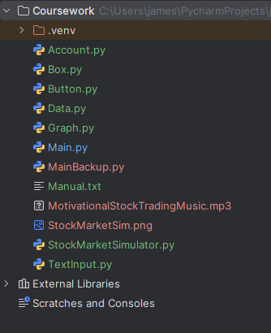

Bibliography

Bibliography:

Source | Information gained | Validity of source
https://stockscan.io/stock-market-simulator | Images for “existing solutions” section, in addition to inspiration for features my simulator needs. | It is a widely used online stock market simulator, making it a good example of what my project should be like.
https://simul8or.com/ | Same as above | Same as above
https://fakeonomy.com/learn | Same as above | Same as above
https://www.pygame.org/docs/ | Information about the pygame library – functionality and syntax. Allows me to make graphics. | Official pygame website.
https://www.geeksforgeeks.org/ | Explanations of topics with coded examples. Helps greatly when learning about how to implement a new feature | Same as above
https://www.w3schools.com/ | Same as above | Same as above
https://yfinance-python.org/index.html | Information about the yfinance library – functionality and syntax. Allows me to retrieve financial data from yahoo finance | Same as above
https://code.visualstudio.com/Docs/supporting/requirements | Hardware requirements for running visual studio code | Same as above
https://www.jetbrains.com/help/pycharm/installation-guide.html#toolbox | Hardware requirements for pycharm | Same as above

